HUAWEI CloudLink Bar 210
25.0
 | Product Overview
 | Issue | 02
 | Date | 2026-01-09

 | HUAWEI TECHNOLOGIES CO., LTD. |  | 

Copyright © Huawei Technologies Co., Ltd. 2026. All rights reserved.
No part of this document may be reproduced or transmitted in any form or by any means without prior written consent of Huawei Technologies Co., Ltd.

Trademarks and Permissions
and other Huawei trademarks are trademarks of Huawei Technologies Co., Ltd.
All other trademarks and trade names mentioned in this document are the property of their respective holders.

Notice
The purchased products, services and features are stipulated by the contract made between Huawei and the customer. All or part of the products, services and features described in this document may not be within the purchase scope or the usage scope. Unless otherwise specified in the contract, all statements, information, and recommendations in this document are provided "AS IS" without warranties, guarantees or representations of any kind, either express or implied.
The information in this document is subject to change without notice. Every effort has been made in the preparation of this document to ensure accuracy of the contents, but all statements, information, and recommendations in this document do not constitute a warranty of any kind, express or implied.

Huawei Technologies Co., Ltd.
Address: | Huawei Industrial Base  Bantian, Longgang  Shenzhen 518129  People's Republic of China
Website: | https://e.huawei.com

Security Declaration
Product Lifecycle
Huawei's regulations on product lifecycle are subject to the Product End of Life Policy. For details about this policy, visit the following web page:
https://support.huawei.com/ecolumnsweb/en/warranty-policy

Vulnerability
Huawei's regulations on product vulnerability management are subject to the Vul. Response Process. For details about this process, visit the following web page:
https://www.huawei.com/en/psirt/vul-response-process
For vulnerability information, enterprise customers can visit the following web page:
https://securitybulletin.huawei.com/enterprise/en/security-advisory

Initial Digital Certificate
The Initial digital certificates on Huawei devices are subject to the Rights and Responsibilities of Initial Digital Certificates on Huawei Devices. For details about this document, visit the following web page:
https://support.huawei.com/enterprise/en/bulletins-service/ENEWS2000015789

Huawei Enterprise End User License Agreement
This agreement is the end user license agreement between you (an individual, company, or any other entity) and Huawei for the use of the Huawei Software. Your use of the Huawei Software will be deemed as your acceptance of the terms mentioned in this agreement. For details about this agreement, visit the following web page:
https://e.huawei.com/en/about/eula

Lifecycle of Product Documentation
Huawei after-sales user documentation is subject to the Product Documentation Lifecycle Policy. For details about this policy, visit the following web page:
https://support.huawei.com/enterprise/en/bulletins-website/ENEWS2000017761

Contents
1 Product Positioning 1
2 Product Highlights 2
3 Platform Connection 4
3.1 CloudVC Network 4
3.2 IdeaManager Network 5
4 Product Structure 6
4.1 Appearance 6
4.2 Rear Panel 7
4.3 Indicators 10
4.4 Remote Control 10
4.5 Required Microphone Array 13
4.5.1 Mic 500 Series 13
5 Functions and Features 15
5.1 HD Video 15
5.2 Hi-Fi Audio 15
5.3 Intelligent Content Sharing 15
5.4 Intelligent Tracking 16
5.5 Audio Diagnostics 16
5.6 Multistream Conferencing 17
5.7 Multiple Layouts 17
5.8 Joining or Initiating a Conference 18
5.9 Conference Control 19
5.10 Barge-in/Forcible Release 22
5.11 BYOM 22
5.12 Address Book 22
5.13 Globalization 22
5.14 Operations, Administration, and Maintenance 23
5.14.1 Batch Configuration 23
5.14.2 Customizing the Wallpaper and Startup Animation 23
5.14.3 Resetting the Web Password 23
5.15 Remote Viewing 23
5.16 APIs for Third-Party Integration 24
6 Security and Reliability 25
7 Operations and Maintenance 28
7.1 GUIs 28
7.1.1 Remote Control UI 28
7.1.2 IdeaShare UI 28
7.1.3 Web Interface 30
7.2 Maintenance and Upgrade 31
7.2.1 Log Management 31
7.2.2 Diagnostics 31
7.2.3 Inspection 31
7.2.4 CHR Data Collection 31
7.2.5 Upgrade 32
8 Technical Specifications 33
8.1 Physical Specifications 33
8.2 Performance Specifications 35
8.3 Ports and Protocols 37
8.4 Standards Compliance 38
8.5 HEVC Authorization 39
9 Glossary 40

Product Positioning
CloudLink Bar 210 is Huawei's next-generation integrated HD video conferencing endpoint running HarmonyOS with an inner camera, microphone array, and HD codec, as well as a full-HD PTZ camera that features up to 3x digital zoom, to ensure that the speaker is always centered within the frame. The Bar 210 comes with a 1080p HD display, and is ideal for small and medium-sized conference rooms.

Product Highlights
Ingenious Design
- Cohesive body design, with an inner camera, microphone array, and HD codec, which is easy to connect and install.
- Six built-in digital microphones, 100 Hz to 20 kHz wide frequency range, and precise sound pickup within 8 m, providing crisp, natural human voices.
High Security and Reliability
- Huawei's HarmonyOS, proprietary core technologies, and high-computing hardware platform architecture are supported for powerful performance.
- Chinese cryptographic algorithms are supported for conferences. Signaling and media protocols use the SM2, SM3, and SM4 algorithms for authentication and encryption. Data is transmitted in ciphertext and will not be disclosed upon loss.
HD Video and Auto-Framing
- With Auto-Framing enabled, the camera displays a panoramic view of all participants at the site.
- Huawei's proprietary Video Motion Enhancement (VME) technology effectively removes noises from images with moving objects to improve video quality.
- H.265 1080p multistream conferences are supported so that endpoints can encode and decode multiple channels of streams in different formats at the same time, allowing users to flexibly adjust the continuous presence layout and view any site.
Hi-Fi Audio
- The built-in microphone array features an 8 m sound pickup distance and uses intelligent algorithms to ensure lossless voice pickup, encoding, decoding, and transmission.
- Opus + NetATE + AJB improve the audio quality.
- Audio multistreaming enables endpoints to decode multiple channels of audio streams at the same time, mix them, and output them, to reduce platform resource consumption.
- Acoustic echo cancellation (AEC), automatic noise gain (ANG), and automatic gain control (AGC) are combined to deliver clear audio.
BYOM
- Bring Your Own Meeting (BYOM), enabling you to initiate or join a cloud conference on a personal computer and invoke the camera, microphone, and speaker of the endpoint, for better audiovisual experience of remote sites
- IdeaShare wireless projection and one-tap sharing from a PC or mobile phone, avoiding the need for complex cables
- Wired projection via HDMI and Type-C
Easy Operations
Standard next-generation remote control with stylish appearance in the palm of your hand

Platform Connection

CloudVC Network
The endpoint can be connected to the CloudVC network to meet video communication requirements of enterprises and carriers.
              - Networking scheme
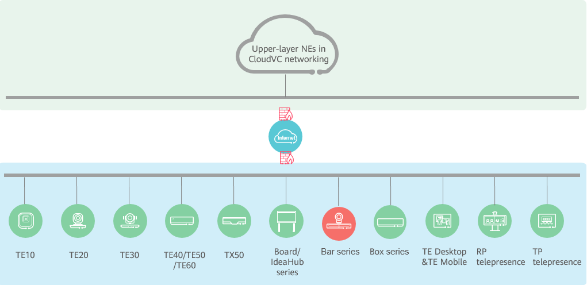

In this networking scheme:
- In the CloudVC networking, the endpoint connects to the network through standard H.323 or SIP.
- The endpoint can work with various types of conferencing endpoints and clients to implement audio and video calling, content sharing, and service interworking.

IdeaManager Network
Endpoints can connect to the IdeaManager to meet endpoint management and O&M requirements in scenarios where a large number of endpoints are connected.
The IdeaManager is an integrated endpoint management solution for enterprises. It provides end-to-end O&M and management capabilities to help customers improve O&M efficiency and reduce O&M costs. By deployment mode, the IdeaManager can be classified into IdeaManager (cloud service) and IdeaManager (on-premises). The platform supports unified management of endpoints, including configuration delivery, O&M management, app management, and certificate management.

This function is dependent on a supporting version of the IdeaManager.

Product Structure

Appearance
              - Appearance
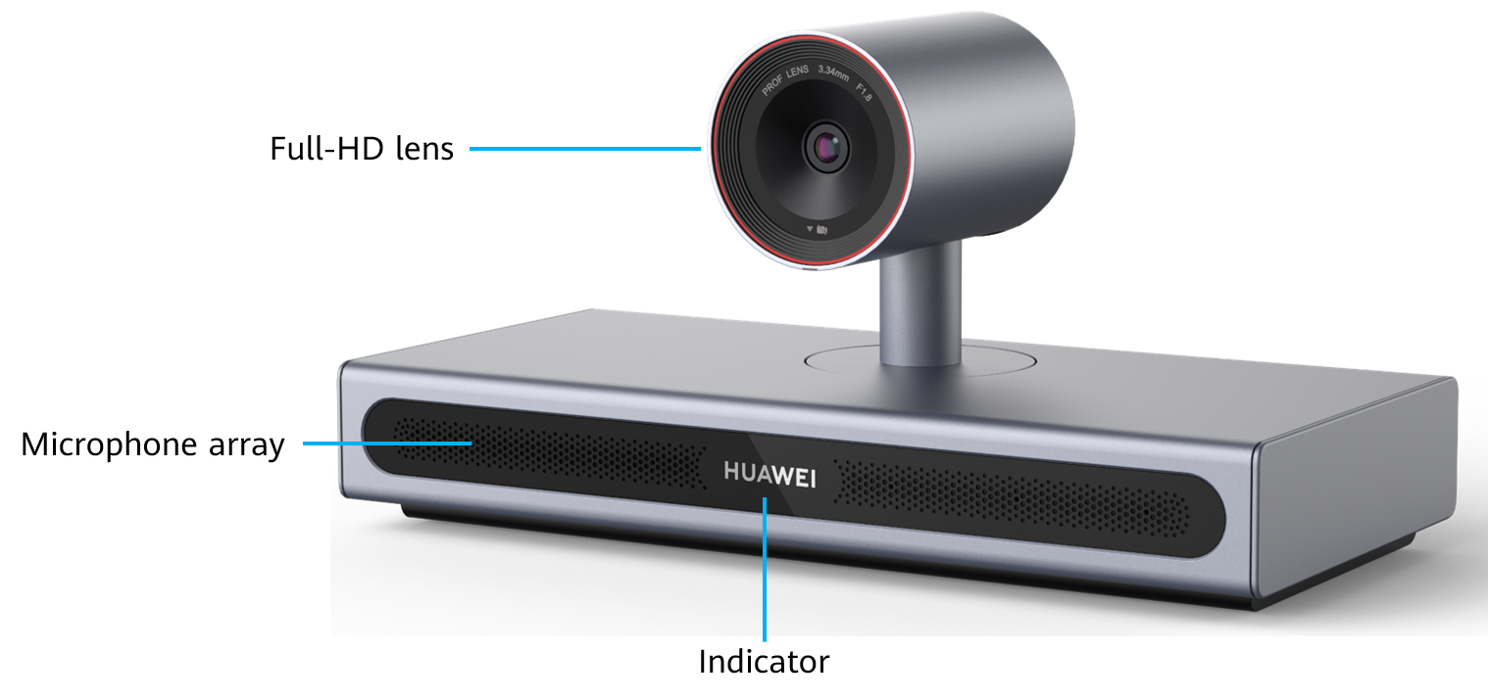

                - Component description
Component | Function
Full-HD main lens | Shoots video of the local site.
Microphone array | Supports local sound pickup within a 180-degree pattern at a maximum distance of 8 meters.
Indicator (two-color) | Shows whether the endpoint is running, sleeping, or faulty.

Rear Panel
              - Rear panel
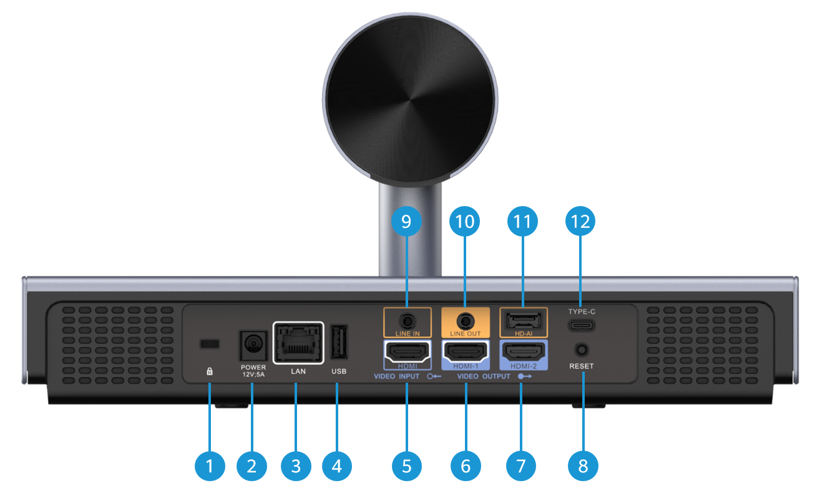

                - Component description
Category | No. | Component | Function
Audio input ports | 11 | HD-AI audio input port | Connects to a microphone array such as Mic 500 series.
Audio input ports | 9 | 3.5 mm audio input port | Connects to an audio input source such as a computer.
Audio output ports | 10 | 3.5 mm audio output port | Connects to an external speaker to deliver audio from remote sites.
Video output ports | 7 | HDMI video output port, which supports a resolution of up to 4K 60 fps and audio output  NOTE  - To display 4K 50 fps or 4K 60 fps videos, only HDMI 2.0 cables can be used. Otherwise, a black screen or screen crack may occur. To display videos with 4K 30 fps or lower resolutions, the HDMI 1.4 or HDMI 2.0 cable can be used.  - When the video output resolution is 4K at 30 fps, it is recommended to keep the cable length within 5 m. For 4K at 60 fps, the cable should ideally be no longer than 3 m. If long-distance transmission is required, you are advised to use an HDMI extender. | Connects to a display device as the second output.  - When Output port policy is set to Extended mode 1, the conference material is displayed. If no material is shared, the local video is displayed.  - When Output port policy is set to Extended mode 2, the remote video is displayed.  - When Output port policy is set to Extended mode 3 and the conference material is shared, the local or remote video is displayed; if no material is shared, the local video is displayed.  - When Output port policy is set to Single-screen, there is no output by default. If Image displayed preferentially is set and multiple options are selected, the priority of the presentation is higher than that of the remote video and local video (in sequence).
Video output ports | 6 | HDMI video output port, which supports a resolution of up to 4K 60 fps and audio output  NOTE  - To display 4K 50 fps or 4K 60 fps videos, only HDMI 2.0 cables can be used. Otherwise, a black screen or screen crack may occur. To display videos with 4K 30 fps or lower resolutions, the HDMI 1.4 or HDMI 2.0 cable can be used.  - When the video output resolution is 4K at 30 fps, it is recommended to keep the cable length within 5 m. For 4K at 60 fps, the cable should ideally be no longer than 3 m. If long-distance transmission is required, you are advised to use an HDMI extender. | Connects to a display device as the first output.  - When Output port policy is set to Extended mode 1, the local or remote video is displayed.  - When Output port policy is set to Extended mode 2, the conference material or local video is displayed.  - When Output port policy is set to Extended mode 3, the conference material is displayed. If no material is shared, the remote video is displayed.  - When Output port policy is set to Single-screen, the video of the local or remote site or the conference material is displayed.
Video input ports | 5 | HDMI video input port, which supports a resolution of up to 4K 30 fps and audio input  NOTE  When the video input resolution is 4K, it is recommended that the cable length be within 5 m. For long-distance transmission, you are advised to use an HDMI extender. | Content input port, which can connect to devices such as a computer.  Connects to an HDMI input source.
Other components | 1 | Kensington security slot | Connects to a Kensington lock to secure the endpoint. The Kensington lock should be prepared separately.
Other components | 2 | Power input port, 12 V/5 A | Connects to a power supply.
Other components | 3 | Ethernet port (10/100/1000 Mbit/s, full-duplex and half-duplex supported) | Connects to an external service port.
Other components | 4 | USB Type-A port | Connects to a USB device, such as a USB flash drive or camera.
Other components | 8 | Reset pin hole (Use the tip of a pen or similar to reset.) | - During startup, press and hold this pin hole for 3 to 5 seconds to enter eRecovery mode.  - When the endpoint is running, press and hold the pin hole for 13s to reset it to factory settings.
Other components | 12 | USB Type-C port | - Connects to a computer or mobile device for projection and sharing. When connecting to a computer, you can also use the microphone, speaker, and camera of the endpoint as virtual peripherals.  - Connects to another USB device, such as a USB flash drive or camera.

Indicators
By checking the status of the indicator on an endpoint, you can check its operating status and ensure that it is working properly with other video conferencing devices. Table 4-3 lists indicator statuses.
                - Indicator statuses and corresponding endpoint statuses
Indicator Status | Endpoint Status
Off | Powered off
Blinking green twice per second | Powering on
Blinking green four times per second | Upgrading
Steady green | Working properly
Blinking green once | Responding to a press on a remote control button
Breathing green (gradually lighting, then dimming) | Sleeping
Steady red | Muted
Blinking red once every 5s | Faulty hardware
Blinking red four times per second | Faulty software
Blinking red twice every 5s | Overtemperature or fan fault
Blinking red twice per second | IP address conflict

Remote Control
The remote control is used with the endpoint. You can use the remote control to place calls and control conferences on the display.
              - Remote control buttons
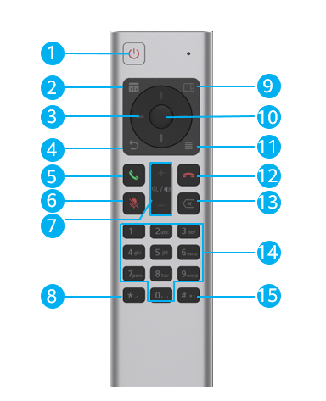

                - Remote control buttons
No. | Button | Description
1 | Power button | Press to restart or shut down the endpoint or place it in sleep mode.
2 | Start/Stop presentation sharing | Starts or stops sharing a presentation.
3 | Arrows | Displays the conference control bar, scroll the screen, or rotate the camera.
4 | Back | Press to return to the previous screen or close the current screen.
5 | Place/Answer call | Press to initiate a call to access the conference screen or start a conference.
6 | Mute/Unmute microphone | Press to mute or unmute the microphone.
7 | Increase/Decrease volume  Zoom in or zoom out on image | Increase and decrease the volume, and zoom in and zoom out on images.
8 | Asterisk (*) | Press to enter a dot in the conference IP address when the soft keyboard is disabled.  Press to enter an asterisk (*) when the soft keyboard is enabled.
9 | Video layout | Press to switch the video layout.
10 | OK button | Press to confirm the current operation or display the conference control bar.
11 | Menu | Press to display the conference control bar, edit camera presets, and edit recent call records.
12 | Hang up | Press to end or leave a conference.
13 | Delete | Press to delete the current content.
14 | Keypad | - Press to enter digits.  - During a conference, you can press and hold a number key ranging from 1 to 9 to switch to the corresponding camera preset.
15 | Number sign (#) | Press to enter the number sign (#).

When the endpoint is in sleep mode, you can press the power button on the remote control to wake it up.

Required Microphone Array

Mic 500 Series
The HUAWEI CloudLink Mic 500 series compact microphone array supports 360-degree sound pickup with an optimal range of six meters, lossless broadband audio transmission, and excellent 3A audio processing technology. It works with Huawei's full series of video conferencing endpoints to deliver an entirely new hi-fi stereo audio experience. (3A = AEC: Acoustic Echo Cancellation; AGC: Automatic Gain Control; ANS: Automatic Noise Suppression)
              - Mic 500 series
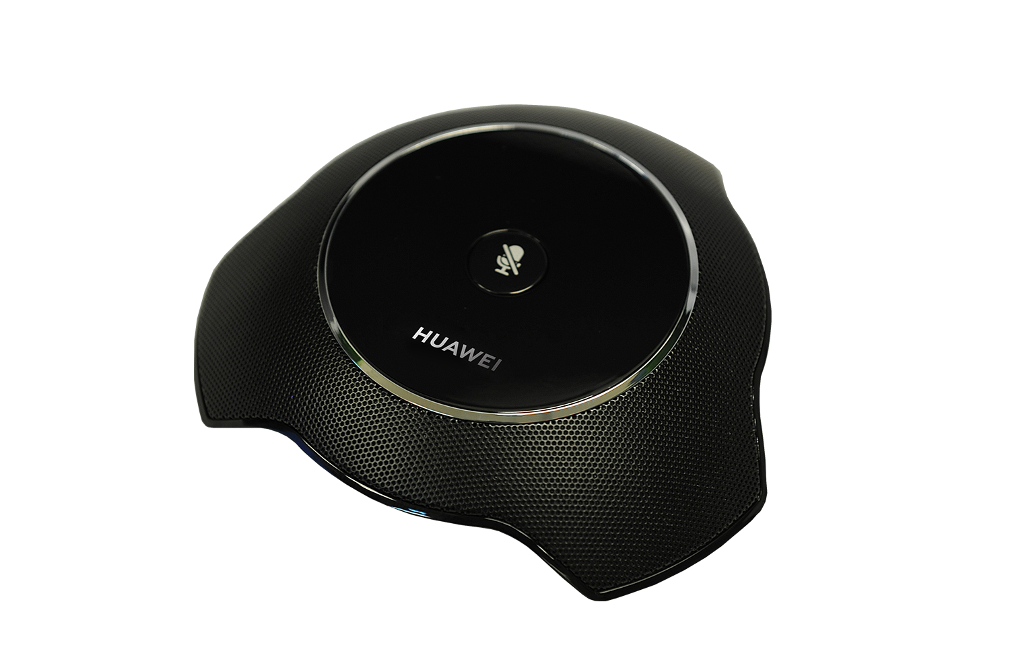

- Elegant appearance and compact design with low power consumption
The appearance of the Mic 500 is designed by a top-notch design company. The metal grid design ensures an extraordinary sound collection. The top cover employs a black glossy style, circled by a bright silver edge, and provides one button for muting or unmuting. The microphone array presents itself as a small-sized (15 cm diameter), visually appealing, and technically professional device.
- Plug and play
The Mic 500 can be directly connected to an endpoint for use, with no need for any configurations. It fits well with various conference rooms and is effortless to use.
- Superb hi-fi audio
The Mic 500 supports a sampling rate of 48 kHz, a full frequency range, and dual-channel hi-fi stereo to deliver an unimaginable audio experience. When working with the endpoint, it automatically adapts to various audio codec protocols such as Opus, AAC-LD, G.722, and G.711.
- Superior audio experience
The Mic 500 supports 360-degree sound pickup with an optimal range of 6 meters. This allows participants at the local site to hear every sound nuance coming from participants at the remote site.
- Excellent audio processing technologies
- AEC
This technology eliminates echo from video conferences, creating enjoyable interaction experience.
- ANS
This technology reduces noise for video conferencing to deliver hi-fi audio.
- AGC
This technology guarantees stable and natural audio.

Functions and Features

HD Video
- The video encoding and decoding protocols for both video and content support H.265, delivering 1080p 30 fps video and 4K 8 fps data experience.
- Face detection and backend image enhancement adapt to WDR illumination, reduce bandwidth consumption, improve image definition, and enhance motion images.

Hi-Fi Audio
- The endpoint supports AEC, ANS, AGC, VoiceClear, AudioEnhancer, and lip synchronization.
- Opus-related technologies are adopted, including Forward Error Correction (FEC), Backward Error Correction (BEC), Packet Loss Concealment (PLC), Net Automatic Transfer-Enhancement (netATE), and Audio Jitter Buffer (AJB).
- Built-in microphone array with 8-meter sound pickup, and external microphone array for an extended sound pickup range, to deliver clear, crisp audio of speakers.

Intelligent Content Sharing
Content Sharing over a Cable Connection
You can connect to a computer through the HDMI or Type-C port and then share the computer desktop. Presentation plug-and-share is supported and the other party can preempt the presentation sharing right to share content with the remote site.
Wireless Projection
Wireless projection frees you from complex cable connections and allows you to easily share your computer and mobile device screens. When multiple wireless projection sources are connected, you can switch among them. The endpoint supports a maximum of 50 projection sources.
- With the IdeaShare mobile client, you can share a mobile device screen.
- Using the IdeaShare client for PC, you can share your computer desktop.
- When the IdeaShare client is used on a Windows or macOS computer, the screen extension function is supported, for you to share the extended screen to the endpoint.
- A maximum of nine clients can be used to share content of up to nine devices to one endpoint at the same time.

Intelligent Tracking
With the Auto-Framing function, the endpoint automatically adjusts its camera based on the number and positions of participants to take the optimal panoramic view.
              - Intelligent tracking
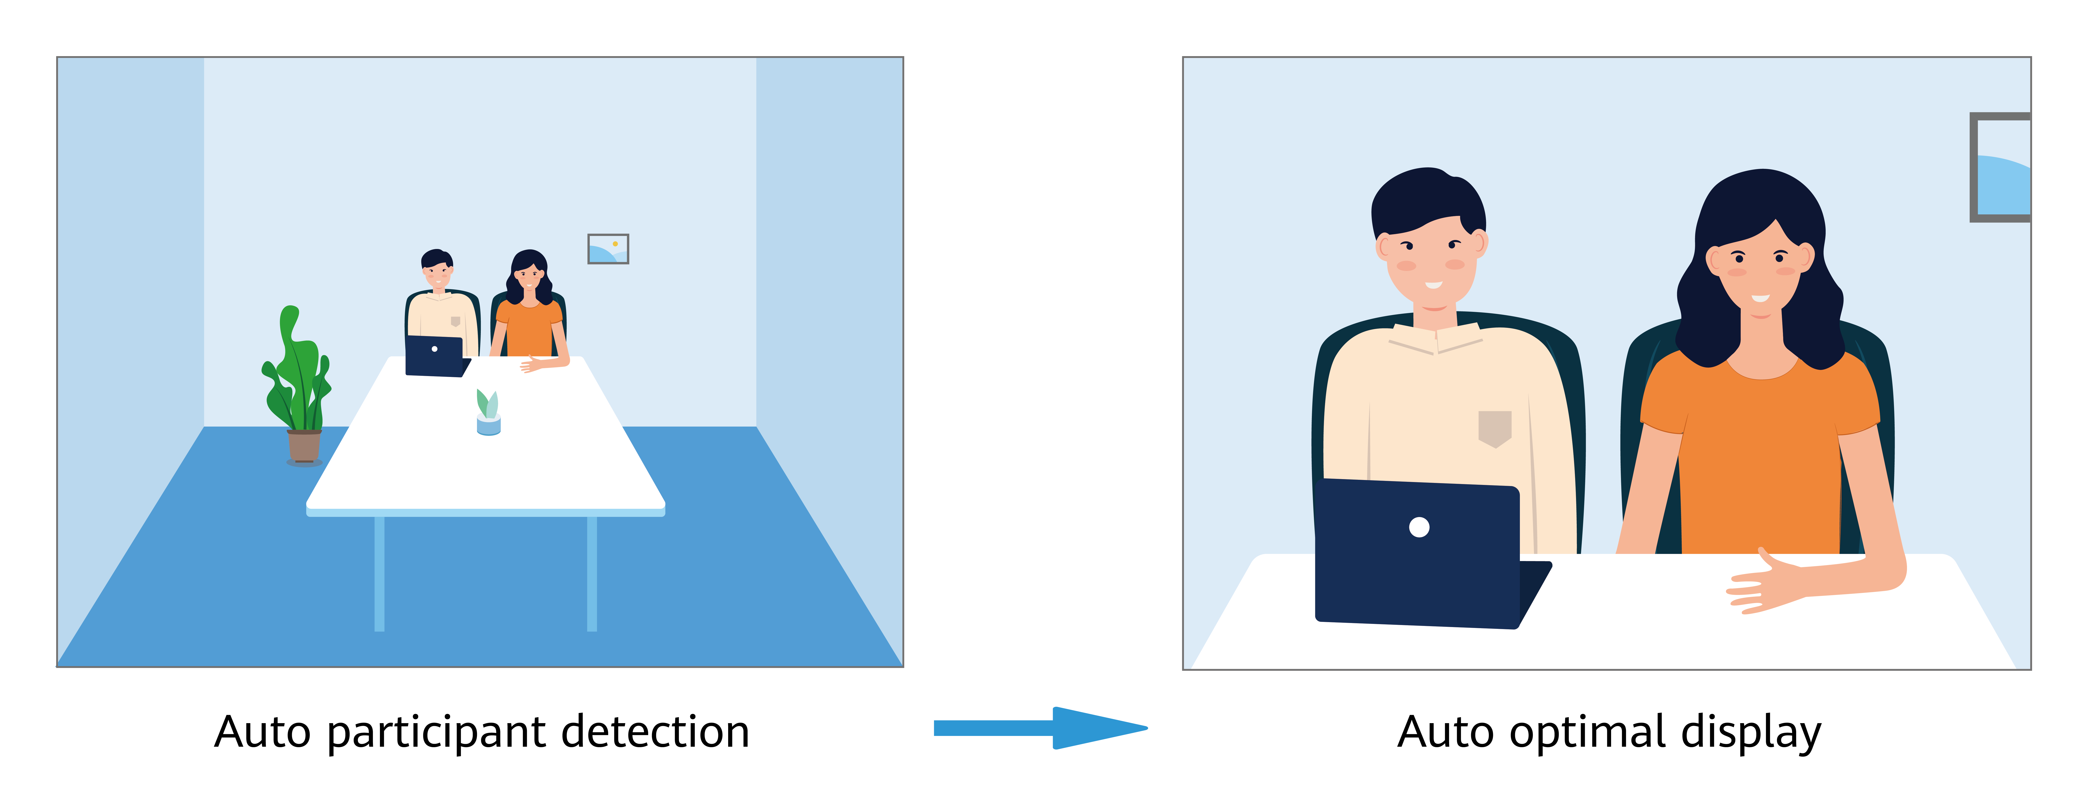

Audio Diagnostics
The endpoint supports the audio test and echo detection, to quickly locate audio problems of the endpoint and facilitate product maintainability.

Multistream Conferencing
Multistream conferencing leverages Scalable Video Coding (SVC), with which the endpoint is responsible for video codec and the continuous presence layout, and the MCU (CloudMCU or VP9800 series MCU) only forwards video streams at different resolutions or frame rates. In this way, the workload is relieved, the latency is reduced, and access of mass endpoints is made possible.
A maximum of four channels of video streams can be sent from endpoints to the MCU. The resolution ranges from 180p to 1080p. A maximum of 25 channels of video streams can be forwarded from the MCU to each endpoint. The resolution, up to 1080p allowed, depends on the actual bandwidth.
When multiple audio streams are supported, the endpoint sends one channel of audio streams to the MCU. The MCU forwards a maximum of three channels of audio streams to each endpoint. An endpoint supports a maximum of three channels of decoding, mixing, and local output.
- Audio multistreaming is supported only when the CloudVC solution of 23.0 or later is used and the audio protocol is Opus.
- A maximum of 25 video panes are supported only when the CloudVC solution of 24.1 or later is used and the video protocol is H.265.

Multiple Layouts
You can view the composite of video and content on one screen by adjusting the screen layout.
Non-Multistream Conferencing
The following layouts are available:
- Full screen
Video, content, or whiteboard is displayed in full-screen mode.
- Picture in Picture (PiP)
The PiP mode includes one full-screen video and a small window that can be located at any of the four corners. By default, the small window lies in the upper right corner. In a video conference, the small window size is about 1/16 of the full screen size.
- Picture out Picture (PoP)
Two or more panes are separately displayed on one screen.
Multistream Conferencing
The following layouts are available:
- Presenter view
- When content sharing is in progress during a conference, shared content is displayed in the large pane.
- When no content is shared, the large pane presents the speaker. A speaker can be configured to permanently stay in the large pane.
- If a user selects a site to view, the video of the selected site is displayed in the large pane.
- If a user broadcasts a site, the layout is switched to PiP mode. The video of the broadcast site is displayed in the large pane, and the video of the local site is displayed in the small pane.
- PiP view
- When content sharing is in progress during a conference, shared content is displayed in the large pane. The small pane presents the video of a site. Video display sequence: broadcast site > speaker > other sites.
- When no content is shared, the large pane presents the speaker. A speaker can be configured to permanently stay in the large pane. The video of another site is displayed in the small pane.
- If a user chooses to broadcast or view a site, the site will be presented in the large pane. The small pane presents shared content or video of another site.
- Gallery view
Video of sites and shared content are displayed in identical panes (25 at most).
              - Video layout


Joining or Initiating a Conference
Joining a Conference
You can join a conference:
- From the conference schedule
- By entering the conference ID
- By scanning the QR code using the HW CloudLink soft client (supported only on the SMC)
Initiating a Conference
The endpoint supports multipoint recording. Before creating a conference, check whether Recording conference needs to be selected.
A conference can be arranged using any of the following methods:
- Starting a conference instantly
You can start a conference instantly through the Virtual Meeting Room (VMR) with just one click or through SiteCall. This function is applicable to the scenario where you have not scheduled any conferences but need to start a conference right now. After a conference is created, you can directly invite sites to the conference by calling them. Alternatively, send the conference ID to sites. They can then dial the conference ID to join the conference.
- Initiating a multipoint conference
Select multiple contacts to initiate a conference and set parameters, such as the chairperson password and whether to encrypt the conference.
- Initiating a point-to-point (P2P) conference
Enter keywords to search for a site, enter the site number or IP address, or directly select a site to place a call to the site.
- Creating a scheduled conference
When creating a conference, you can set the conference start time and duration. After a scheduled conference is created, a conference schedule will be generated, and participants will be reminded to join the conference when the conference starts.

Conference Control
Both the chair site and common sites in a conference can control the conference, but the operations they can perform are different, as listed in Table 5-1.
The chair site has more conference control functions. Common sites can also perform some simple and useful conference control operations.
                - Operations the chair site and common sites can each perform
Role | Conference Control Function
Chair site | - Inviting a site  - Deleting a disconnected site  - Calling an unconnected site  - Disconnecting a site  - Muting or unmuting the microphone of a site  - Ending a conference  - Extending a conference  - Releasing chair control rights  - Broadcasting or stopping broadcasting a site  - Broadcasting or stopping broadcasting continuous presence (supported only in non-multistream conferences)  - Viewing a site  - Viewing continuous presence (supported only in non-multistream conferences)  - Canceling viewing (supported only in non-multistream conferences)  - Configuring Focus on Speaker  - Giving the floor to a site or revoking the floor from a site  - Setting continuous presence (supported only in non-multistream conferences on the web interface)  - Broadcasting sites consecutively (supported only in non-multistream conferences on the web interface)  - Viewing sites consecutively (supported only in non-multistream conferences on the web interface)  - Locking or unlocking a conference  - Locking presentation for a conference  - Locking presentation for a site  - Unlocking presentation  - Canceling presentation sharing for a conference (supported only on the web interface)  - Muting or unmuting the speaker (supported only on the web interface)  The endpoint supports multipoint recording. Before creating a conference, select Recording conference. The chair site has the following conference control rights:  - Starting recording  - Pausing recording
Common sites | - Leaving a conference  - Viewing a site  - Viewing continuous presence (supported only in non-multistream conferences)  - Canceling viewing (supported only in non-multistream conferences)  - Requesting chair control rights  - Muting or unmuting the local microphone  - Unmuting itself after being muted by the chair  - Raising hands to request the floor  - Revoking chair control rights (Only the SiteCall creator of an H.323 non-multistream conference on the SMC2.0 network can perform this operation on the web interface.)

              - Conference control on the web interface
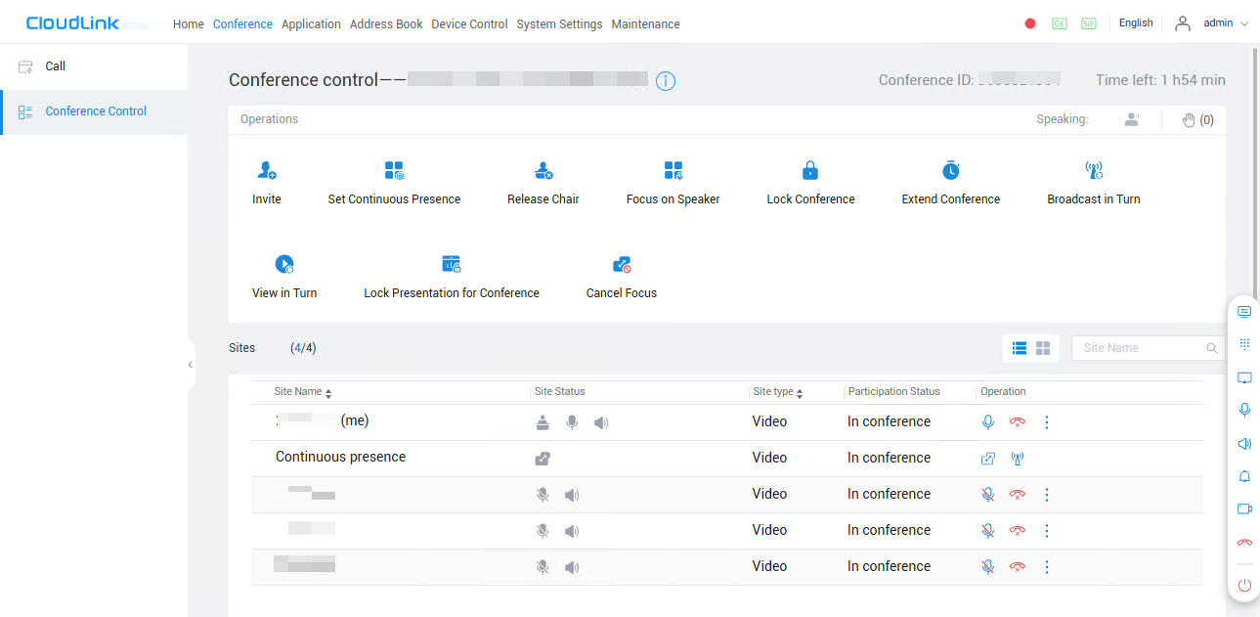

              - Conference control interface managed using the remote control
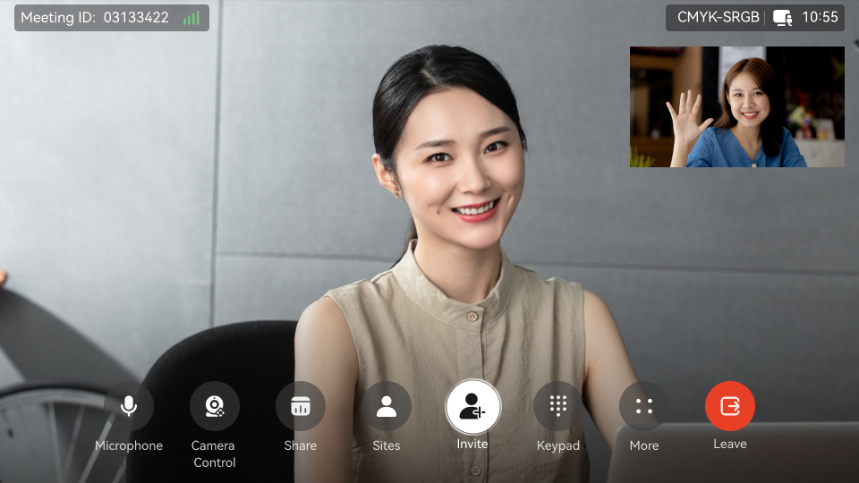

Barge-in/Forcible Release
After the barge-in/forcible release function is enabled on an endpoint, it is allowed to receive calls from other endpoints or conferences when the endpoint is in an H.323 call. When receiving a call with a higher priority, the endpoint can hold or hang up the current call based on the configuration and automatically answer the new call.
The barge-in/forcible release feature ensures that the endpoint in calling state does not miss other important calls.

BYOM
The endpoint can be connected to a computer using a Type-C cable or IdeaShare Windows client. After the connection, the camera, microphone, and speaker of the endpoint can be used by the computer.
Participants can enjoy a wide field of view and long-distance sound pickup in professional conference rooms. More participants at the local site can participate in efficient discussions, and the video and audio played for participants at the remote site are clear.

Address Book
The address book stores site information, with which you can directly start a conference. The endpoint can quickly obtain a site's information from the corporate address book or LDAP server.
The administrator can perform the following operations:
- Edit and delete contacts on the web interface, sort contacts, and add sites to the address book. The sites that are found from the corporate address book cannot be saved to the local address book.
- On the remote control UI or web interface, query sites in the local address book and corporate address book, initiate calls to these sites, or invite other sites to join a conference.
- On the web interface, export and import the local address book to quickly update records in batches.

Globalization
The endpoint's interfaces support time zone settings and application, as well as multiple languages. If some countries in the selected time zone use daylight saving time (DST), the endpoint automatically enables DST and changes its clock to comply with DST.
The interfaces of endpoints support the following languages: Simplified Chinese, Traditional Chinese, English, Spanish (Europe), French, Arabic, Japanese, Italian, Portuguese (Brazil), German, Thai, Turkish, Korean, Kazakh, Romanian, Bulgarian, Sinhala, Serbian, Hungarian, Greek, and Polish.
Portuguese (Brazil) is supported only after the Portuguese license is imported.

Operations, Administration, and Maintenance

Batch Configuration
The endpoint supports enterprise service access. After the access is successful, the management platform (IdeaManager or SMC) automatically delivers the default configuration to the endpoint to complete quick endpoint configuration. In addition, the management platform can deliver configurations in batches to complete key configurations, improving O&M efficiency.

Customizing the Wallpaper and Startup Animation
You can change the home screen wallpaper on the web interface.
The startup animation can be replaced with a custom animation to meet personalized requirements.

Resetting the Web Password
If you forget the administrator password of the endpoint, you can reset the password in the following ways:
- If the endpoint is connected to the IdeaManager (cloud service), click Forgot Password? on the web login interface of the endpoint, use your mobile device to scan the QR code, log in to the IdeaManager (cloud service) as prompted, and reset the password.
- If the endpoint is connected to the SMC or IdeaManager platform, contact the administrator to log in to the platform and deliver the password again.
- In other scenarios, you are advised to restore factory settings and reset the password.

Remote Viewing
After the remote viewing function is enabled on the remote control UI, log in to the web interface, effortlessly switch between local and remote video or presentation sources for viewing in real time, and capture photos.
This function involves personal privacy. Ensure that its use complies with local laws and regulations.

APIs for Third-Party Integration
The endpoint provides HTTP-compliant third-party APIs to implement various functions, including login authentication, site calling, site query, conference control, address book management, system configuration, and status query, as shown in Figure 5-5.
Users can choose necessary APIs based on their actual needs to develop required functions and integrate them into other products or applications.
              - Functions implemented through HTTP APIs
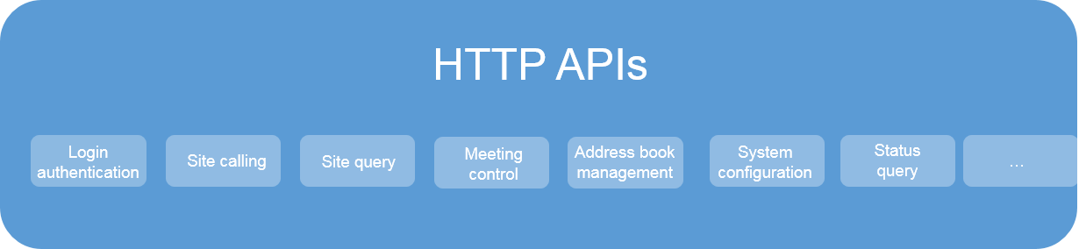

Security and Reliability
Operating System Security
Security maintenance for the system layer ensures that the operating system runs smoothly and also supports stable services at the application layer.
- The endpoint uses the customized operating system. Permission isolation and minimum permissions are used to restrict the file permission, account, and password of the operating system, preventing unauthorized access and ensuring system access security.
- The endpoint supports secure startup. During the startup process, the integrity of the U-Boot, kernel, and application software is verified level by level to ensure that all software running on the endpoint is valid, thereby ensuring reliable and secure running of the endpoint.
System Management and Maintenance Security
- Software packages (including patches) are released only after they are scanned by at least three types of mainstream antivirus software and no issues are detected. In special cases, explanation is provided for alarms.
- Comprehensive logging is provided to record all user operations and system exceptions.
- A two-level certificate chain is supported to ensure the transmission security of confidential data.
Network Security
- The firewall protects your IP network by separating the internal and external network communication data. Using the Network Address Translation (NAT) technology and signaling exchange between public network protocols and private network protocols, the firewall enables sites on local area networks (LANs) in different places to use video conferences. With NAT, a device on a LAN is allocated with a dedicated internal IP address that uniquely identifies the device on the LAN, and the device uses an external IP address to communicate with external devices. NAT mapping enables the entire private network to connect to the Internet through only a few IP addresses. Through the firewall-port–based control, the private network is more secure.
- The media latching and standard H.460 traversal technology are used to set up secure video call connections between public and private networks and between private networks through the firewall.
Network Adaptability
- Leading technologies, including Super Error Concealment (SEC), Hybrid Automatic Repeat Request (HARQ) retransmission, and automatic deceleration, are utilized to deliver clear and smooth video even when the network condition is poor.
- The endpoint supports Opus, Net Automatic Transfer-enhancement (netATE), and Audio Jitter Buffer (AJB) to improve audio quality against the changing network status.
- The endpoint supports bandwidth sharing. Video, content, and data in a conference share the same bandwidth, which improves network utilization and delivers smooth HD video images.
- The proprietary Intelligent Rate Control (IRC) technology is used to automatically detect network service bandwidth occupation and intelligently select the optimal resolution based on the bandwidth to ensure high conferencing quality.
- Various encryption measures are taken, such as SRTP, TLS, and HTTPS, ensuring secure and stable running of the video conferencing system.
- Chinese cryptographic algorithms are supported.
Web Request Authentication
- When a user requests access to a specified web page or submits a Servlet request, the endpoint checks whether the user's session identifier is valid and whether the user is authorized to perform the operation.
- The server implements the final authentication on the user.
- Before transmitting user-generated data to clients, the server verifies the data and encodes it using HyperText Markup Language (HTML) to prevent malicious code injection and cross-site scripting attacks.
- Web security software is used to scan the web server and applications to ensure that there are no high-risk vulnerabilities.
Protocol Anti-Attack Measures
- The communication matrix is provided in the product documentation. Do not enable the services and ports that are not described in the communication matrix.
The communication matrix contains the following information: open ports, transport layer protocols used by the ports, NEs that use the ports to communicate with peer NEs, application layer protocols used by the ports and description of the services at the application layer, whether services at the application layer can be disabled, authentication modes adopted by the ports, and port functions (such as data traffic control).
- To ensure the security and stability of the video conferencing system, the endpoint utilizes multiple encryption measures, including H.235 (for encryption of media and signaling streams), SRTP, TLS, and HTTPS.
- The endpoint supports the SNMPv3 protocol, which features higher adaptability and security. The username and password are needed to connect the network management system to the endpoint.
- Robustness testing tools are used to scan protocols to ensure that there are no high-risk vulnerabilities.
Protection of Sensitive Data
- The log, diagnostics, debug, and alarm information does not contain sensitive data.
- Sensitive data is transmitted only through secure channels or after being encrypted.
- To prevent sensitive data from being leaked, the endpoint checks the complexity of passwords. When a password is being entered, each stroke is displayed as "." or "*", and the entered password cannot be copied.
- Sensitive data such as passwords and ciphering contexts must not be recorded in logs. If sensitive data really needs to be recorded, it should be displayed as "***".
- Only standard encryption algorithms and key negotiation mechanisms are used. Proprietary algorithms are not allowed.
Privacy Protection During Audio Diagnostics
During the use of audio diagnostics by an endpoint, user test voice is collected and then played back. The collected test voice is then cached in the endpoint memory and will be deleted once the diagnostics page is exited. The test voice will not be stored on the device or any other place after the test is complete.
Security Design
- The non-metal parts of the exterior use the V0 flame retardant (FR) materials.
- The component security design meets the admission requirements of the EU and China.
- Labels and security tips are used.

Operations and Maintenance

GUIs

Remote Control UI
You can use the remote control to control the system, facilitating operations on the display.
Using the remote control, you can control conferences, modify system settings, control microphones and speakers, and control local cameras.
              - Home screen of the remote control UI
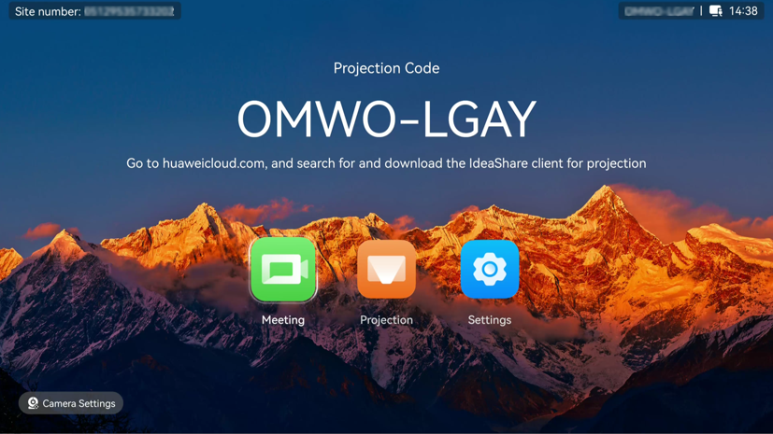

IdeaShare UI
IdeaShare is a wireless projection client designed for the endpoint. It can be installed on a PC or mobile device.
              - IdeaShare mobile client
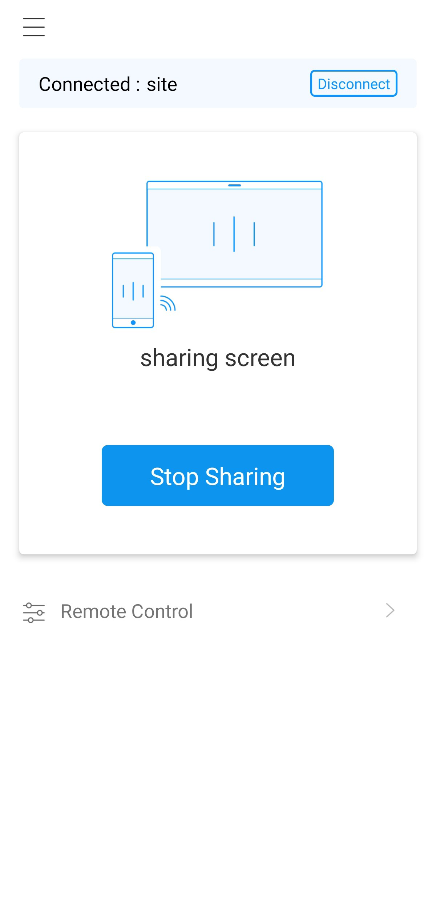

              - IdeaShare PC client
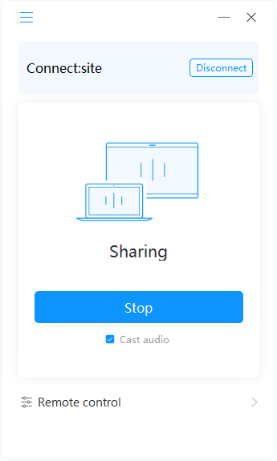

Web Interface
The endpoint can be remotely operated by the administrator from its web interface. The web interface allows simultaneous operations from up to 10 users through the same account. However, only the last operation takes effect.
The main functions available on the web interface are as follows:
- Conferencing
- Applications
- Address book
- Device control
- System settings
- Maintenance

Maintenance and Upgrade

Log Management
The endpoint records logs about user operations and system exceptions, helping the administrator maintain the system and locate faults.
Logs are saved as files. Users can view the recorded logs and export all the recorded logs on the web interface.

Diagnostics
The endpoint can detect the hardware running status, network connections, audio input/output, video input/output, common parameter settings, and server registration status to help users locate faults.

Inspection
Tasks supported by the SMC2.0, SMC, and IdeaManager to inspect the endpoint include:
- Check the status of IP lines.
- Check the system software version.
- Check the system performance, including the temperature and fan status.
- Check the H.323 and SIP registration status.
- Check the camera control status.
- Check the content source connection status and input port settings.
- Check the video input cable connection status and video input port settings.
- Collect certificate information. (Only the SMC and IdeaManager support this task.)
- Continue inspection after the endpoint restarts or ends a call.
- Check whether the SIP transmission type, SSL encryption for the address book, and call encryption are secure (only for the SMC and IdeaManager).
- Check whether the HTTP switch configuration is secure (only for the SMC and IdeaManager).
- Report the inspection status and result to the SMC2.0, SMC, and IdeaManager.

CHR Data Collection
When the endpoint is connected to the SMC, call information can be collected to generate call history records (CHRs) for sessions and media streams, which can be periodically reported to the SMC. O&M personnel can obtain the CHR data files from the SMC and import them into the IdeaManager for data parsing, enabling rapid fault locating.

Upgrade
You can upgrade the endpoint to the latest version to fix its vulnerabilities and use the new functions provided in the latest version.
- An endpoint can be upgraded manually on the web interface.
- You can upgrade the endpoint by importing the upgrade file from a USB flash drive.
- As a manageable device, the endpoint can be upgraded using the SMC and SMC2.0. If multiple endpoints exist, they can be upgraded in batches.
- After being connected to the IdeaManager (on-premises), the endpoint can be upgraded through the IdeaManager endpoint management platform.

Technical Specifications

Physical Specifications
                - Physical specifications
Item | Specifications
System
Operating system | HarmonyOS
Electricity supply requirements
Working voltage | 100–240 V AC (12 V, 5 A DC output from the adapter)
Working frequency | 50–60 Hz
Maximum power consumption | 46 W
Environmental requirements (in use)
Ambient temperature | 0℃ to 40℃
Relative humidity | 10%–95%
EMC | Class A
Working altitude | < 5000 m (16404 ft)
Ambient noise | < 46 dBA SPL
Environmental requirements (idle)
Ambient temperature | –40°C to +70°C (–40°F to +158°F)
Relative humidity (non-condensing) | 5% to 95%
Dimensions and weight
Device dimensions (H x W x D) | 157.5 mm x 145 mm x 308 mm
Package dimensions (H x W x D) | 275 mm x 260 mm x 575 mm
Net weight | 2.2 kg
Gross weight | 4.735 kg
Camera
Image sensor | 8-megapixel, 1/2.8-inch CMOS
Resolution | Up to 1920 x 1080 (1080p 30 fps)
Zoom | 3x digital zoom
Focal length | 3.34 mm
Maximum aperture | F1.8
Maximum horizontal field of view | 80°
Maximum vertical field of view | 50°
Camera presets | Local camera: 32 at most; remote camera: 6 at most
PTZ | e-PTZ adjustment
Image mode
Image mode | Image modes: standard, vivid, natural, and custom
Automatic adjustment
Automatic adjustment | Auto white balance (AWB); auto exposure (AE)
Exposure mode | Auto, manual, and shutter priority
White balance mode | Auto, manual, and one-push
PTZ (manual)
Pan/Tilt angle | Pan: +/–100°  Tilt: –90° to +30°
Built-in microphone
Sound pickup | Range: 180°; distance: 8 m
Installation
Installation mode | Wall-mounted installation, horizontal placement, installation on top of a TV set, and tripod-mounted installation
Peripherals
Microphone | A microphone array such as two Mic 500s can be connected.
Remote control
Infrared signal reception | Straight line: ≤ 20 m; leftward/rightward angle: 6 m and ≤ 45°; upward/downward angle: 6 m and ≤ 45°
Battery specifications | 2 x Alkaline AAA batteries

Performance Specifications
                - Performance specifications
Item | Specifications
Call bandwidth | 64 kbit/s to 8 Mbit/s
Video capabilities (H.264) | Minimum bandwidth required to deliver video of a specific resolution (without any packet loss):  - 512 kbit/s for 1080p 30 fps  - 768 kbit/s for 720p 60 fps  - 384 kbit/s for 720p 30 fps  - 128 kbit/s for 4SIF/4CIF 30 fps  - 64 kbit/s for SIF/CIF/QSIF/QCIF/SQSIF/SQCIF 30 fps
Video capabilities (H.265) | Minimum bandwidth required to deliver video of a specific resolution (without any packet loss):  - 384 kbit/s for 1080p 30 fps  - 512 kbit/s for 720p 60 fps  - 256 kbit/s for 720p 30 fps
Content sharing capabilities | - Content sharing over a wireless connection  In a conference:  - IdeaShare mobile client (Android/HarmonyOS): up to 1080p 30 fps  - IdeaShare mobile client (iOS): up to 1080p 30 fps  - IdeaShare PC client (Windows): up to 4K 30 fps^{[1]}/1080p 60 fps  - IdeaShare PC client (macOS): up to 1080p 30 fps  Local view:  - IdeaShare mobile client (Android/HarmonyOS): up to 1080p 30 fps  - IdeaShare mobile client (iOS): up to 1080p 30 fps  - IdeaShare PC client (Windows): up to 4K 30 fps^{[2]}/1080p 60 fps  - IdeaShare PC client (macOS): up to 2K 30 fps  - Content sharing over a cable connection  Input resolutions (HDMI): 640 x 480 60/72/75/85 fps, 800 x 600 56/60/72/75/85 fps, 1024 x 768 60/70/75/85 fps, 1152 x 864 60/75/85 fps, 1280 x 600 60 fps, 1280 x 720 60/75/85 fps, 1280 x 768 60/75/85 fps, 1280 x 800 60/75/85 fps, 1280 x 960 60/75/85 fps, 1280 x 1024 60/75/85 fps, 1360 x 768 60 fps, 1366 x 768 60 fps, 1440 x 900 60 fps, 1400 x 1050 60 fps, 1600 x 900 60 fps, 1600 x 1200 60 fps, 1680 x 1050 60 fps, 1920 x 1080 24/25/30/50/60 fps, 1920 x 1200 60 fps, 3840 x 2160 25/30 fps  Codec resolution: CIF (352 x 288), 640 x 480, 4CIF (704 x 576), 800 x 600, 1024 x 768, 720p (1280 x 720), 1280 x 1024, 448p (768 x 448), 1080p (1920 x 1080), 1600 x 1200, 1920 x 1200, 1152 x 864, 1280 x 600, 1280 x 768, 1280 x 800, 1280 x 960, 1360 x 768, 1366 x 768, 1440 x 900, 1400 x 1050, 1600 x 900, 1680 x 1050, 2048 x 1152, 2048 x 1236, 2048 x 1536, 2048 x 1556, 2560 x 1440, 2560 x 1600, 2560 x 2048, 2880 x 1620, 2880 x 1800, 3200 x 1800, 4K (3840 x 2160)  Output resolution: 1920 x 1080, 3840 x 2160
Dual-stream (video + content) capabilities | Video conferencing:  1080p 30 fps + 1080p 30 fps (4K 8 fps)  Data conferencing:  1080p 30 fps (4K 8 fps)
Operating system and hardware requirements for IdeaShare mobile client installation | - Android 8.0 or later, 2 GB or higher memory  - iOS 13 or later  - HarmonyOS 2.0 to 5.0 (excluding 5.0)
Operating system requirements for IdeaShare PC client installation | - Windows 7, 8, 8.1, 10, and 11 (32- and 64-bit)  - macOS 10.13.6 or later
Operating system requirements for the screen extension function supported by the IdeaShare client | - Windows 10 1607 or later  - macOS 10.14 or later

[1] and [2]: Hardware requirements: Intel Core i7-6600 or later (the first two digits of the version number are greater than or equal to 6) and driver version 26.20.100.6861 (April 2019) or later.

Ports and Protocols
                - Ports and protocols
Port | Description and Quantity | Standards and Protocols Compliance | Remarks
Video input ports | - 1 x inner camera  - 1 x HDMI (4K 30 fps, audio input supported)  - 1 x Type-C (4K 30 fps, audio input supported) |  | -
Video output ports | 2 x HDMI (4K 60 fps, audio output supported) |  | -
Audio input ports | - 1 x built-in microphone array  - 1 x 3.5 mm  - 1 x HD-AI (two microphones cascaded)  - 1 x HDMI (audio input supported)  - 1 x Type-C (audio input supported) | - | They can be connected to a microphone array such as two Mic 500s.
Audio output ports | - 1 x 3.5 mm  - 2 x HDMI (audio output supported) | - | -
USB ports | - 1 x USB 3.0 Type-A port  - 1 x USB 2.0 Type-C port | - Type-A: USB 3.0  - Type-C: USB 2.0 | -
Network port | 1×10/100/1000M LAN | - | -
Power input port | 1 x power input port | - | -

Standards Compliance
                - Standards compliance
Item | Standards
Video encoding and decoding protocols | H.265 (including H.265 SVC), H.264 (including H.264 HP, H.264 BP, and H.264 SVC), H.263 (supported only by presentation), and H.263+ (supported only by presentation)
Audio encoding and decoding protocols | AAC-LD (mono/stereo), G.711A, G.711U, G.722, G.722.1C, G.729A, G.719, and Opus
Multimedia framework protocols | ITU-T H.323 and IETF SIP
Data conferencing | Data conference 2.0
Presentation transmission protocols | ITU-T H.239, Binary Floor Control Protocol (BFCP), and data
Network transmission protocols | TCP/IP, RTP, RTCP, DHCP, DNS, SMTP, SNMP, SNTP, SSH, HTTP, HTTPS, TR-069, IEEE 802.1p/q, and IEEE 802.1X
Other communications protocols | H.225, H.235, H.241, H.245, H.350, H.460, RFC2833, and LDAP
IP protocols | IPv4/IPv6 dual stack
Encryption protocols | H.235, STARTTLS, TLS, SRTP, dual-stream encryption, and Chinese cryptographic algorithms

HEVC Authorization


Glossary
                - Glossary
Numerics
4CIF | 4 x Common Intermediate Format  A video resolution of 704 x 576 pixels.
4SIF | 4 x Source Input Format  A video format with a resolution of 704 x 480 pixels that uses progressive scanning.
A
AAC | Advanced Audio Coding
AEC | Acoustic Echo Cancellation
AGC | Automatic Gain Control
AJB | Audio Jitter Buffer
ANS | Automatic Noise Suppression
API | Application Programming Interface  A particular set of rules and specifications that are used for communication between software programs.
Auto-Framing | Based on the number, location, and motion of participants, this function automatically adjusts the camera to provide a dynamic overview of the full room.
C
CHR | Call History Record
CIF | Common Intermediate Format
Contacts | Users can save the information about the IP address, number, type, and bandwidth of a remote site to a contact.
D
DNS | Domain Name System  A mechanism that maps easy-to-remember domain names to IP addresses recognizable for network devices.
dual-stream | During a conference, two channels of video streams can be sent or received simultaneously. One channel is used for transmitting video (such as the video captured by a camera) and the other channel is used for transmitting content (such as a computer desktop).
E
endpoint | An endpoint is a terminal that converts languages, sound, text, image, table, data and video from physical display to electronic signals or from electronic signals to physical display. A terminal generates and sends signals (such as telecommunications circuit setup or release) that maintain the normal running state of the telecommunications network, and it receives the call signals of telecommunications switch and transmission.
G
G.722 | Audio codec standard that uses adaptive differential pulse-code modulation (ADPCM). Its data rate is 48 kbit/s, 56 kbit/s, or 64 kbit/s.
H
H.239 | A standard recommended by ITU-T. It enables a video conference to simultaneously transmit both video and data content (for example, computer desktop).
H.263 | A video codec standard for video conferences at low rates. Five formats are available: SQCIF, QCIF, CIF, 4CIF, and 16CIF.
H.264 | Compared with H.263, H.264 can provide the same-quality video at half of the bit rate, with strong error resilience.
HD | High Definition
HDMI | High Definition Multimedia Interface
HTTP | Hypertext Transfer Protocol
HTTPS | Hypertext Transfer Protocol over Secure Sockets Layer  An HTTP protocol that runs over transport layer security (TLS) and Secure Sockets Layer (SSL) for secured transactions. It is used to establish a reliable channel for encrypted communication and secure identification of a network web server.
I
initiate call | A process where the calling party dials the called party's alias or IP address to set up a call and exchange audiovisual information with the called party.
L
LAN | Local Area Network
LCD | Liquid Crystal Display
LDAP | Lightweight Directory Access Protocol  A network protocol based on TCP/IP, which allows access to a directory system agent (DSA). It involves some reduced functionality from X.500 Directory Access Protocol (DAP) specifications.
M
media stream | Data stream (such as audio, video and fax) between different bearer networks.
N
netATE | Net Automatic Transfer-enhancement
R
RTCP | Real-Time Transport Control Protocol  A protocol used to monitor data delivery. RTCP enables the receiver to detect if there is any packet loss and to compensate for any delay jitter.
S
SEC | Super Error Concealment
SIF | Source Input Format
SIP | Session Initiation Protocol
SMC | Service Management Center  A videoconferencing service management system that manages videoconferencing devices (including GKs, MCUs, and participant endpoints) and allocates videoconferencing resources.
SRTP | Secure Real-time Transport Protocol  A real time transport protocol with enhanced security and encryption mechanism-based RTP.
SSH | Secure Shell  A network security protocol formulated by the IETF's Network Working Group on the basis of the application layer to implement secure remote login and other secure network services. The use of SSH can effectively prevent information leakage during remote management. It is initially a program in the Unix operating system and adopted by other operating platforms soon. SSH can fix vulnerabilities on the network when it is used correctly. The SSH client is applicable to multiple platforms. SSH can run on almost all UNIX platforms, including HP-UX, Linux, AIX, Solaris, Digital UNIX, Irix, and other platforms.
SVC | Scalable Video Coding
sound pickup distance | The maximum distance within which sounds can be picked up by a microphone.
T
TCP/IP | Transmission Control Protocol/Internet Protocol
TLS | Transport Layer Security
V
VMR | Virtual Meeting Room

