HUAWEI IdeaHub K3 (Alternative Configuration)
25.0
 | Product Overview
 | Issue | 02
 | Date | 2026-02-11

 | HUAWEI TECHNOLOGIES CO., LTD. |  | 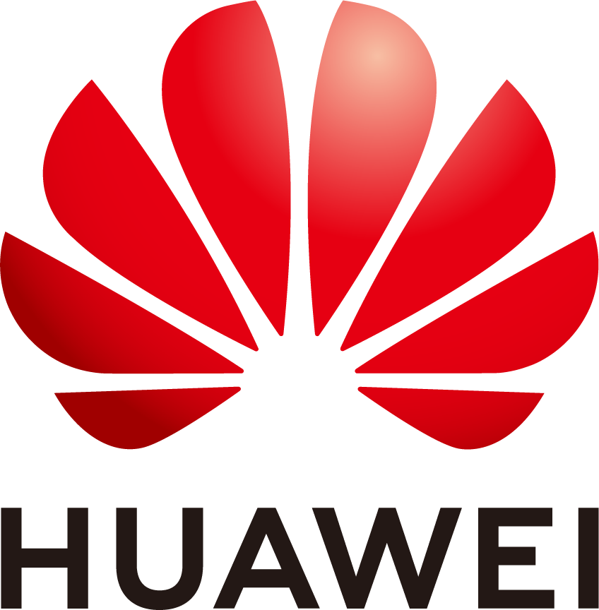

Copyright © Huawei Technologies Co., Ltd. 2026. All rights reserved.
No part of this document may be reproduced or transmitted in any form or by any means without prior written consent of Huawei Technologies Co., Ltd.

Trademarks and Permissions
and other Huawei trademarks are trademarks of Huawei Technologies Co., Ltd.
All other trademarks and trade names mentioned in this document are the property of their respective holders.

Notice
The purchased products, services and features are stipulated by the contract made between Huawei and the customer. All or part of the products, services and features described in this document may not be within the purchase scope or the usage scope. Unless otherwise specified in the contract, all statements, information, and recommendations in this document are provided "AS IS" without warranties, guarantees or representations of any kind, either express or implied.
The information in this document is subject to change without notice. Every effort has been made in the preparation of this document to ensure accuracy of the contents, but all statements, information, and recommendations in this document do not constitute a warranty of any kind, express or implied.

Huawei Technologies Co., Ltd.
Address: | Huawei Industrial Base  Bantian, Longgang  Shenzhen 518129  People's Republic of China
Website: | https://e.huawei.com

Security Declaration
Product Lifecycle
Huawei's regulations on product lifecycle are subject to the Product End of Life Policy. For details about this policy, visit the following web page:
https://support.huawei.com/ecolumnsweb/en/warranty-policy

Vulnerability
Huawei's regulations on product vulnerability management are subject to the Vul. Response Process. For details about this process, visit the following web page:
https://www.huawei.com/en/psirt/vul-response-process
For vulnerability information, enterprise customers can visit the following web page:
https://securitybulletin.huawei.com/enterprise/en/security-advisory

Initial Digital Certificate
The Initial digital certificates on Huawei devices are subject to the Rights and Responsibilities of Initial Digital Certificates on Huawei Devices. For details about this document, visit the following web page:
https://support.huawei.com/enterprise/en/bulletins-service/ENEWS2000015789

Huawei Enterprise End User License Agreement
This agreement is the end user license agreement between you (an individual, company, or any other entity) and Huawei for the use of the Huawei Software. Your use of the Huawei Software will be deemed as your acceptance of the terms mentioned in this agreement. For details about this agreement, visit the following web page:
https://e.huawei.com/en/about/eula

Lifecycle of Product Documentation
Huawei after-sales user documentation is subject to the Product Documentation Lifecycle Policy. For details about this policy, visit the following web page:
https://support.huawei.com/enterprise/en/bulletins-website/ENEWS2000017761

Contents
1 Product Highlights 1
2 Platform Access 2
2.1 Networking 2
2.2 Capabilities 2
3 Product Structure 3
3.1 Large Screen 3
3.1.1 Appearance 3
3.1.2 Ports and Functional Modules 6
3.1.3 Indicators 7
3.2 OPS 8
3.2.1 Standard OPS 8
3.2.1.1 Appearance 8
3.2.1.2 Ports and Functional Modules 9
3.2.1.3 Indicators 10
3.2.2 Alternative OPS 11
3.2.3 OPS Installation 14
3.3 Controller 15
4 Functions and Features 18
4.1 Ultra-HD Display Resolution 18
4.2 Hi-Fi Audio 18
4.3 Smart Projection 19
4.4 Whiteboard Collaboration 20
4.5 Mirror & Control 22
4.6 Dual-Screen Display 22
4.7 Multi-Window 22
4.8 Wireless Connections 22
4.9 HiBoard Welcome Page 23
4.10 Apps 23
4.11 Globalization 24
4.12 Operations, Administration, and Maintenance 24
4.12.1 Batch Configuration 24
4.12.2 Changing a Wallpaper 24
4.13 Serial Port Control 25
4.14 Keeping Applications Alive in the Background 25
4.15 Developer Options 25
5 Security and Reliability 26
5.1 Operating System Security 26
5.2 Email Security 26
5.3 Protocol Anti-Attack Measures 26
5.4 Protection of Sensitive Data 26
5.5 System Management and Maintenance Security 27
5.6 Security Design 27
5.7 Secure Startup 27
6 Operations and Maintenance 28
6.1 GUIs 28
6.1.1 Touchscreen UI 28
6.1.2 IdeaShare UI 29
6.2 Maintenance and Upgrade 30
6.2.1 Log Management 30
6.2.2 Device Diagnostics 30
6.2.3 Inspection 30
6.2.4 Upgrade 31
7 Technical Specifications 32
7.1 Physical Specifications 32
7.2 Performance Specifications 36
7.3 Protocol and Standards Compliance 38
8 Glossary 39

Product Highlights
Huawei IdeaHub K3 (IdeaHub or endpoint for short) features healthy and secure teaching and easy-to-use functions to meet the requirements of smart interactive classrooms, digital classrooms, and remote interactive classrooms.
- Healthy and secure teaching: 4K soft light screen and optical anti-blue light for comfortable eye protection; upgraded anti-collision baffle to protect teaching assets; native system for secure and efficient daily teaching.
- Easy-to-use functions: Wi-Fi 6 peer-to-peer (P2P) connection for one-step projection; Multi-Window for efficient multitasking; Mirror & Control, redefining classroom interactions.
Table 1-1 lists endpoint models.
                - Models
Product | IdeaHub K3
Large Screen | - IHK3-65XA  - IHK3-86XA  - IHK3-98XA
OPS (Standard) | OPS A01 D (06190047)
OPS (Alternative) | - OPS W021 Z (06190037)  - OPS W022 Z (06190034)  - OPS W021 D (06190041)  - OPS W022 D (06190040)  - OPS W021 Z (06190054)  - OPS W022 Z (06190053)

Platform Access

Networking
An IdeaHub can connect to the IdeaManager platform through the OPS and manage the large screen and OPS on the IdeaManager platform.
The IdeaManager is an integrated endpoint management solution for enterprises and provides E2E endpoint management and O&M capabilities to meet requirements in scenarios where a large number of endpoints are connected. The IdeaManager helps customers improve O&M efficiency and reduce O&M costs. By deployment mode, the IdeaManager can be classified into IdeaManager (cloud service) and IdeaManager (on-premises).

Capabilities
                - Capabilities
Platform | Access Mode | Whiteboard Scenario | Projection Scenario
IdeaManager | - IdeaManager (cloud service): Manually enter an access code or scan a QR code to access the platform.  - IdeaManager (on-premises): Manually enter an access code to access the platform. | Use a browser to scan a QR code to transfer the whiteboard content. | Use the IdeaShare client for projection.

Product Structure

Large Screen

Appearance
Front View
              - Front view
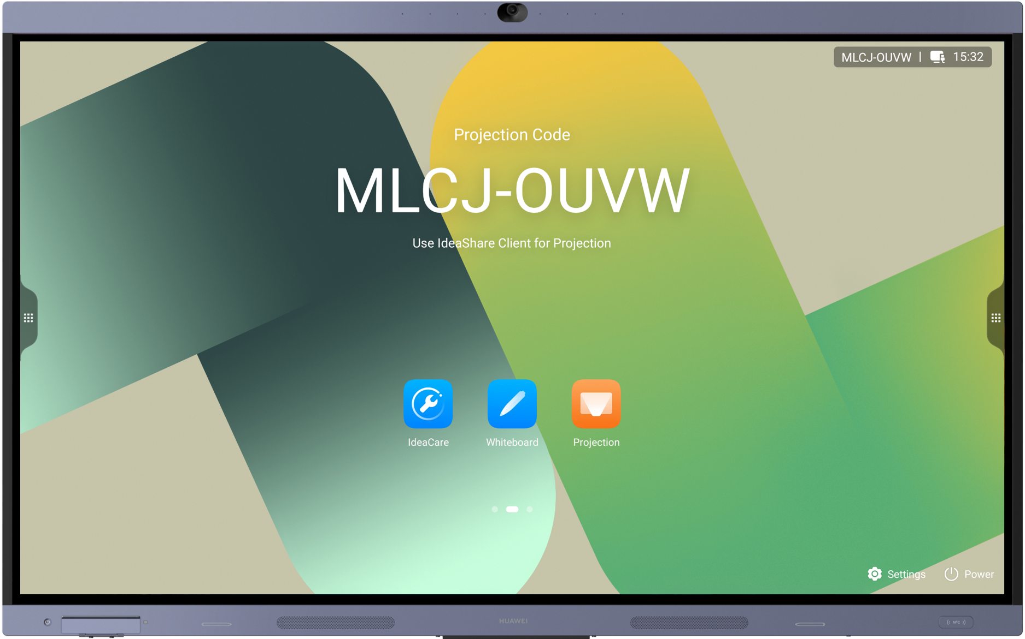

              - Modules in the front view
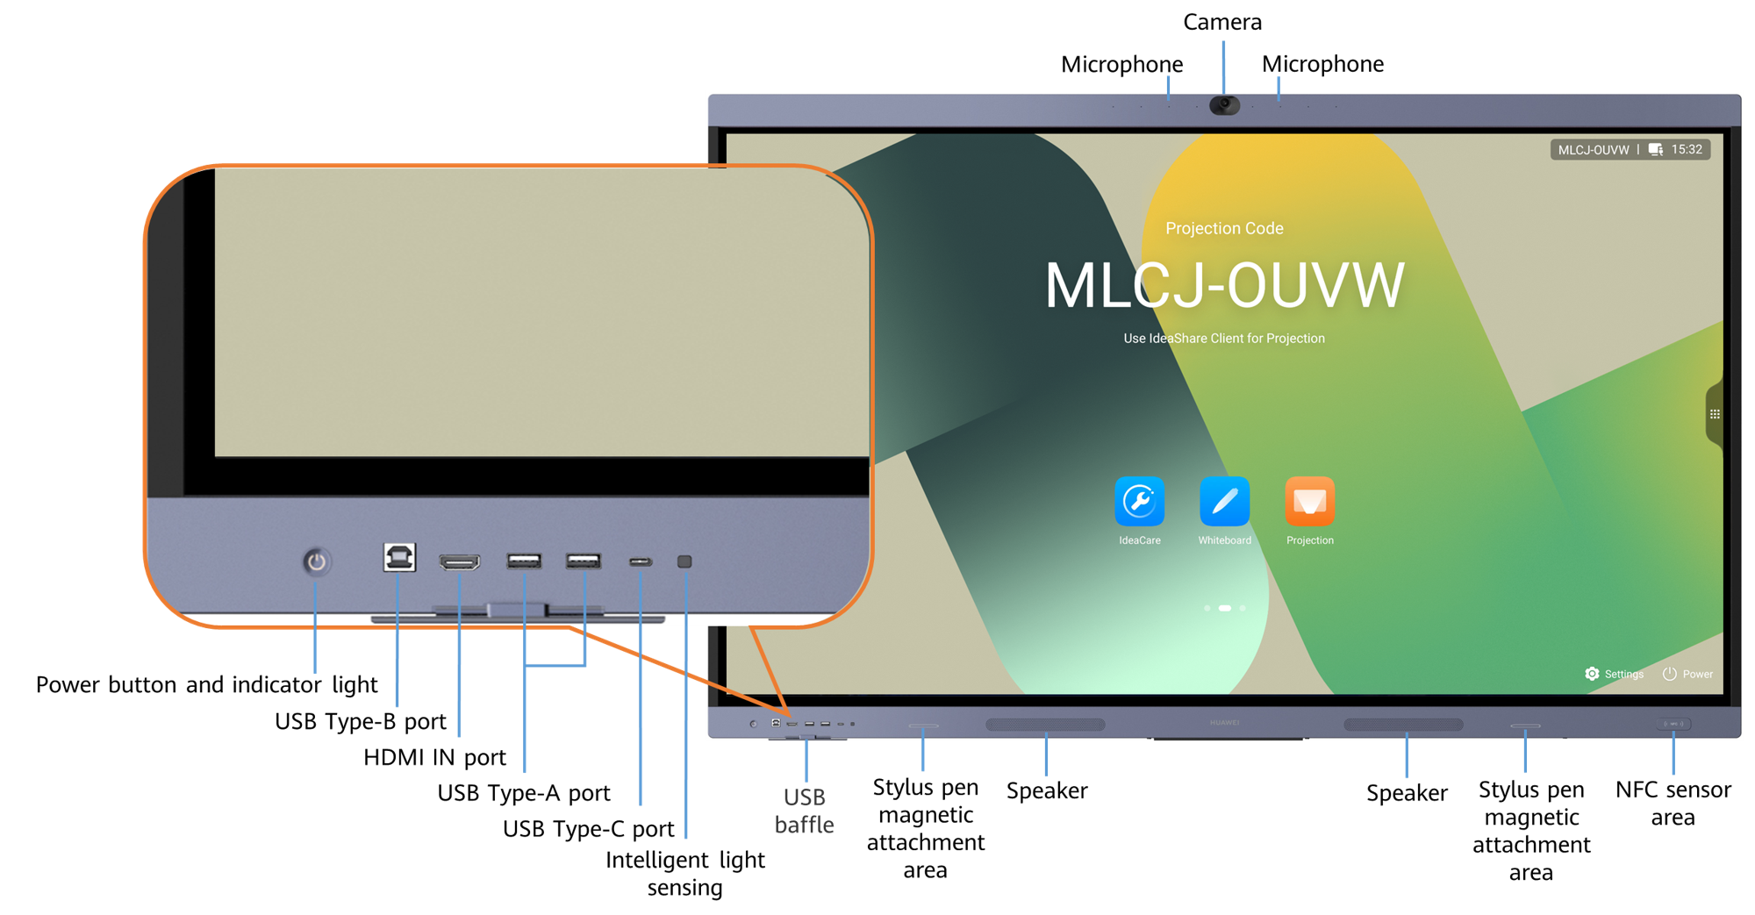

Rear View
              - Rear view of the 65-inch large screen
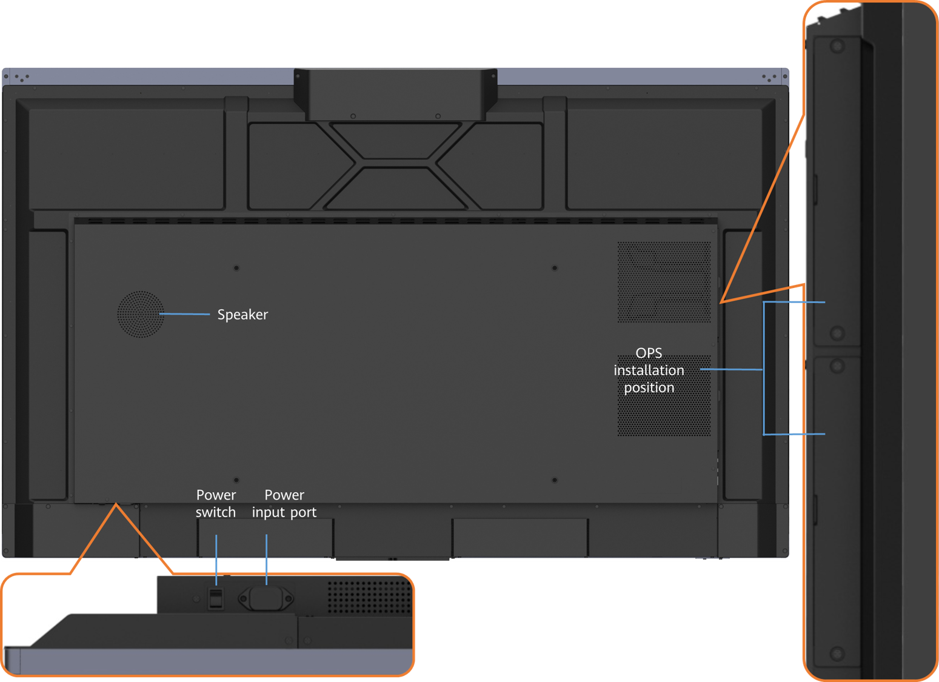

              - Rear view of the 86-inch large screen
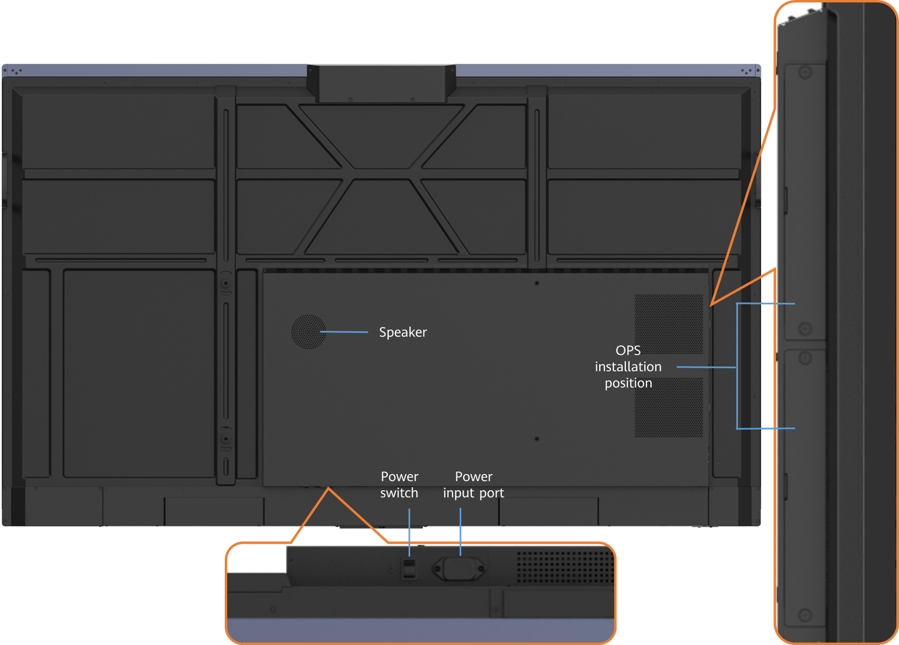

              - Rear view of the 98-inch large screen
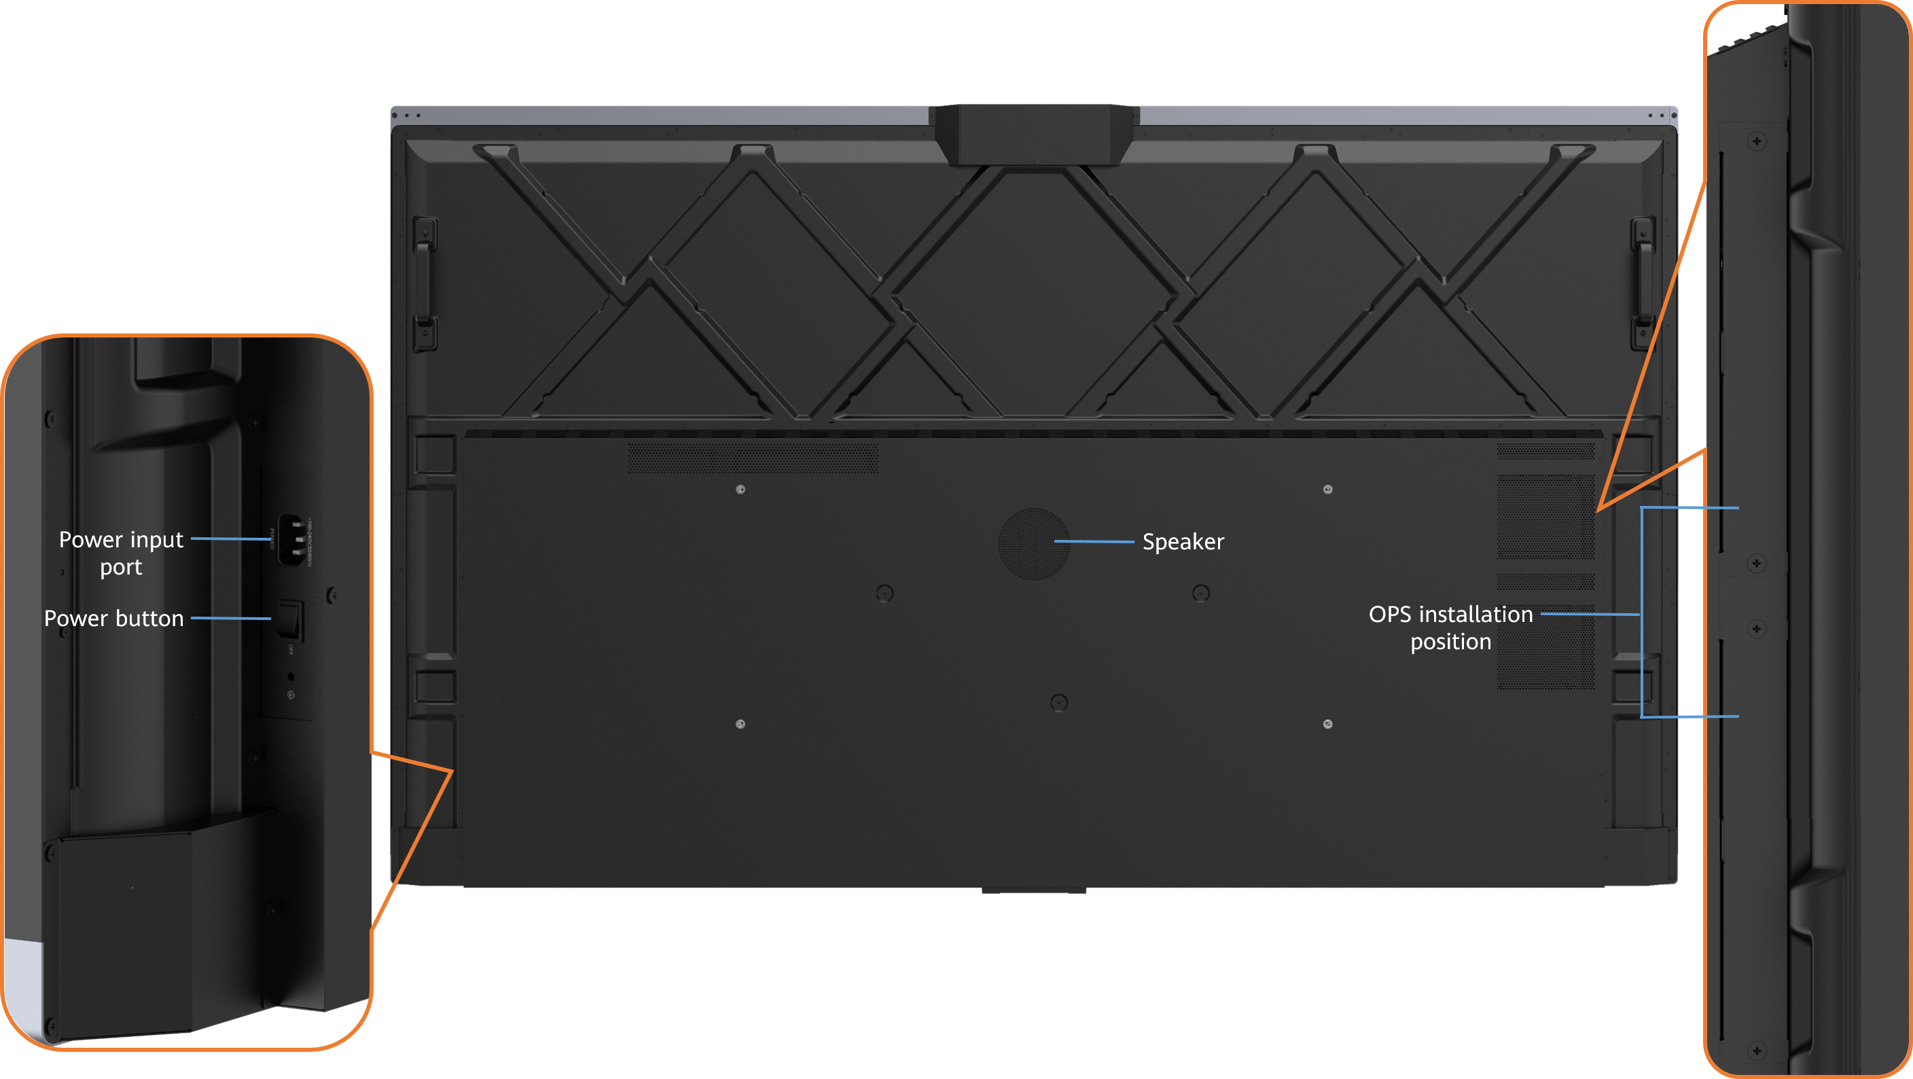

Ports and Functional Modules
              - Ports and functional modules
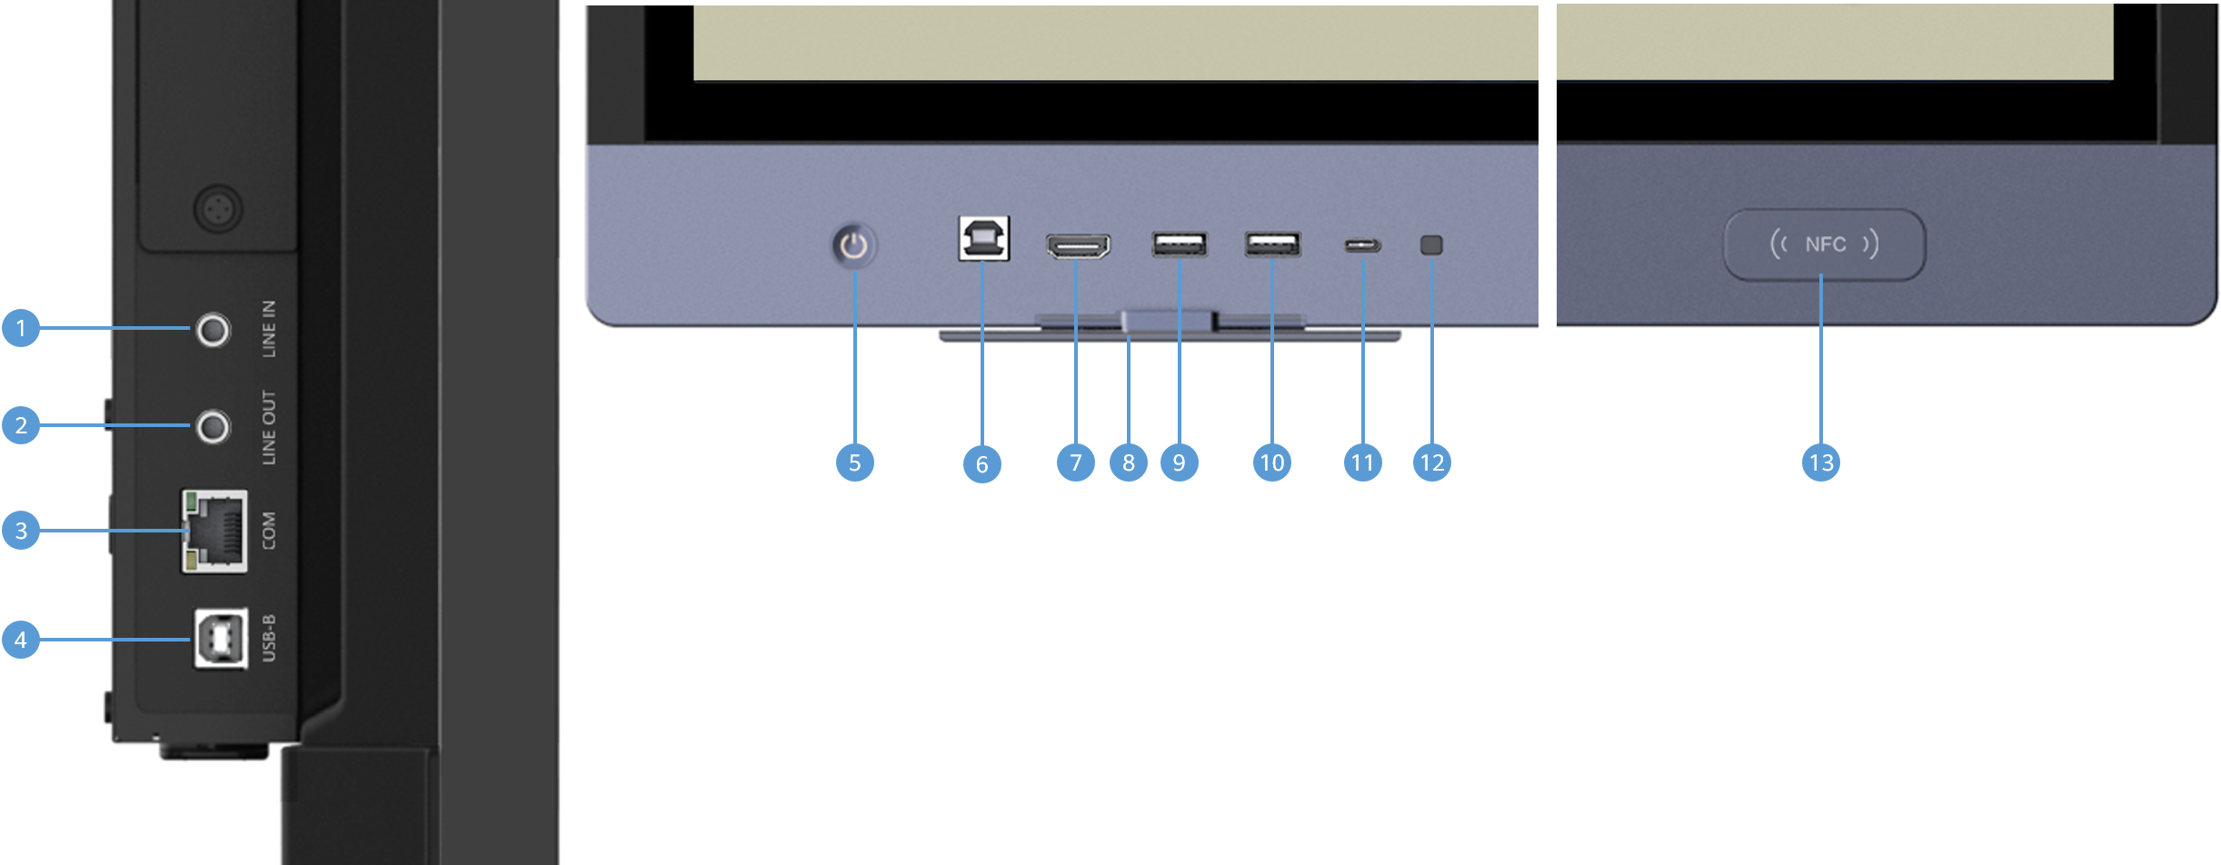

                - Description of ports and functional modules
Category | No. | Description | Function
Audio input port | 1 | 3.5 mm audio input port | Connects to an audio input source, such as a computer.
Audio output port | 2 | 3.5 mm audio output port | Connects to an audio output device, such as an external speaker.
Other ports | 3 | COM port | Connects to a serial cable for remote management of the endpoint.
USB port | 4 | USB 2.0 Type-B port | Connects to a computer and works with the HDMI port on the OPS to reversely control the computer during content sharing over a cable.
Button | 5 | Power button and indicator | - You can put the endpoint into sleep mode or wake it up by pressing the power button.  - After a soft shutdown, you can power on the endpoint by pressing the power button.  - You can press and hold the power button for 3 seconds to display the power menu.  - The indicator indicates the endpoint running status.
USB port | 6 | USB 2.0 Type-B port | Connects to a computer and works with the HDMI port on the large screen to reversely control the computer during content sharing over a cable.
Video input port | 7 | HDMI video input port, which supports audio input | Connects to an HDMI input device as the presentation source, such as a computer.
Functional module | 8 | USB baffle | Prevents the connected external USB device from being hit to cause damage to the device or port when you move the blackboard.
USB port | 9 | USB 3.0 Type-A port | Supports the following USB devices: IdeaShare Key (Type-A), USB flash drive, keyboard, mouse, Controller receiver, microphone, and speaker.
USB port | 10 | USB 3.0 Type-A port | Supports the following USB devices: IdeaShare Key (Type-A), USB flash drive, keyboard, mouse, Controller receiver, microphone, and speaker.
USB port | 11 | USB Type-C port | - Connects to a presentation source such as a computer or mobile device for projection sharing and reverse control.  - Connects to an IdeaShare Key (Type-C) for pairing or upgrade.  - Supports the following USB devices: USB flash drive, microphone, and speaker.  - Supports the PD 3.0 fast charging protocol and up to 65 W fast charging.
Functional module | 12 | Intelligent light sensing | Intelligently adjusts the screen brightness based on the ambient light illuminance.
Functional module | 13 | NFC sensor area | Enables quick access to the endpoint touchscreen without a verification code by using the bound NFC card when the screen verification code is enabled.

Indicators
By checking the indicator status, you can learn about the running status of an endpoint in a timely manner and ensure the normal running of the endpoint and its peripheral devices. Table 3-2 describes indicator statuses.
                - Indicator statuses
Indicator Status | Endpoint Status
Off | Powered off
Blinking green twice per second | Powering on
Blinking green four times per second | Upgrading
Steady green | Working properly
Breathing green (gradually lighting, then dimming) | Hibernating
Blinking red once every 5 seconds | Faulty hardware
Blinking red twice every 5 seconds | Overheated
Blinking red once per second | Faulty touchscreen
Blinking red twice per second | IP address conflict
Blinking red four times per second | Faulty software

OPS

Standard OPS

Appearance
              - Appearance of OPS A01 D
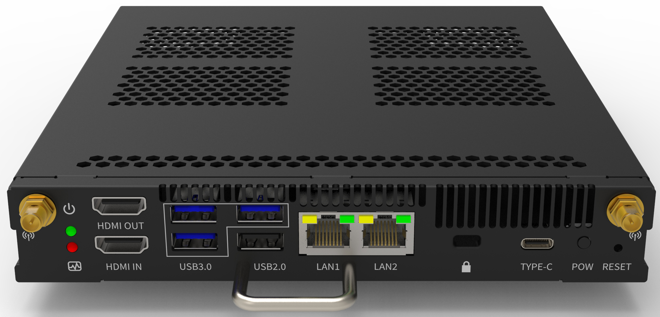

Ports and Functional Modules
OPS A01 D
              - Ports and functional modules of OPS A01 D
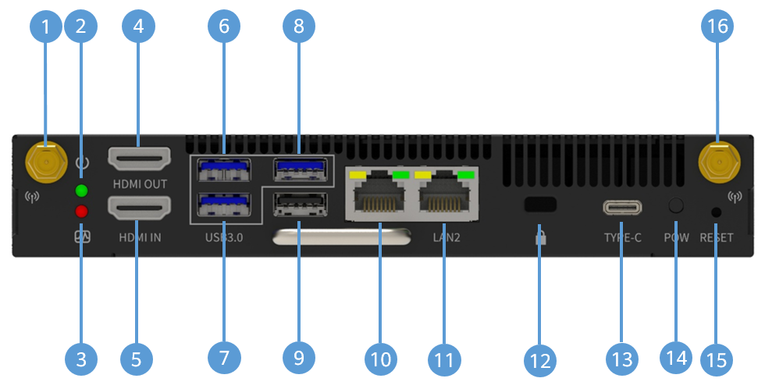

                - Description of ports and functional modules
Category | No. | Description | Function
Indicator | 2 | Power indicator | Indicates the power status.
Indicator | 3 | Running indicator | Indicates the system running status.
Video output port | 4 | HDMI video output port | Connects to the second extended display.
Video input port | 5 | HDMI video input port, which supports audio input | Connects to an HDMI input device, such as a computer.
USB port | 6 | USB 3.0 Type-A port | Supports the following USB devices: IdeaShare Key (Type-A), USB flash drive, keyboard, mouse, Controller receiver, microphone, and speaker.
USB port | 7 | USB 3.0 Type-A port | Supports the following USB devices: IdeaShare Key (Type-A), USB flash drive, keyboard, mouse, Controller receiver, microphone, and speaker.
USB port | 8 | USB 3.0 Type-A port | Supports the following USB devices: IdeaShare Key (Type-A), USB flash drive, keyboard, mouse, Controller receiver, microphone, and speaker.
USB port | 9 | USB 2.0 Type-A port | Supports the following USB devices: IdeaShare Key (Type-A), USB flash drive, keyboard, mouse, Controller receiver, microphone, and speaker.
Other ports | 10 | Ethernet port (10/100/1000 Mbit/s, full-duplex and half-duplex supported) | - Functions as the LAN IN port for the OPS to access the Internet.  - Functions as the LAN OUT port for other devices to access the Internet.  NOTE  The two Ethernet ports cannot both be LAN IN or LAN OUT ports.
Other ports | 11 | Ethernet port (10/100/1000 Mbit/s, full-duplex and half-duplex supported) | - Functions as the LAN IN port for the OPS to access the Internet.  - Functions as the LAN OUT port for other devices to access the Internet.  NOTE  The two Ethernet ports cannot both be LAN IN or LAN OUT ports.
Other ports | 12 | Lock slot | Security slot
USB port | 13 | USB 2.0 Type-C port | - Supports the following USB devices: IdeaShare Key (Type-C), USB flash drive, microphone, and speaker.  - Supports the USB debugging function after developer options are enabled.
Button | 14 | Power button | Powers on or off the device by pressing the power button.
Button | 15 | Reset button | Restores the operating system. Ensure the device is off, press and hold the reset button, and then press the power button to power on the device.
Other ports | 1 | Antenna port | Connects to an antenna.
Other ports | 16 | Antenna port | Connects to an antenna.

Indicators
By checking the indicator status, you can learn about the running status of an OPS in a timely manner and ensure its normal running. Table 3-4 describes indicator statuses.
                - OPS A01 D indicator statuses
Indicator | Indicator Status | Description
Power indicator | Steady red | The device is powered on, and the screen is on or off.
Power indicator | Off | The device is shut down.
Running indicator | Steady green | The system is running properly.
Running indicator | Blinking green | The system is starting.
Running indicator | Off | The system is shut down.
Ethernet port indicator | Yellow off | The network is disconnected.
Ethernet port indicator | Steady yellow | The network is properly connected.
Ethernet port indicator | Blinking yellow | Data is being transmitted.
Ethernet port indicator | Green off | Either there is no connection, or the network speed is limited to 10 Mbit/s.
Ethernet port indicator | Steady green | The 100 or 1000 Mbit/s network is connected.

Alternative OPS
After the Windows OPS is configured for the endpoint, third-party software can be installed and run on Windows.

The OPS must match the product.
                - Main information about alternative OPSs
OPS Name & Code | Main Modules on the Front Panel | Appearance
- OPS W021 Z (06190037)  - OPS W022 Z (06190034)  - OPS W021 D (06190041)  - OPS W022 D (06190040)  - OPS W021 Z (06190054)  - OPS W022 Z (06190053) | Ports:  - 1 x RJ45 network port  - 1 x DP display port  NOTE  Only the OPS W021 Z and OPS W022 Z are involved.  - 1 x HDMI display port  - 1 x LINE IN microphone jack  - 1 x LINE OUT audio output port  - 2 x Wi-Fi antenna port  - Type-A port  NOTE  - The OPS W021 Z (06190037) and OPS W022 Z (06190034) include three USB 2.0 Type-A ports and three USB 3.0 Type-A ports.  - The OPS W021 D and OPS W022 D include three USB 2.0 Type-A ports and three USB 3.2 Type-A ports.  - The OPS W021 Z (06190054) and OPS W022 Z (06190053) include two USB 2.0 Type-A ports and four USB 3.0 Type-A ports.  - 1 x USB 3.0 Type-C port  NOTE  Only the OPS W021 Z (06190054) and OPS W022 Z (06190053) are involved.  Buttons:  - 1 x Power button  - 1 x one-touch restore button  - 1 x Restart button  NOTE  Only the OPS W021 Z (06190037) and OPS W022 Z (06190034) are involved.  Indicators:  - 1 x Power-on indicator (green)  - 1 x Power indicator (red)  - 1 x Disk indicator (yellow)  Others:  1 x Security lock hole | Figure 3-9  Figure 3-10  Figure 3-11

              - Appearance of the OPS W021 Z (06190037) or OPS W022 Z (06190034)
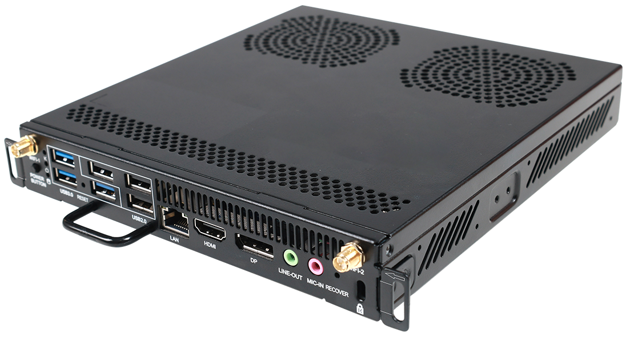

              - Appearance of the OPS W021 D or OPS W022 D
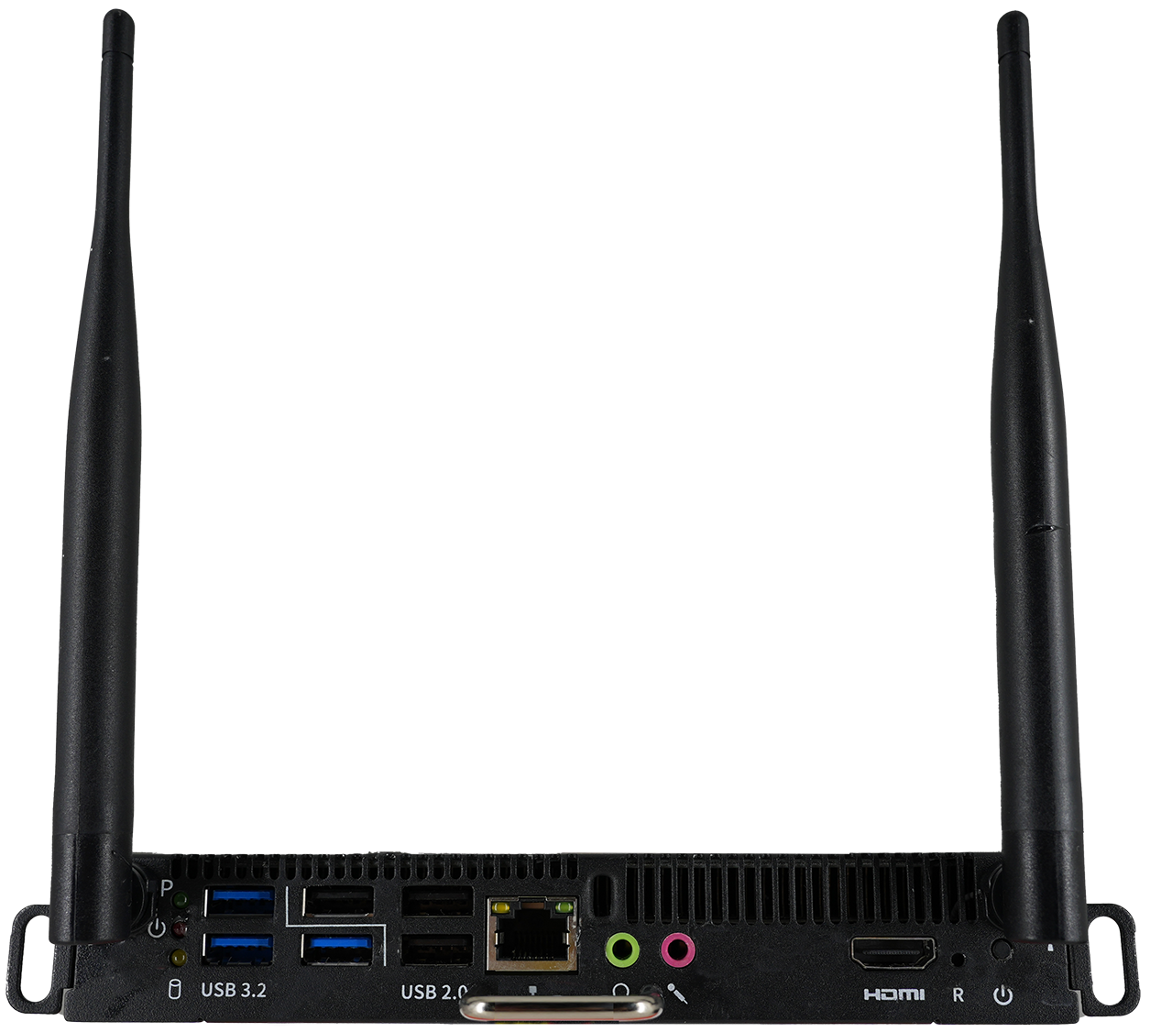

              - Appearance of the OPS W021 Z (06190054) or OPS W022 Z (06190053)
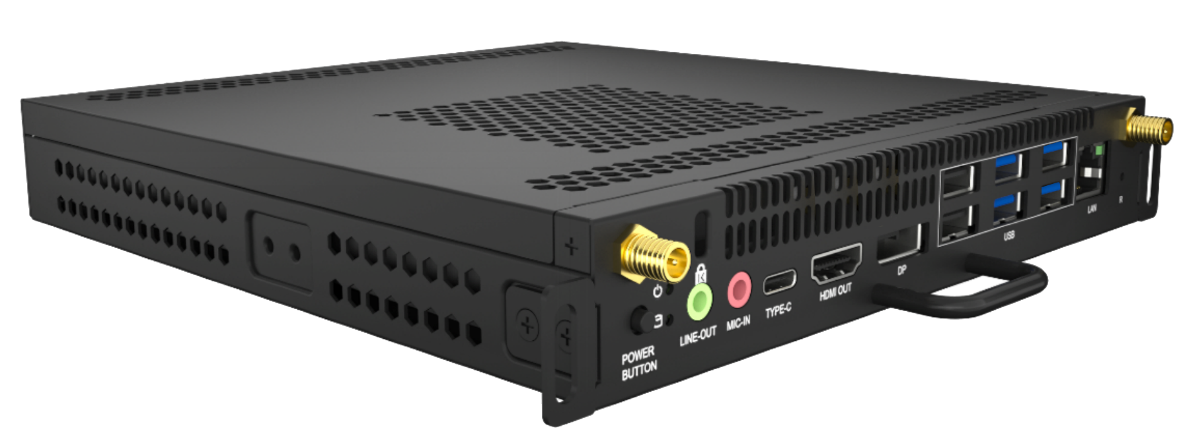

OPS Installation
As an embedded computer module, the OPS can be easily installed or removed using a screwdriver.
- The large screen supports only one standard OPS and one alternative OPS.
- Different OPS models differ slightly in appearance and screw positions, but their installation methods are similar. The following uses the installation of one OPS model in the OPS1 slot as an example.
- Ensure that the endpoint is powered off before OPS installation and uninstallation. Otherwise, an OPS error may occur.
              - Installing the OPS
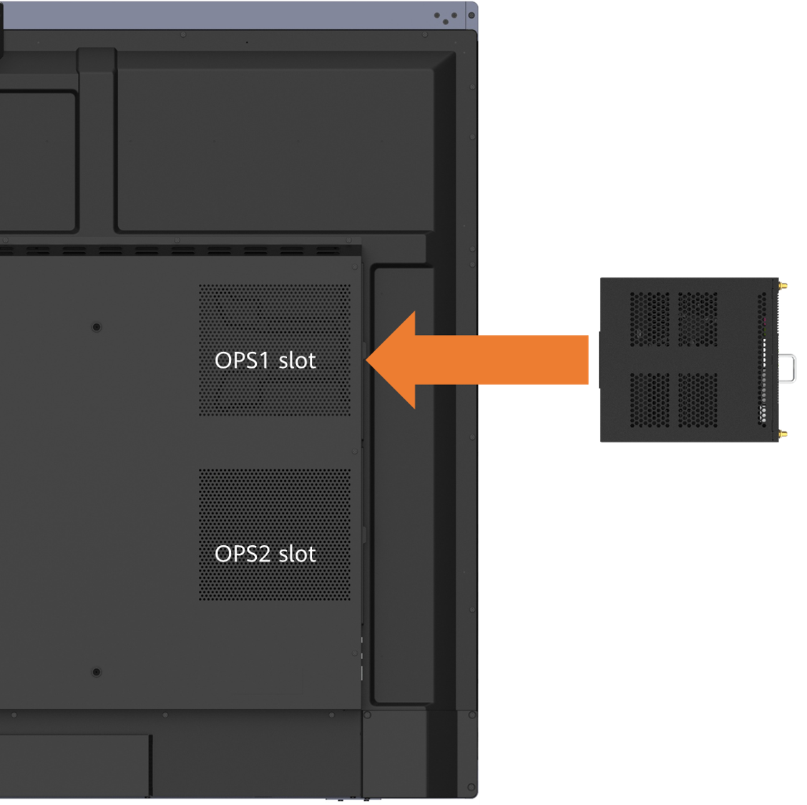

Controller
You can configure the Controller and Controller receiver for an endpoint. The Controller can be used to perform multiple routine operations and provide convenient control functions.
              - Controller and receiver
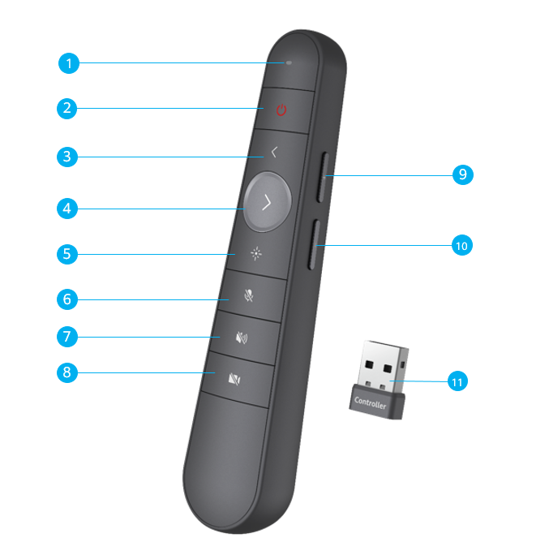

                - Functions of the Controller and receiver
No. | Function | Description
1 | Indicator | Displays the working status of the Controller.
2 | Sleep/Wake up | After you press this button, the endpoint enters or wakes up from the sleep mode.
3 | Turn to the previous page | Go back to the previous page on the whiteboard and in presentations and documents.
4 | Turn to the next page | Turn to the next page on the whiteboard and in presentations and documents.
5 | Laser pointer | Press and hold the button to move the laser pointer dot, and press the button to perform the tap operation.
6 | Mute/Unmute the microphone | Press the button to mute or unmute the microphone.
7 | Mute/Unmute the speaker | Press the button to mute or unmute the speaker.
8 | Enable/Disable the camera | Press the button to turn on or off the camera.
9 | Increase the volume | Press or hold the button to increase the volume.
10 | Decrease the volume | Press or hold the button to decrease the volume.
11 | Controller receiver | Insert the Controller receiver into the USB Type-A port to receive signals from the Controller.

Functions and Features

Ultra-HD Display Resolution
The IdeaHub supports a resolution of 4K 60 fps. 4K delivers four times the resolution of 1080p screens, giving incredible clarity and lifelike detail to images on a larger screen.
              - 4K ultra-HD video
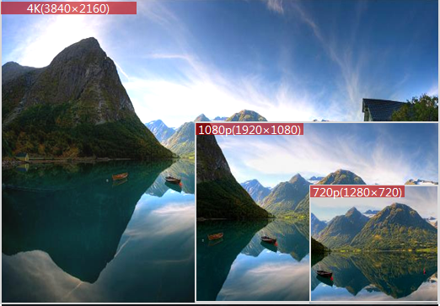

Hi-Fi Audio
- Supports Acoustic Echo Cancellation (AEC), Automatic Noise Suppression (ANS), and Automatic Gain Control (AGC), as well as VoiceClear, burst noise suppression, reverberation suppression, and lip synchronization.
- Based on the installation mode of an endpoint, you can select the corresponding configuration item. For example, you can select Standard (floor stand-mounted), Wall-mounted, or Wall-recessed to achieve better audio and video effects.

Smart Projection
An IdeaHub supports wired and wireless projection modes. Both modes provide basically the same functions. You can use either of the two modes based on your needs to easily share audio files, videos, images, and other files on your mobile device or PC. In addition, the IdeaHub supports reverse control and annotation, making projection and information interaction simple and efficient.
Wired Projection
An IdeaHub can connect to a computer using an HDMI cable to share the computer's desktop. The IdeaHub supports plug-and-share. In addition, when the computer is also connected to the endpoint's USB Type-B port through another cable, reverse control is supported.
An IdeaHub can connect to a computer or mobile device using a USB Type-C cable to share the computer or mobile device's desktop. The IdeaHub supports plug-and-share. The IdeaHub can also reversely control the computer or mobile device.
- For wired projection, use the HDMI cable of the large screen with the front-panel USB Type-B port of the large screen or an OPS HDMI cable with the side-panel USB Type-B port of the large screen.
- Only the USB Type-C port on the large screen supports Type-C wired projection.
Wireless Projection
Wireless projection frees you from complex cable connections and allows you to easily share your computer and mobile device screens.
- With the IdeaShare mobile client, you can share a mobile device screen.
- With the IdeaShare Windows/macOS computer client, you can share your computer desktop.
- With the IdeaShare Android/HarmonyOS/Windows client, the Wi-Fi P2P connection mode is supported. Projection can be started even if the mobile device and IdeaHub are not on the same network.
- Simply insert the IdeaShare Key into the IdeaHub for pairing and then into your computer to easily share your desktop with the IdeaHub.
- You can reversely control the computer desktop by performing tap, drag, and double-tap operations on the touchscreen. When a PowerPoint file is in slideshow mode on the computer, you can turn pages or end the slideshow using the touchscreen.
- On the endpoint and devices with host rights, you can manage screen sharing permissions for the client and IdeaShare Key.
              - IdeaShare Key (Type-A)
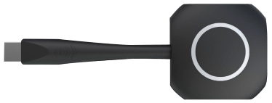

              - IdeaShare Key (Type-C)
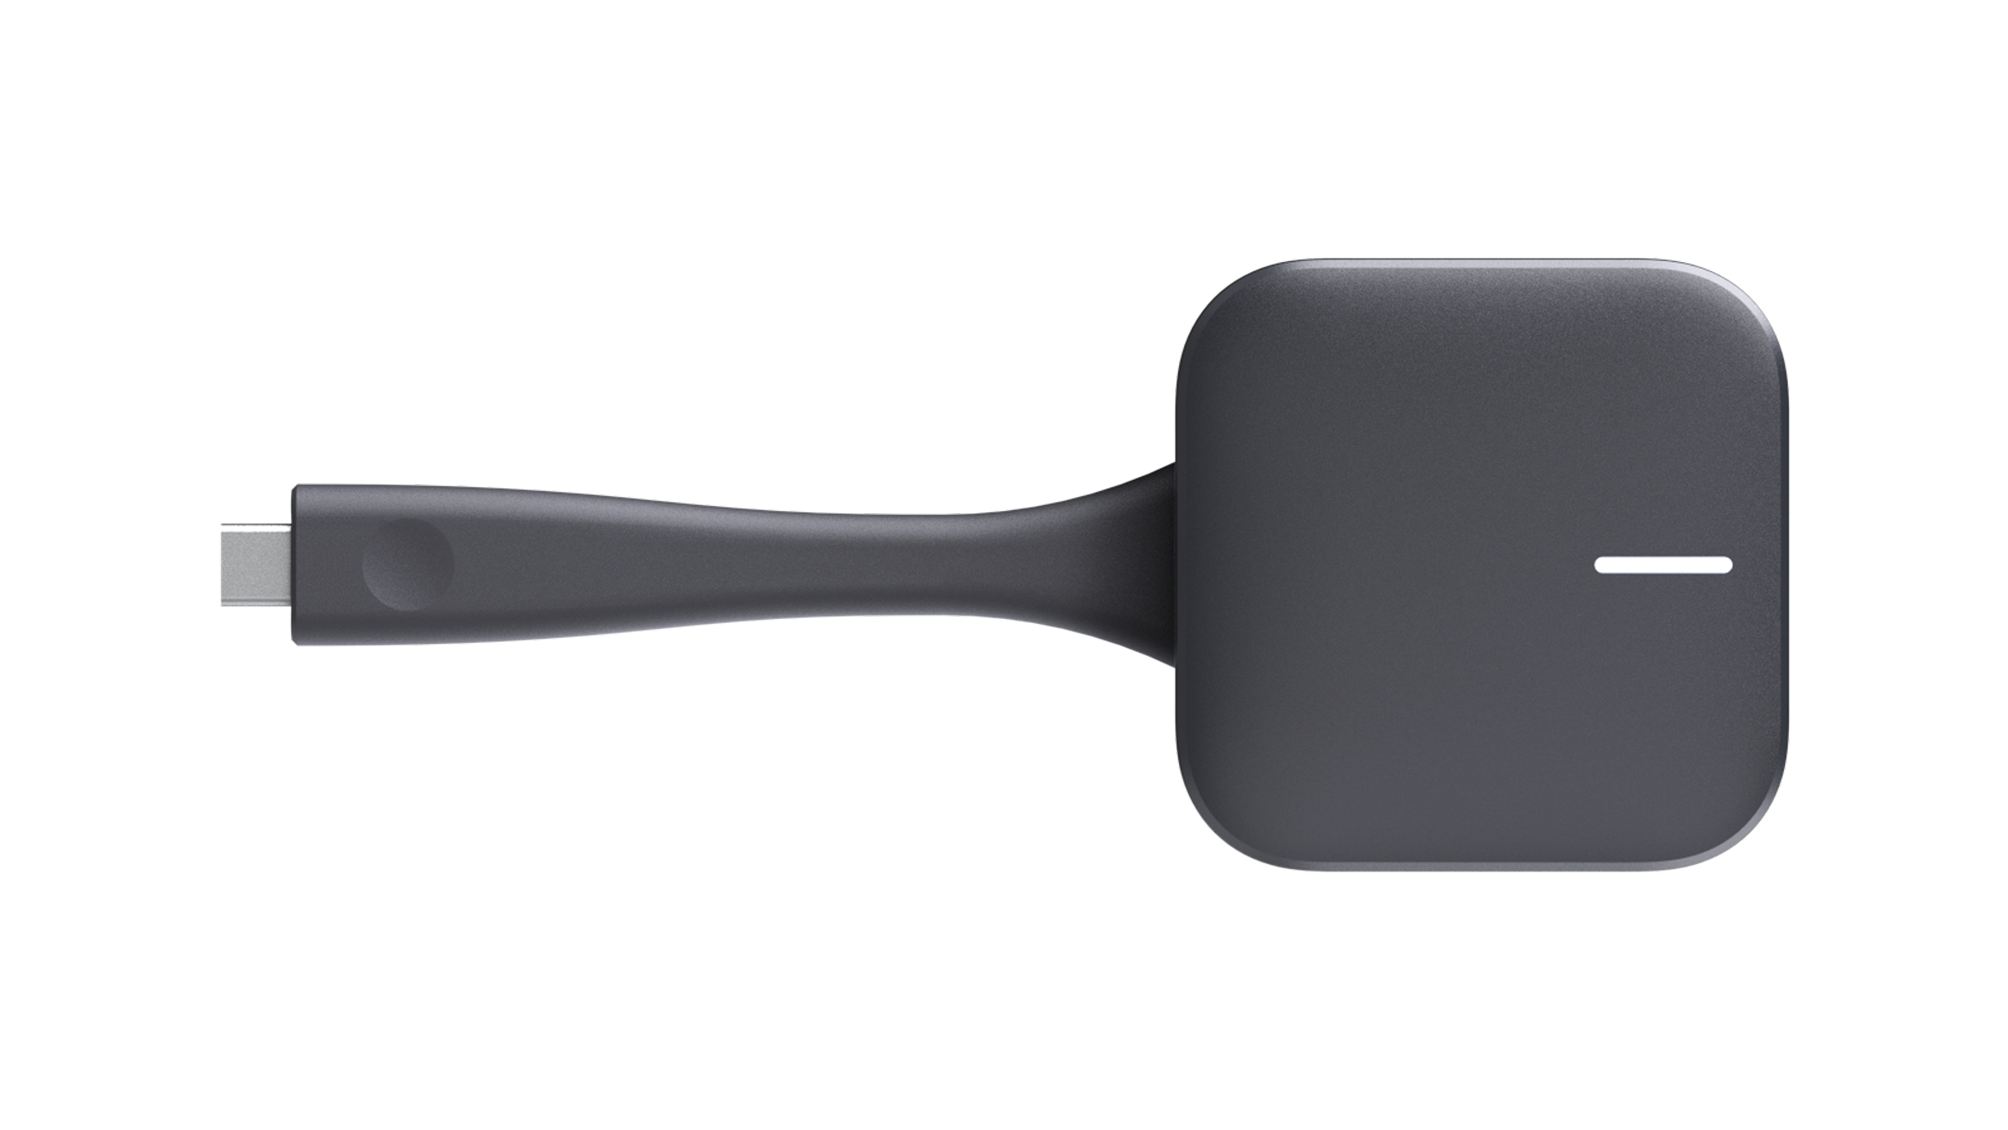

Whiteboard Collaboration
An IdeaHub's built-in whiteboard features ultra-low writing latency and smooth writing. The whiteboard provides multiple writing modes and mistouch prevention to meet the requirements of daily office and education writing scenarios. Whiteboard content can be easily saved and transferred through multiple methods. Users can choose a method as they like.
                - Whiteboard collaboration functions
Function | Description
Creating a whiteboard | Create a maximum of 100 whiteboard pages and set their background color to white, gray, or dark green.
Writing on a whiteboard | - Write with your finger or a stylus pen.  - Support a handwriting effect for a fountain pen.  - Support writing in the highlighter effect.  - Support intelligent writing recognition of shapes and texts.  - Support adjustment of line thickness for handwriting (in fountain pen, pencil, and highlighter effects).  - Support writing with up to ten fingers at the same time.  - Select, move, zoom in/out on, delete, and edit shapes and texts, or cancel the preceding operations.  - Insert shapes such as triangles, quadrilaterals, and circles.  - Insert images.  - Insert content from the favorites.  - Use the intelligent search function in the whiteboard app and insert the search results into the whiteboard. These functions are available only after an endpoint is connected to the IdeaManager (cloud service) and a large model is configured on the IdeaManager (cloud service).
Operating a whiteboard | - Perform operations such as zooming in, zooming out, erasing, and dragging the canvas by using your finger.  - Circle an area. You can move, zoom in/out on, copy, paste, or delete the selected content, add it to favorites, or change the color in the circled area.  - Support precise erasing and full screen clearing.  - Erase only highlighter strokes.  - Crop a single image.
Saving a whiteboard | - Save the whiteboard to a local directory.  - Save the whiteboard to a USB flash drive.  - Transfer the whiteboard content via emails on condition that email accounts have been configured.  - Save content by scanning the QR code through a browser after the endpoint is connected to the IdeaManager.  - Share whiteboard files to third-party apps.
Closing a whiteboard | Before closing a whiteboard, you can choose whether to save the whiteboard content.
Deleting a whiteboard | Delete whiteboard pages or files.
Opening a whiteboard | - Open a whiteboard from a local directory.  - Open a whiteboard in a USB flash drive.
Annotation | - Annotate on local apps.  - Support annotations during wired projection on the OPS and wireless projection.  - Support global annotation.  - Save annotations to a local directory of the endpoint.  - Open annotation files from a local directory of the endpoint.  - Send annotated content via email.  - Add content on one split screen to the other, which is the whiteboard, as an image using the annotation function in split-screen mode.  - Touch and hold the annotation background to enter the editing state and crop the annotation background.

Mirror & Control
Connecting the IdeaShare client or IdeaShare Key (Type-C) to an IdeaHub streams the OPS to your mobile device or PC for portable control and extended viewing capabilities.
On the endpoint and devices with host rights, you can manage mirror & control permissions for the client and IdeaShare Key.

Dual-Screen Display
An IdeaHub supports dual-screen clone. You can connect the IdeaHub to an extended screen using an HDMI cable to clone the content on the OPS screen to the extended screen.

Multi-Window
An IdeaHub allows you to open two apps at the same time in split-screen mode on the OPS screen, reducing complex operations caused by app switching and improving usage efficiency. You can also adjust the split-screen ratio of app windows for proper display areas.

Wireless Connections
A large screen used with an OPS supports 2 x 2 Wi-Fi technology (that is, 2-channel input and 2-channel output of Wi-Fi data), dual antennas, and dual bands (2.4 GHz and 5 GHz). Both Wi-Fi and hotspot can be enabled at the same time.
If Wi-Fi is enabled, the endpoint automatically detects and connects to Wi-Fi networks. You can set the IP address in DHCP or static mode. This function applies to scenarios in which no wired network is available and you need to connect the endpoint to the network via Wi-Fi.
When the IdeaHub has its hotspot enabled, it can serve as a hotspot for connecting other devices (such as a PC) to Wi-Fi.
- The large screen contains the radio transmission module with the type approval code CMIIT ID:25J44B200091.
- The OPS A01 D contains the radio transmission module with the type approval code CMIIT ID:25J44M8U9016.

HiBoard Welcome Page
The IdeaHub supports the HiBoard welcome page. Three welcome page background images are available by default, and users can customize the content and font of the welcome page. You can also upload customized welcome page background images.
              - HiBoard
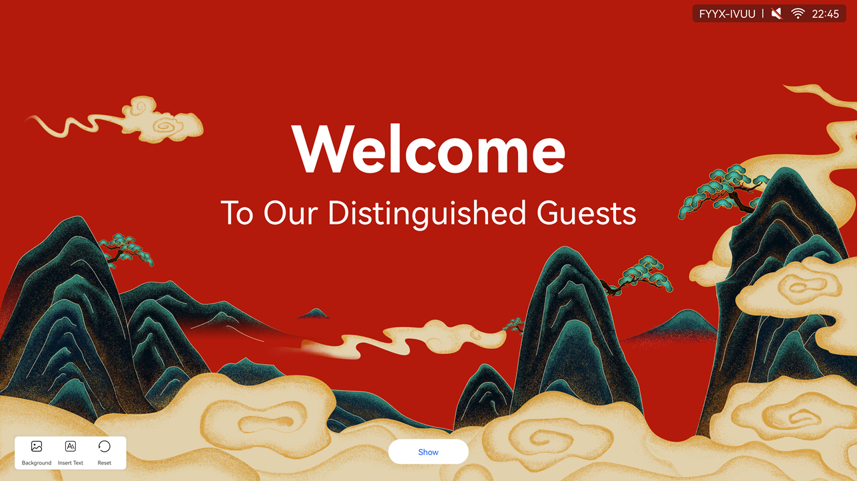

Apps
The IdeaHub has common office apps pre-installed, covering various scenarios such as whiteboard and projection, satisfying users' requirements for digital office. You can customize the apps on the home screen based on use frequency, in a simple and efficient manner.
              - Apps
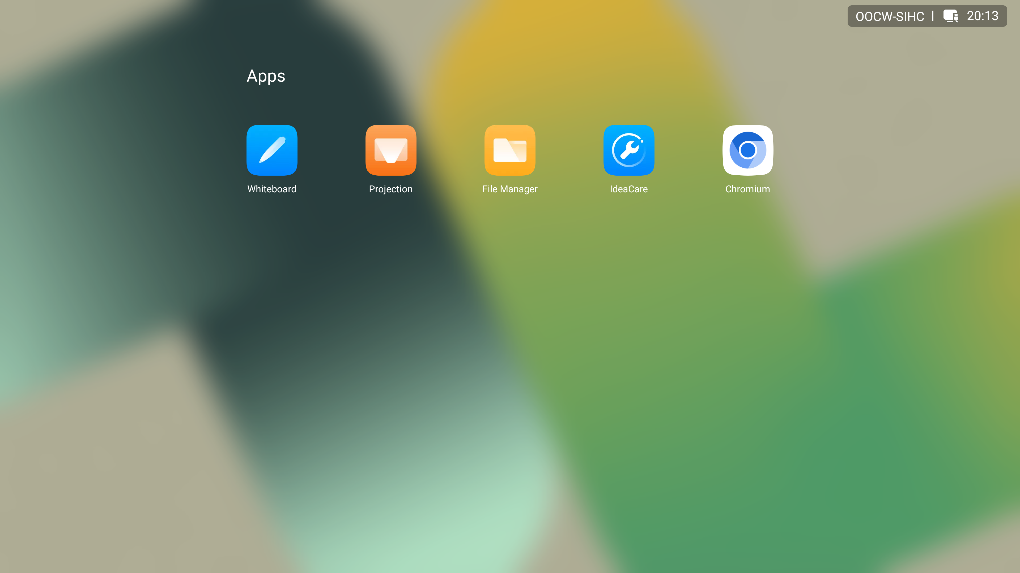

Globalization
An IdeaHub supports multiple languages and time zone settings. If some countries and regions in the selected time zone use daylight saving time (DST), the IdeaHub automatically enables DST and changes its clock to comply with DST, meeting needs of different users.
The IdeaHub supports the following languages: Simplified Chinese, traditional Chinese, English, Spanish, French, Russian, Japanese, Arabic, Italian, Portuguese, German, Thai, Turkish, Korean, Kazakh, Romanian, Bulgarian, Sinhala, and Serbian.
The large screen supports only simplified Chinese and English.

Operations, Administration, and Maintenance

Batch Configuration
An IdeaHub can be connected to enterprise services through the OPS, and deliver configurations through the IdeaManager management platform to complete key configurations in batches, improving O&M efficiency.

Changing a Wallpaper
An IdeaHub allows you to change wallpapers and import custom wallpapers.

Serial Port Control
The IdeaHub's open RS232 protocol control API enables efficient remote endpoint management.
The API provides the following functions:
- Remote shutdown/startup
- Remote sleep
- Remote wakeup
- Volume adjustment
- Screen brightness adjustment
The functions are supported only when the IHK3-98XA is used.

Keeping Applications Alive in the Background
An IdeaHub allows users to select applications that need to be kept alive in the background to prevent them from being automatically closed by the system.

Developer Options
Developer options provide users with in-depth optimization functions. It is recommended that users disable developer options immediately after using them. Developer options of the IdeaHub include:
- USB Debugging: When enabled, you can debug the IdeaHub, copy data, and install apps on it using the computer connected to the IdeaHub through a USB port.
- Revoking USB Debugging Permission: Revoke the previously granted USB debugging permissions from all the computers. After the permissions are revoked, the current USB debugging stops.

Security and Reliability

Operating System Security
Security maintenance for the system layer ensures that the operating system runs smoothly and also supports stable services at the application layer. The IdeaHub uses an Android operating system and provides powerful anti-attack capabilities.

Email Security
To ensure the security of email accounts and email sending, the STARTTLS protocol is used by default to authenticate the email server and send encrypted emails.

Protocol Anti-Attack Measures
- The communication matrix is provided in the product documentation. Do not enable the services and ports that are not described in the communication matrix.
The communication matrix contains the following information: open ports, transport layer protocols used by the ports, NEs that use the ports to communicate with peer NEs, application layer protocols used by the ports and description of the services at the application layer, whether services at the application layer can be disabled, authentication modes adopted by the ports, and port functions (such as data traffic control).
- Multiple security encryption measures, such as Transport Layer Security (TLS) and HTTPS, are used to ensure user security.
- An endpoint supports anti-brute-force-cracking. When the number of authentication failures reaches the preset value, the endpoint is locked. You can access the endpoint again only when this duration ends.

Protection of Sensitive Data
- The log, diagnostics, debug, and alarm information does not contain sensitive data.
- Sensitive data can be transmitted through secure channels or after being encrypted.
- The endpoint checks the complexity of passwords. When a password is being entered, each character is displayed as "." or "*", and the entered password cannot be copied.
- Sensitive data such as passwords and encrypted contexts must not be recorded in logs. If sensitive data really needs to be recorded, it should be displayed as "***".
- Only standard encryption algorithms and key negotiation mechanisms are used. Proprietary algorithms are not allowed.

System Management and Maintenance Security
- Software packages (including patches) are released only after they are scanned by at least three types of mainstream antivirus software, and no issues are detected. In special cases, an explanation is provided for alarms.
- All user operations and system exceptions are logged.
- A two-level certificate chain is supported to ensure the transmission security of confidential data.

Security Design
- Safety labels and tags are attached to the exterior of the product to remind users to avoid high-risk operations.
- The component security design meets the admission requirements of the EU and China.

Secure Startup
The IdeaHub supports secure startup. During the startup process, the integrity of the U-Boot, kernel, and app software is verified level by level to ensure that all software running on the IdeaHub is valid, thereby ensuring reliable and secure running of the IdeaHub.

Operations and Maintenance

GUIs

Touchscreen UI
An IdeaHub uses a brand-new touchable collaboration system. You can simply tap icons to perform basic operations, such as to open an app, turn on/off a camera, or adjust the volume.
              - Home screen of the OPS screen
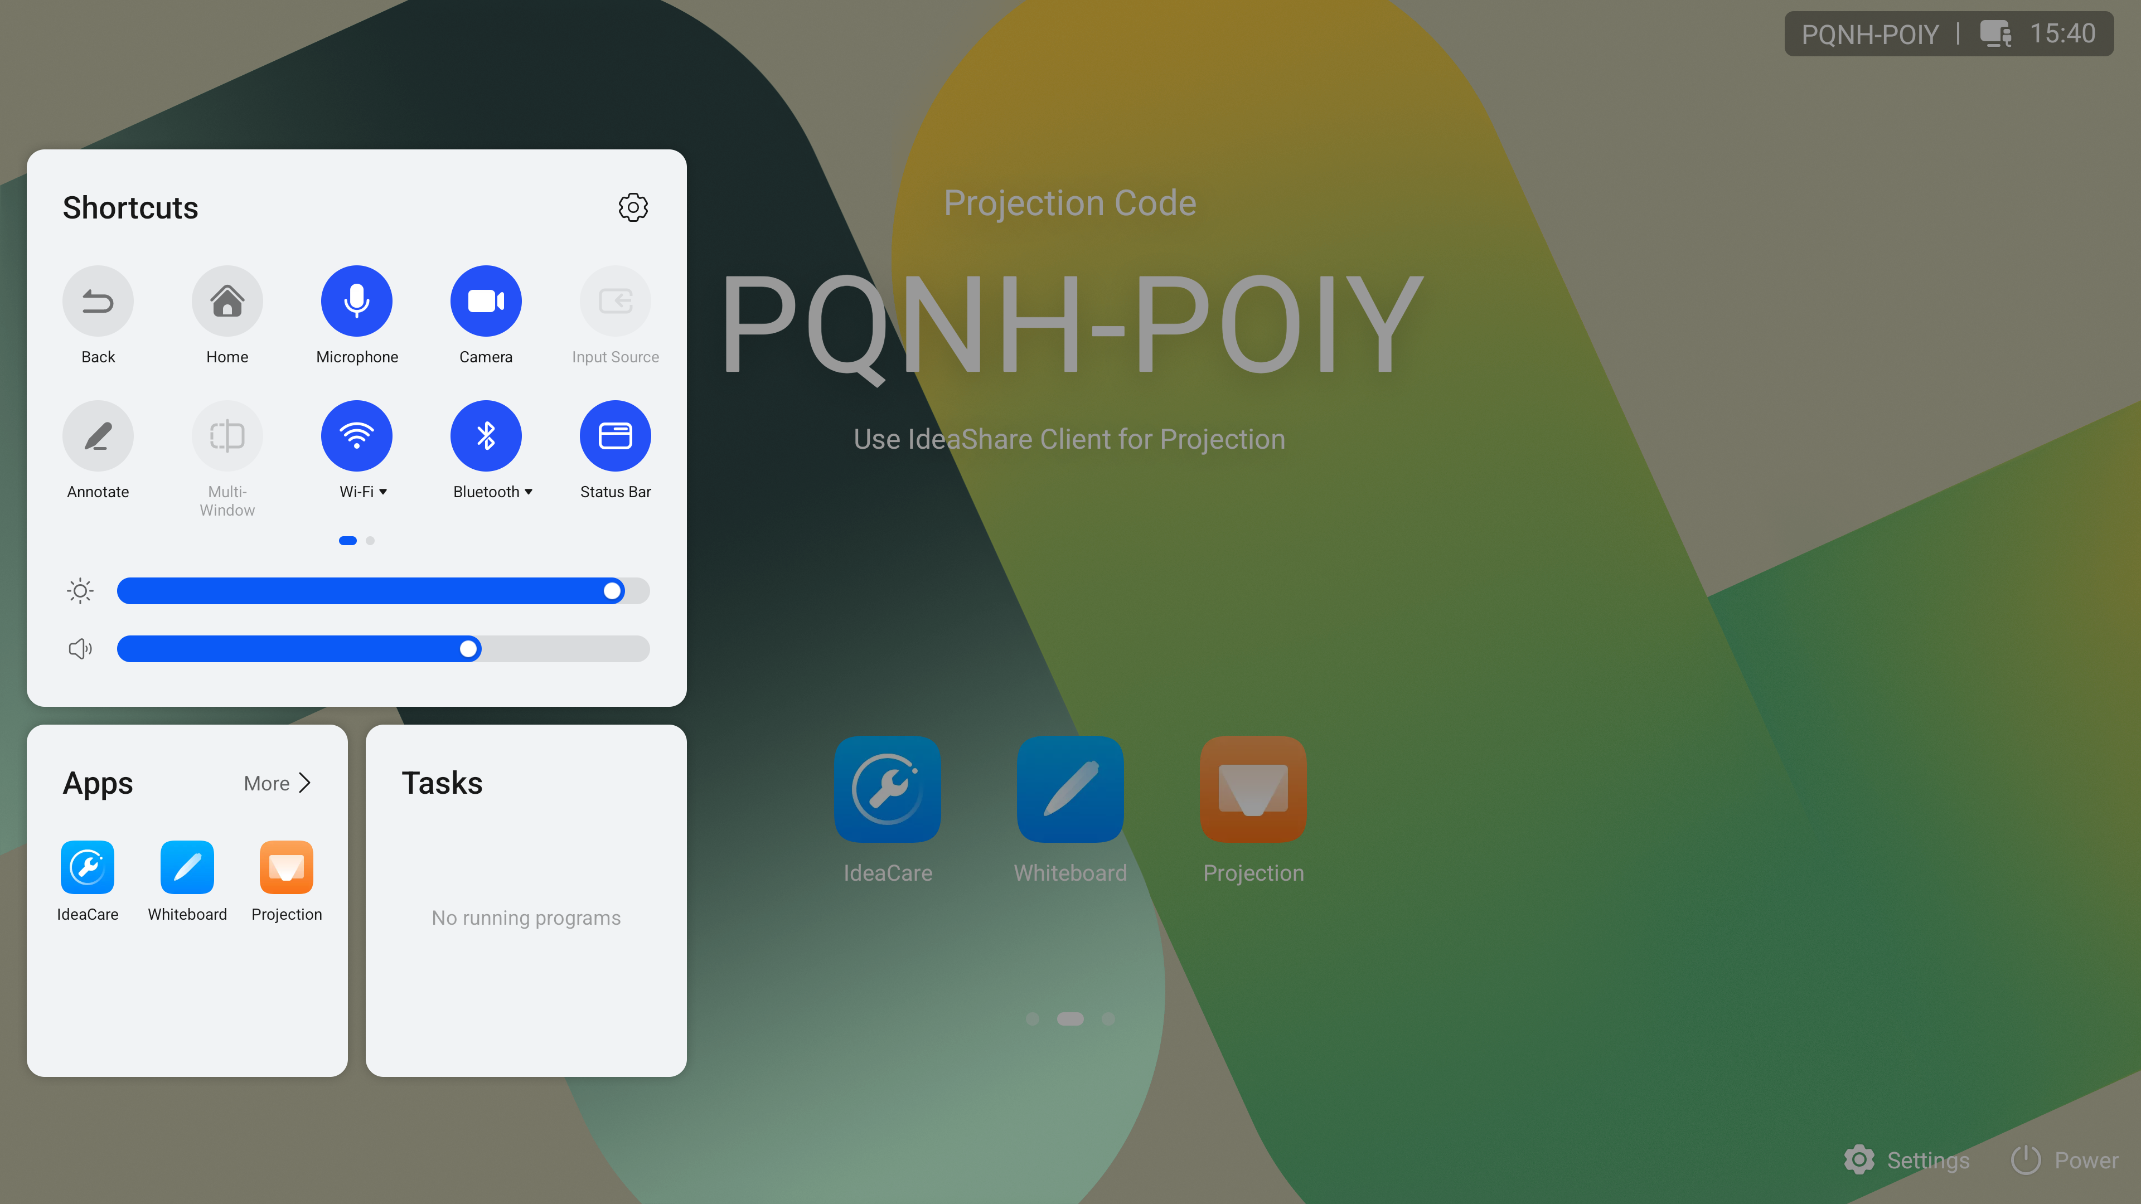

              - Large screen


IdeaShare UI
The IdeaShare is a wireless projection client designed for the IdeaHub. It can be installed on an Android/iOS/HarmonyOS mobile device or Windows/macOS computer. A maximum of 50 users can be connected at the same time. When one site is sharing content, other sites can preempt the presentation sharing right.
The IdeaShare wireless projection clients for Android, iOS, HarmonyOS, macOS, and Windows integrate the remote control function, allowing users to mute or unmute the microphone, turn on or off the camera, and adjust the volume. In addition, the Android, HarmonyOS, macOS, Windows, and iOS versions of the IdeaShare wireless projection client is integrated with the mirror & control function, allowing users to remotely view and control the large screen.
              - IdeaShare UI
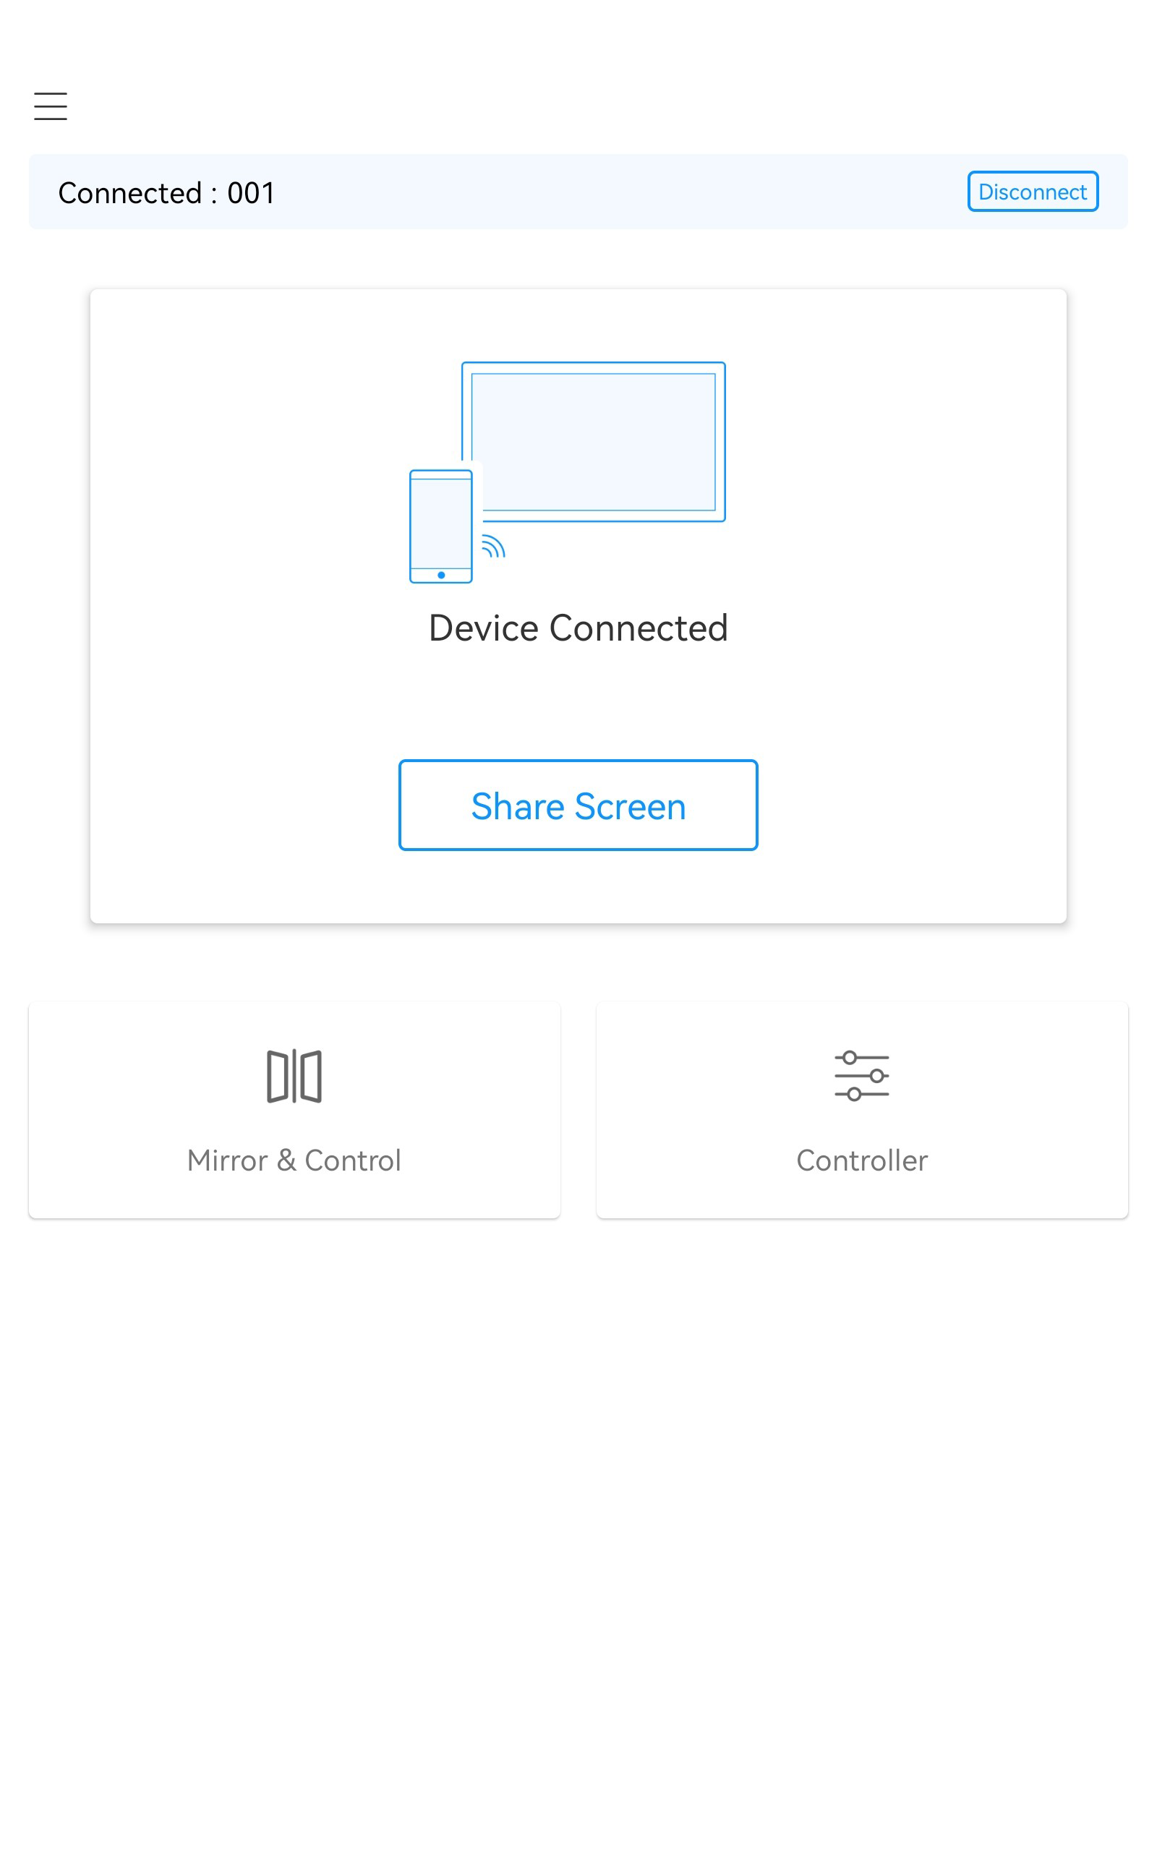

Maintenance and Upgrade

Log Management
An IdeaHub records logs about user operations and system exceptions, helping the administrator maintain the system and locate faults.
Logs are stored in files. You can use the one-click diagnostic function of the IdeaCare app to export large-screen and OPS logs.

Device Diagnostics
An endpoint has a built-in IdeaCare app. You can use this app to perform full diagnostics, quick diagnostics, diagnostics by category, and one-click diagnostics, and export diagnostics reports.

Inspection
The following inspection tasks can be executed on the IdeaManager for the IdeaHub:
- Check the status of IP lines.
- Check the system software version.
- Check the system performance, including the temperature status.
- Check the video input cable connection status and video input port settings.
- Check the certificate status.
- Report the inspection result and status to the IdeaManager.
The functions are supported only when the IHK3-98XA is used.

Upgrade
You can upgrade an endpoint to fix vulnerabilities and use new functions. The following upgrade methods are supported:
- You can import upgrade files using a USB flash drive to upgrade the large screen and OPS.
- After an endpoint is connected to the public network, the software version of the large screen and OPS can be automatically updated. You can also manually check for the latest version on the touchscreen and update the software.
- You can manually upgrade the large screen and OPS on the IdeaManager.

Technical Specifications

Physical Specifications
                - Physical specifications
Parameter Name | Content
System (standard OPS)
CPU | Quad-core A76 + Quad-core A55
Memory | 8 GB
Storage space | 128 GB
AI computing power | 6 TOPS
Operating system | Android 15
Screen display
Backlight type | D-LED
Aspect ratio | 16:9
Resolution | 3840 × 2160
Display area | - 65-inch model: 1428.48 mm × 803.52 mm  - 86-inch model: 1895.04 mm × 1065.95 mm  - 98-inch model: 2158.85 mm × 1214.35 mm
Pixel pitch | - 65-inch model: 372.0 μm × 372.0 μm  - 86-inch model: 493.5 μm × 493.5 μm  - 98-inch model: 562.2 μm × 562.2 μm
Pixel defect | The defect standard complies with ISO 9241 Class I.
Refresh rate | 60 Hz
Response time | 8 ms
Brightness (typical value) | 350 nits
Screen brightness uniformity | ≥ 70%
Contrast | 1200:1
Viewing angle | ≥ 178°
Color depth | 10 bits (8 bits + FRC)
Hardware-based anti-blue light | Supported
Glass surface treatment | Anti-glare
Screen lamination | Zero-gap bonding
Glass surface hardness | ≥ 7H
Color gamut | 72% NTSC
Screen touch control
Touch control precision | ±1 mm
Max. touch points | 40 points
Touch control type | Infrared touch control
Touch response time | ≤ 4 ms
Auto-brightness | Supported
Camera
Lens type | Fixed focal length
Sensor size | 1/2''
Horizontal field of view | 122.5°
Aperture | F2.8
Video resolution | 1920 × 1080
Zoom | 5x digital
Vertical angle of view | 92.2°
TV distortion | < 40%
Shooting distance | 0.5 m to infinity
PTZ adjustment | e-PTZ
Automatic exposure (AE) | Supported
Automatic white balance (AWB) | Supported
Built-in microphone
Quantity | 8
Sampling frequency | 48 kHz
Sampling bits | 16 bits
Sound pickup distance | 10 m
Sound pickup angle | 180°
Built-in speaker
Quantity | 2 × (tweeter + full-frequency unit) + 1 × woofer
Total speaker power | 2 × 20 W + 1 × 20 W
Sound output mode | Front tweeters and full-frequency speakers and rear woofers
Frequency response range | 90 Hz–20 KHz
Stereo | Supported
Max. sound level | 92 dB SPL@1 m
Electricity supply requirements
Rated operating voltage | 100–240 V AC
Operating frequency | 50 Hz/60 Hz
Max. power consumption | - 65-inch model: < 350 W  - 86-inch model: < 480 W  - 98-inch model: < 600 W
Typical power (without OPS; brightness of 300 nits) | - 65-inch model: 150 W  - 86-inch model: 250 W  - 98-inch model: 320 W
Standby power | < 0.5 W
Environmental requirements (in use)
Ambient temperature | 0°C to +40°C
Relative humidity | 10% to 95%
Operating altitude | ≤ 5000 m
Operating duration (hour/day) | ≤ 16 hours/day
MTBF | > 100,000 hours
Device operating lifespan | 5 years
Environmental requirements (idle)
Ambient temperature | –20ºC to +60ºC
Relative humidity (non-condensing) | 5% to 95%
Physical parameters of the entire system
Product dimensions | - 65-inch model: 924.7 mm × 1484.5 mm × 90 mm  - 86-inch model: 1188.9 mm × 1953.0 mm × 90 mm  - 98-inch model: 1341.7 mm × 2216.4 mm × 96.4 mm
Package dimensions | - 65-inch model: 1030 mm × 1620 mm × 210 mm  - 86-inch model: 1291 mm × 2090 mm × 215 mm  - 98-inch model: 1570 mm × 2360 mm × 280 mm
Net weight | - 65-inch model: 37 kg  - 86-inch model: 60 kg  - 98-inch model: 94 kg
Gross weight (including the package) | - 65-inch model: 46 kg  - 86-inch model: 73.5 kg  - 98-inch model: 111 kg
(Optional) Floor stand^{[1]}
Product dimensions | 1525.0 mm × 1302.0 mm × 764.0 mm
Package dimensions | 180 mm × 1390 mm × 845 mm
Net weight | 19.5 kg
Gross weight (including the package) | 24.8 kg
(Optional) Wall-mounted bracket
Product dimensions | 34 mm × 1100 mm × 200 mm
Package dimensions | 55 mm × 1260 mm × 345 mm
Net weight | 4.3 kg
Gross weight (including the package) | 5.3 kg
(Mandatory) Stylus pen
Quantity | 2
Wi-Fi
Quantity of Wi-Fi networks | 1 × Wi-Fi 5 (large screen) + 1 × Wi-Fi 6 (standard OPS)
Wi-Fi protocol | 802.11 a/b/g/n/ac/ax
Supported frequency band | - 2.4 GHz to 2.4835 GHz  - 5 GHz to 5.85 GHz
Maximum transmit power | - 2.4 GHz to 2.4835 GHz: < 20 dBm  - 5 GHz to 5.85 GHz: < 23 dBm
Bluetooth (standard OPS)
Bluetooth version | Bluetooth 5.3
Installation
Installation mode^{[2]} | Floor-mounted, wall-mounted, or wall-recessed

- Dimensions are measured in height × width × depth (H × W × D).
- [1]: The floor stand is applicable only to 65-inch and 86-inch models.
- [2]: Vertical hanging is required for product usage. Horizontal transport is prohibited.

Performance Specifications
                - Performance specifications
Item | Specifications
Content sharing capabilities | - IdeaShare app  - IdeaShare mobile client (Android): up to 1080p 30 fps  - IdeaShare mobile client (HarmonyOS): up to 1080p 30 fps  - IdeaShare mobile client (iOS): up to 1080p 30 fps  - IdeaShare PC client (Windows): up to 4K 30 fps^{[1]}/1080p 60 fps  - IdeaShare PC client (macOS): up to 2K 30 fps  - IdeaShare Key:  - IdeaShare Key (Windows): up to 4K 30 fps^{[2]}/1080p 60 fps^{[3]}  - IdeaShare Key (macOS): up to 2K 30 fps  - HDMI/Type-C projection  Input resolution: 640 x 480 60/72/75/85 fps, 800 x 600 56/60/72/75/85 fps, 1024 x 768 60/70/75/85 fps, 1152 x 864 60/75/85 fps, 1280 x 600 60 fps, 1280 x 720 60/75/85 fps, 1280 x 768 60/75/85 fps, 1280 x 800 60/75/85 fps, 1280 x 960 60/75/85 fps, 1280 x 1024 60/75/85 fps, 1360 x 768 60 fps, 1366 x 768 60 fps, 1440 x 900 60 fps, 1400 x 1050 60 fps, 1600 x 900 60 fps, 1600 x 1200 60 fps, 1680 x 1050 60 fps, 1920 x 1080 24/25/30/50/60 fps, 1920 x 1200 60 fps, 3840 x 2160 25/30/50/60 fps  Output resolution: 1920 x 1080 50/60 fps, 3840 x 2160 25/30/50/60 fps
Operating system requirements for IdeaShare mobile client installation | - Android 8.0 or later  - iOS 13 or later  - HarmonyOS 2.0 to 5.0 (excluding 5.0)
Operating system requirements for IdeaShare PC client installation | - Windows 7, 8, 8.1, 10, and 11 (32- and 64-bit, x86 architecture)  - macOS 10.13.6 or later
Operating system requirements for the IdeaShare client to support Wi-Fi P2P | - Android 8.0 or later  - Windows 10.0.10240.0 or later  - HarmonyOS 2.0 to 5.0 (excluding 5.0)
Operating system requirements for the IdeaShare client to support mirror & control | - Android 8.0 or later  - iOS 13 or later  - HarmonyOS 2.0 to 5.0 (excluding 5.0)  - Windows 10 or 11 (32-bit and 64-bit)  - macOS 10.15 or later
Operating system requirements that support mirror & control using an IdeaShare Key (Type-C) | - Windows 10 or 11 (32-bit and 64-bit)  - macOS 10.15 or later
Recommended client and IdeaShare Key versions for device control permissions (screen sharing and mirror & control) | - Client: IdeaShare Android/HarmonyOS/Windows client V7.06.1.50 or later  - IdeaShare Key (Type-C): Windows V7.06.1.50 or later

- The specifications are obtained from lab tests. The actual specifications may vary depending on the environment and devices.
- [1] and [2]: Hardware requirements: Intel Core i7-6600 or later (the first two digits of the version number are greater than or equal to 6) and driver version 26.20.100.6861 (April 2019) or later.
- [3]: The IdeaShare Key (Type-C) supports up to 1080p 60 fps in DP mode.

Protocol and Standards Compliance
                - Protocol and standards compliance
Item | Protocol/Standard
Network transmission protocols | TCP/IP, RTP, DHCP, DNS, SNTP, HTTP, HTTPS, TR069, and 802.1X
Other communications protocols | UAC and UVC
IP protocols | IPv4 and IPv6
Wi-Fi standards | - 802.11 a/b/g/n/ac/ax are supported.  - The AP, STA, and P2P modes can coexist.  - Wi-Fi supports the following authentication modes: OPEN, SHARE, WPA-PSK, WPA2-PSK, WPA3-Personal, and 802.1x EAP.  - Wi-Fi supports the following encryption modes: NONE, WEP, TKIP, and AES.  - The Wi-Fi server supports the following authentication mode: WPA2-PSK.  - The Wi-Fi server supports the following encryption mode: AES.

Glossary
                - Glossary
Numerics
802.11 | Wireless local area network (WLAN) standard defined by the Institute of Electrical and Electronics Engineers (IEEE) for wireless network communication.
802.1X | Client/Server-based access control and authentication protocol. It prevents unauthorized users or devices from accessing the LAN/WLAN through an access port. After a client associates with an AP, the 802.1X authentication result determines whether the client can use the wireless services provided by the AP. The client can access WLAN resources only after being authenticated.
A
AEC | Acoustic Echo Cancellation
AES | Advanced Encryption Standard
AGC | Automatic Gain Control
ANS | Automatic Noise Suppression
AP | Access Point
D
DHCP | Dynamic Host Configuration Protocol  A LAN network protocol that uses UDP to automatically assign IP addresses to internal networks or network service providers and centrally manage all computers for users or internal network administrators. For details, see "RFC 2131".
DNS | Domain Name System  A mechanism that maps easy-to-remember domain names to IP addresses recognizable to network devices.
E
EAP | Extensible Authentication Protocol
H
HDMI | High Definition Multimedia Interface
HTTP | Hypertext Transfer Protocol
HTTPS | Hypertext Transfer Protocol over Secure Sockets Layer  An HTTP protocol that runs over transport layer security (TLS) and Secure Sockets Layer (SSL) for secured transactions. It is used to establish a reliable channel for encrypted communication and secure identification of a network web server.
M
MTBF | Mean Time Between Failures  A key metric for device operational reliability and stability.
N
NFC | Near Field Communication
O
OPS | Open Pluggable Specification
P
P2P | Peer-to-Peer
R
RTP | Real-time Transport Protocol  A protocol for transmitting audio and video streams. RTP is based on UDP. In the RTP header, a timestamp is defined to ensure that audio and video data can be transmitted and synchronized in real time.
S
SNTP | Simple Network Time Protocol  This protocol is adapted from Network Time Protocol (NTP) for clock synchronization between computers on the Internet.
sound pickup distance | The maximum distance within which sounds can be picked up by a microphone.
STA | Station
T
TCP/IP | Transmission Control Protocol/Internet Protocol
TKIP | Temporal Key Integrity Protocol  An alternative security protocol used in the IEEE 802.11 wireless network standard.
TLS | Transport Layer Security
TR069 | A communication protocol between the customer premises equipment (CPE) and the auto configuration server (ACS). The CPE can use this protocol to complete necessary actions of initialization and operations management, such as service provisioning, function setting, file upload and download, and system detection.
U
UAC | USB Audio Class  A basic standard for audio communication between USB devices. It defines the communication mode between USB audio devices and the host computer.
U-Boot | A boot loader for embedded systems.
USB | Universal Serial Bus  A public interface that implements communication between the equipment and the host controller.
UVC | USB Video Class  A protocol standard defined for USB video capture devices.
W
WEP | Wired Equivalent Privacy  A method of encrypting data transmitted between two devices to prevent unauthorized users from eavesdropping on or intruding into a wireless network.
Wi-Fi | Wireless Fidelity  A short-distant wireless transmission technology. It enables wireless access to the Internet within a range of hundreds of feet wide.
Wi-Fi P2P | Wi-Fi Peer-to-Peer, also called Wi-Fi Direct, is a technology developed by the Wi-Fi Alliance to directly connect devices. It enables users to perform one-to-one or one-to-many communication without using a LAN or AP.
WPA | Wi-Fi Protected Access  A wireless security protocol replacing WEP and aiming to provide stronger security for the IEEE 802.11 WLAN. WPA is a subset of IEEE 802.11i, whose core is IEEE 802.1X and TKIP.
WPA2-PSK | An enhanced version of WPA-PSK. It applies to individual or common home networks. It uses a pre-shared key and supports TKIP and AES encryption modes.
WPA3-Personal | WPA3-Personal uses the 192-bit security protocol and provides higher encryption strength than WPA2. It introduces the Simultaneous Authentication of Equals (SAE) algorithm to prevent brute force cracking attacks on Wi-Fi passwords and uses the forward secrecy mechanism, providing better data protection.
WPA-PSK | WPA-Preshared Key  A WEP pre-shared key authentication mode. Compared with the encryption mode and key authentication mode, the mode is more secure.

