HUAWEI IdeaHub S3
25.0
 | Product Overview
 | Issue | 03
 | Date | 2026-02-11

 | HUAWEI TECHNOLOGIES CO., LTD. |  | 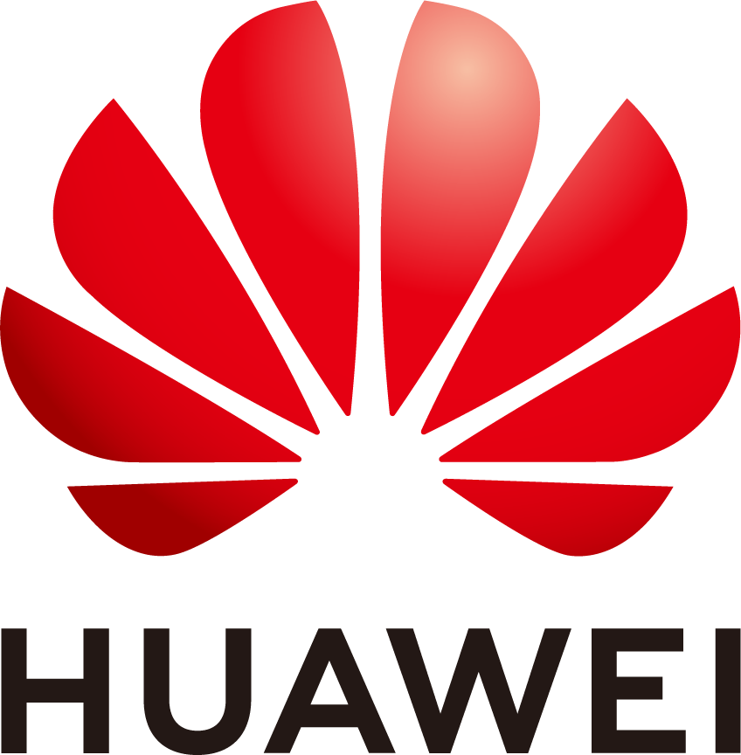

Copyright © Huawei Technologies Co., Ltd. 2026. All rights reserved.
No part of this document may be reproduced or transmitted in any form or by any means without prior written consent of Huawei Technologies Co., Ltd.

Trademarks and Permissions
and other Huawei trademarks are trademarks of Huawei Technologies Co., Ltd.
All other trademarks and trade names mentioned in this document are the property of their respective holders.

Notice
The purchased products, services and features are stipulated by the contract made between Huawei and the customer. All or part of the products, services and features described in this document may not be within the purchase scope or the usage scope. Unless otherwise specified in the contract, all statements, information, and recommendations in this document are provided "AS IS" without warranties, guarantees or representations of any kind, either express or implied.
The information in this document is subject to change without notice. Every effort has been made in the preparation of this document to ensure accuracy of the contents, but all statements, information, and recommendations in this document do not constitute a warranty of any kind, express or implied.

Huawei Technologies Co., Ltd.
Address: | Huawei Industrial Base  Bantian, Longgang  Shenzhen 518129  People's Republic of China
Website: | https://e.huawei.com

Security Declaration
Product Lifecycle
Huawei's regulations on product lifecycle are subject to the Product End of Life Policy. For details about this policy, visit the following web page:
https://support.huawei.com/ecolumnsweb/en/warranty-policy

Vulnerability
Huawei's regulations on product vulnerability management are subject to the Vul. Response Process. For details about this process, visit the following web page:
https://www.huawei.com/en/psirt/vul-response-process
For vulnerability information, enterprise customers can visit the following web page:
https://securitybulletin.huawei.com/enterprise/en/security-advisory

Initial Digital Certificate
The Initial digital certificates on Huawei devices are subject to the Rights and Responsibilities of Initial Digital Certificates on Huawei Devices. For details about this document, visit the following web page:
https://support.huawei.com/enterprise/en/bulletins-service/ENEWS2000015789

Huawei Enterprise End User License Agreement
This agreement is the end user license agreement between you (an individual, company, or any other entity) and Huawei for the use of the Huawei Software. Your use of the Huawei Software will be deemed as your acceptance of the terms mentioned in this agreement. For details about this agreement, visit the following web page:
https://e.huawei.com/en/about/eula

Lifecycle of Product Documentation
Huawei after-sales user documentation is subject to the Product Documentation Lifecycle Policy. For details about this policy, visit the following web page:
https://support.huawei.com/enterprise/en/bulletins-website/ENEWS2000017761

Contents
1 Product Highlights 1
2 Platform Access 2
2.1 Networking 2
2.2 Capability Comparison 3
3 Product Structure 6
3.1 Appearance 6
3.2 Ports and Functional Modules 9
3.3 Indicators 12
3.4 Touch 13
3.5 Controller 14
3.6 Smart Control 2.0 15
3.7 OPS 18
4 Functions and Features 24
4.1 Ultra-HD Display Resolution 24
4.2 Hi-Fi Audio 24
4.3 Intelligent Meeting 25
4.4 Smart Projection 25
4.5 Whiteboard Collaboration 28
4.6 Instant Writing with Stylus 30
4.7 Intelligent Tracking 30
4.8 Acoustic Baffle 31
4.9 Mirror & Control 33
4.10 Dual-Screen Display 33
4.11 App Multiplier 33
4.12 Multi-Window 34
4.13 Wireless Connections 34
4.14 Bulletin Board 35
4.15 HiBoard Welcome Page 35
4.16 Apps 36
4.17 Globalization 37
4.18 Operations, Administration, and Maintenance 37
4.18.1 Batch Configuration 37
4.18.2 Customizing a Startup Animation and Changing a Wallpaper 38
4.18.3 Resetting the Web Password 38
4.19 APIs for Third-Party Integration 38
4.20 Serial Port Control 38
4.21 Keeping Applications Alive in the Background 39
4.22 Developer Options 39
5 Security and Reliability 40
5.1 Operating System Security 40
5.2 Email Security 40
5.3 Web Login Security Protection 40
5.4 Protocol Anti-Attack Measures 41
5.5 Protection of Sensitive Data 41
5.6 System Management and Maintenance Security 41
5.7 Security Design 42
5.8 Secure Startup 42
6 Operations and Maintenance 43
6.1 GUIs 43
6.1.1 Touchscreen UI 43
6.1.2 Touch UI 44
6.1.3 Web Interface 44
6.1.4 IdeaShare UI 45
6.2 Maintenance and Upgrade 46
6.2.1 Log Management 46
6.2.2 Device Diagnostics 46
6.2.3 Inspection 47
6.2.4 Upgrade 47
6.2.5 User Experience Improvement Program 47
7 Technical Specifications 49
7.1 Physical Specifications 49
7.2 Performance Specifications 54
7.3 Protocol and Standards Compliance 58
7.4 HEVC Authorization 58
8 Glossary 59

Product Highlights
Built on the next-gen hardware platform with high-computing power and HarmonyOS, HUAWEI IdeaHub S3 (IdeaHub or endpoint for short) provides intelligent conferencing, Bring Your Own Meeting (BYOM), and more. It is an optimal solution for boundless collaboration and remote conferencing to fit in any room, such as the regular meeting room, executive office, and open office area.
- Used with professional-grade 4K video cameras for clear images even in long meetings
- Auto-Framing and speaker tracking supported; DNN-based dereverberation, and AEC algorithm, improving the immersive intelligent meeting experience
- Intelligent meeting: Adaptation to mainstream cloud meetings with 1080p meeting experience; BYOM — seamless transfer of your meetings
- BYOM: P2P projection at a tap without the need to configure the network; intelligent whiteboard, just like writing on paper; Multi-Window and App Multiplier for user-friendly interaction in landscape mode
- Open and standard SDKs for fast integration with enterprise office apps
- Chip-device-pipe-cloud E2E protection
Table 1-1 lists endpoint models.
                - Models
Product | IdeaHub S3
Model | - IHS3-65SA  - IHS3-75SA  - IHS3-86SA

Platform Access

Networking
SMC2.0
The IdeaHub can be connected to the SMC2.0 to meet centralized O&M management requirements.
The SMC2.0 supports unified endpoint management, including configuration delivery and automatic inspection.
SMC
The IdeaHub can be connected to the SMC to meet centralized O&M management requirements.
The SMC supports unified endpoint management, including configuration delivery, certificate management, web app management, and bulletin board management.
Huawei Cloud Meeting
Based on a public cloud architecture, Huawei Cloud Meeting provides users with HD audio and video conferencing and efficient collaboration.
Users can manage various functions of the endpoints on the platform, including configuration delivery, web app management, and bulletin board management.
IdeaManager
The IdeaManager is an integrated endpoint management solution for enterprises and provides E2E endpoint management and O&M capabilities to meet requirements in scenarios where a large number of endpoints are connected. The IdeaManager helps customers improve O&M efficiency and reduce O&M costs. By deployment mode, the IdeaManager can be classified into IdeaManager (cloud service) and IdeaManager (on-premises).

Capability Comparison
Meeting Quality
                - Meeting quality on each platform
Platform | Capability Description
SMC2.0/SMC | N/A
Huawei Cloud Meeting | - Supports HD video meetings with a resolution of up to 1080p.  - Supports multiple meeting control operations.  - Supports the following meeting layouts: presenter view, PiP view, and gallery view.  - Allows users to join a meeting from the meeting schedule with one click.  - Allows users to initiate a meeting via SiteCall with one click, and initiate multipoint or point-to-point meetings.
IdeaManager | N/A

Client Capabilities
                - Client capabilities supported by each platform
Platform | Meeting Scenario | Whiteboard Scenario | Projection Scenario
SMC2.0/SMC | The mobile phone client is not involved. | Use a browser to scan the QR code to transfer the whiteboard content. | Use the IdeaShare client for projection.
Huawei Cloud Meeting | Join a meeting by scanning the QR code using the Huawei Cloud Meeting client. | - Use a browser to scan the QR code to transfer the whiteboard content.  - Scan the QR code using the Huawei Cloud Meeting client to transfer the whiteboard content. | - Use the IdeaShare client for projection.  - Use the Huawei Cloud Meeting client for projection.
IdeaManager | The mobile phone client is not involved. | Use a browser to scan the QR code to transfer the whiteboard content. | Use the IdeaShare client for projection.

Access Modes
                - Platform access modes
Platform | Access Mode
SMC2.0 | Connect to the platform by adding manageable participants or predefined participants.
SMC | Manually enter the activation code to access the platform.
Huawei Cloud Meeting | Manually enter the activation code or scan the QR code to access the platform.
IdeaManager | - IdeaManager (cloud service): Manually enter the access code or scan the QR code to access the platform.  - IdeaManager (on-premises): Manually enter the access code to access the platform.

Product Structure

Appearance
Front View
              - Front view of the endpoint
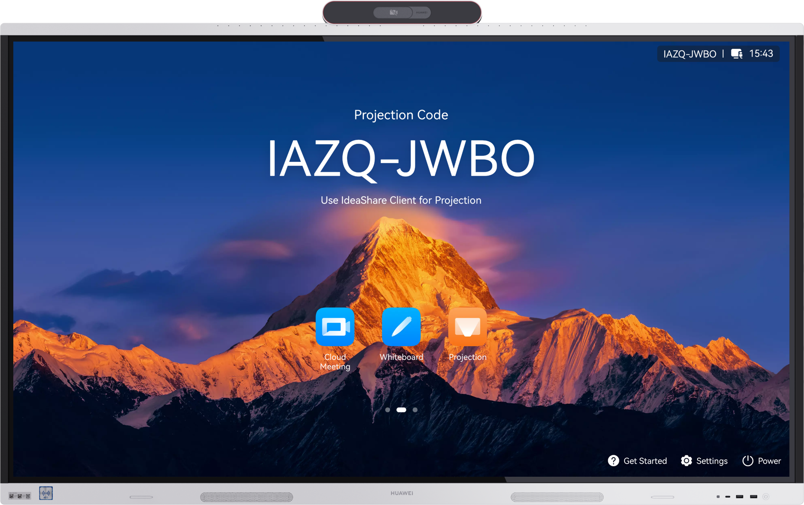

              - Modules in the front view of the endpoint
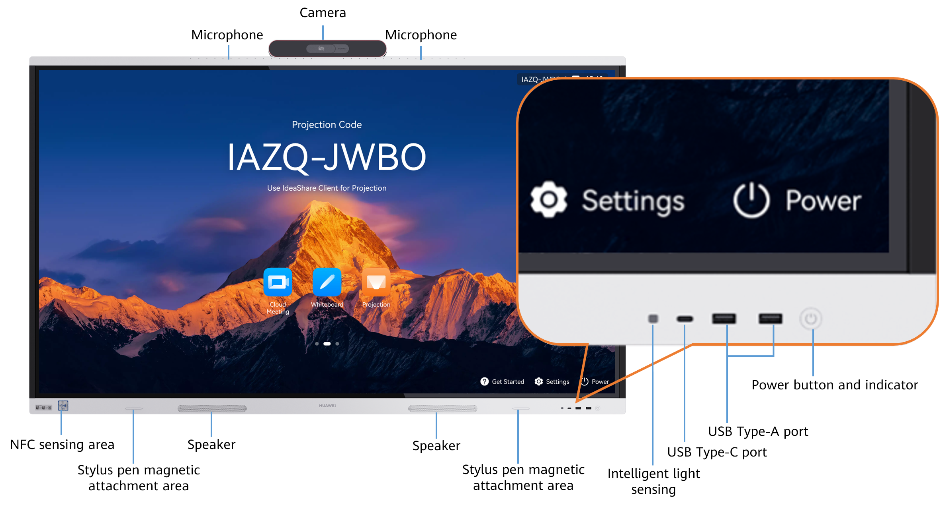

Rear View
              - Rear view of the 65-inch endpoint
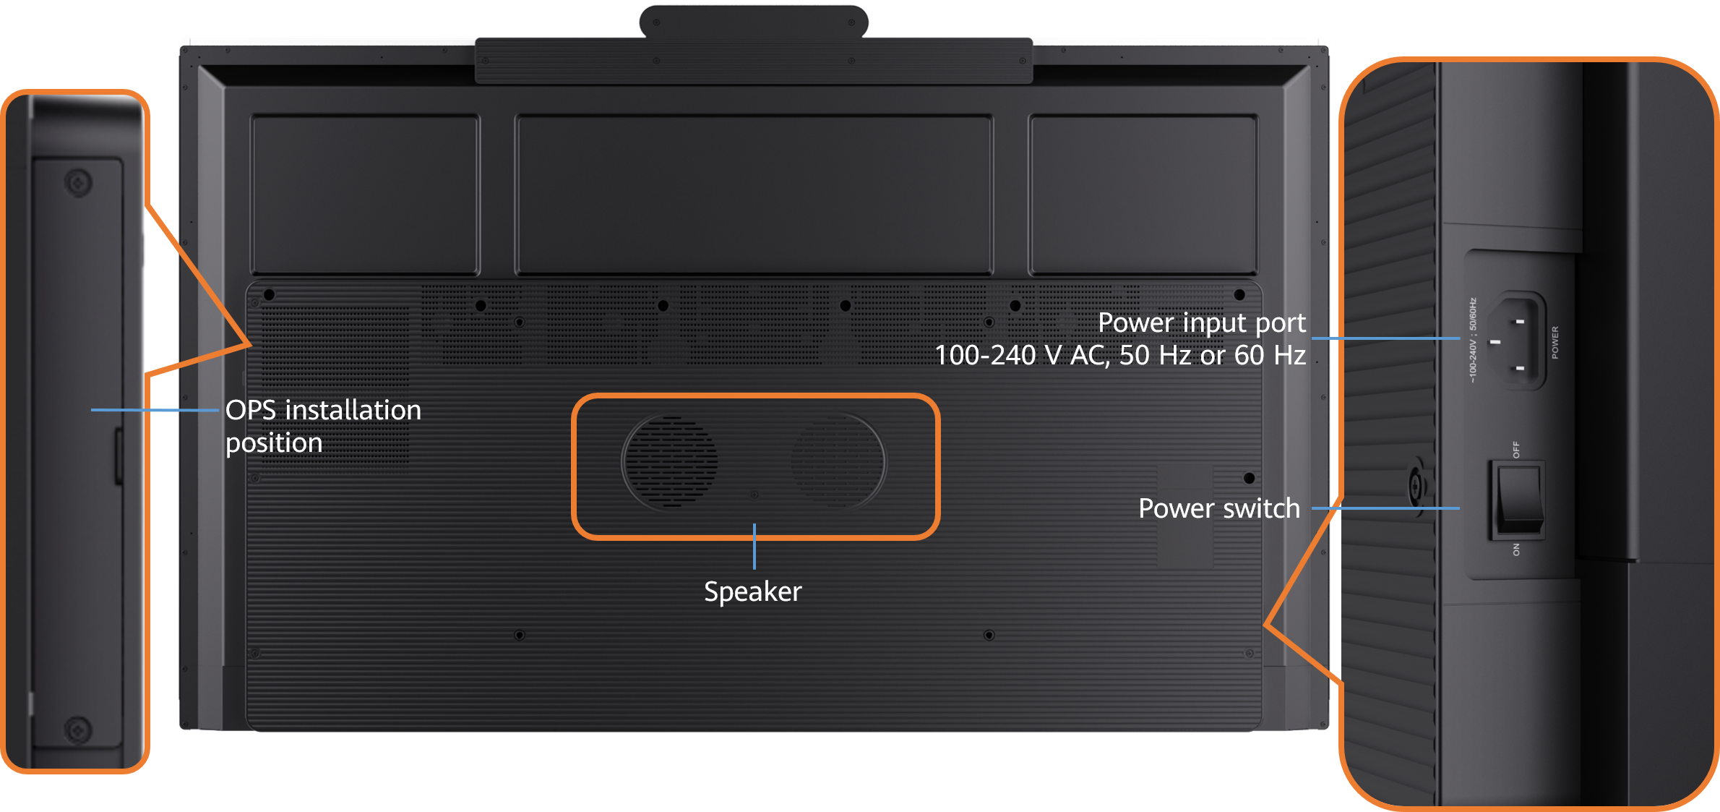

              - Rear view of the 75-inch endpoint
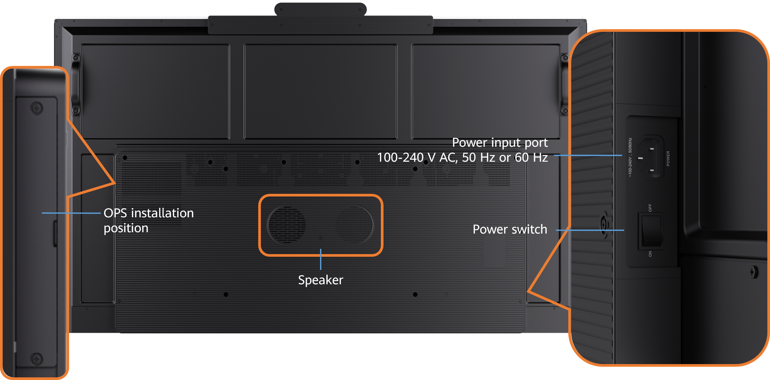

              - Rear view of the 86-inch endpoint
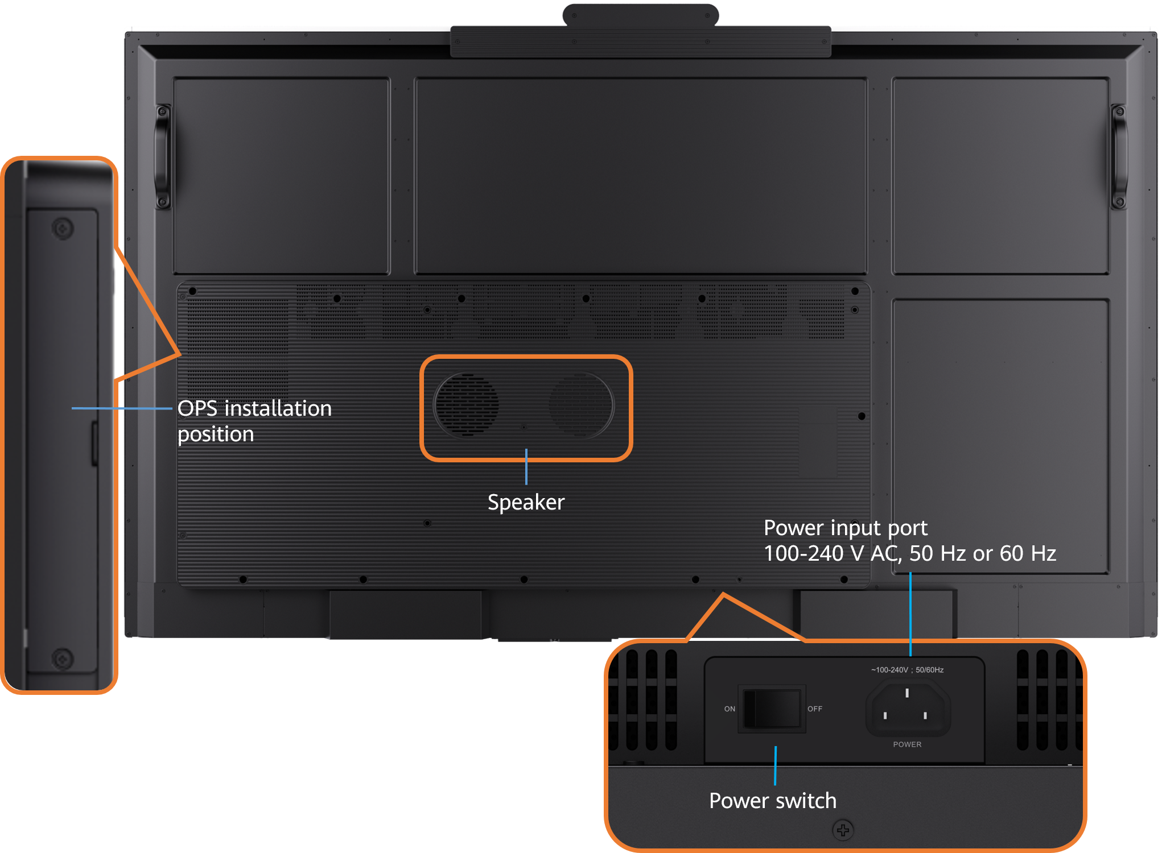

Ports and Functional Modules
              - Ports and functional modules
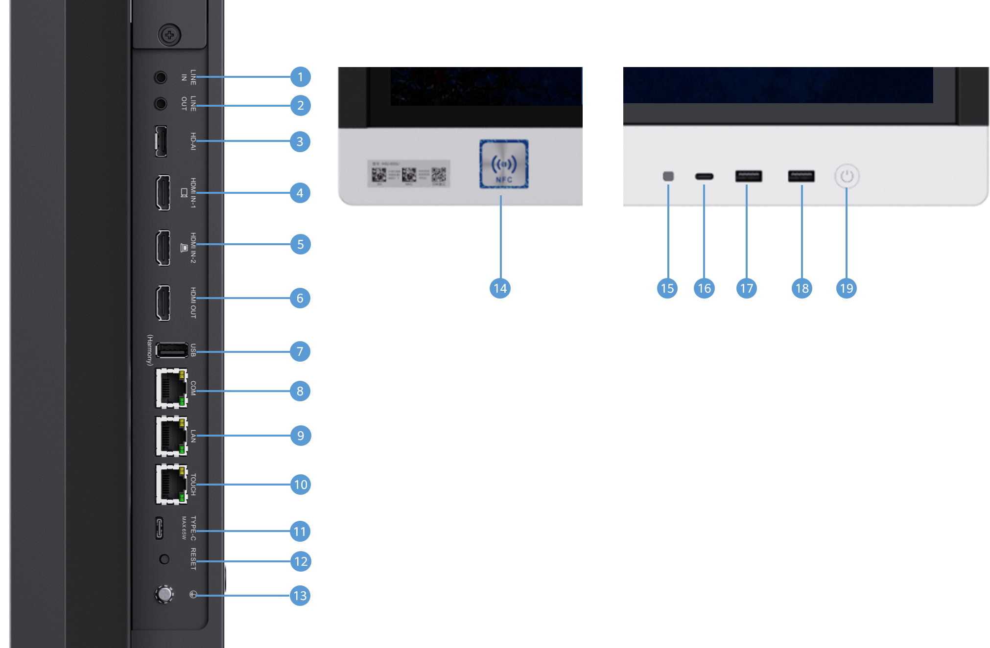

                - Description of ports and functional modules
Category | No. | Port Description | Function
Audio input port | 1 | 3.5 mm audio input port | Connects to an audio input source such as a computer.
Audio output port | 2 | 3.5 mm audio output port | Connects to an audio output device, such as an external speaker.
Audio input port | 3 | HD-AI audio input port | - Connects to a VPM220 or Mic 500 microphone array. Up to two microphones can be cascaded.  - Provides power for the microphone array.
Video input port | 4 | HDMI video input port, which supports audio input | Connects to an HDMI input device, which can be used as the video source or presentation source.
Video input port | 5 | HDMI video input port, which supports audio input | Connects to an HDMI input device, which can be used as the presentation source.  NOTE  This port cannot be used together with the OPS and USB Type-C port connecting to a presentation source.
Video output port | 6 | HDMI video output port, which supports audio output | Connects to the second extended display.
USB port | 7 | USB 3.0 Type-A port | Supports the following USB devices (applicable to non-OPS scenarios): IdeaShare Key (Type-A), USB flash drive, keyboard, mouse, Controller receiver, microphone, speaker, and camera.
Other ports | 8 | COM port | Connects to a serial cable to remotely manage the endpoint or connects to a camera control cable to control an external HDMI camera.
Other ports | 9 | Ethernet port (10/100/1000 Mbit/s, full-duplex and half-duplex supported) | Used for external services.
Other ports | 10 | TOUCH port | Connects the endpoint to the Touch.
USB port | 11 | USB 2.0 Type-C port | - Connects to a presentation source such as a computer or mobile device for projection sharing or reversely controls the computer or mobile device.  - Connects to an IdeaShare Key (Type-C) for pairing or upgrade.  - Supports the following USB devices: USB flash drive, microphone, speaker, and camera.  - Supports the PD 3.0 fast charging protocol and up to 65 W fast charging.  NOTE  When connecting to a presentation source, this port cannot be used together with the HDMI IN-2 port, front USB Type-C port, or OPS.
Button | 12 | RESET button | - During startup, press and hold this button for 3 to 5 seconds to enter eRecovery mode.  - When the endpoint is running, press and hold the button for 13s to reset it to factory settings.
Other ports | 13 | Ground point | Connects to the ground cable to provide ground protection for the endpoint.
Functional module | 14 | NFC sensor area | Used for pairing your endpoint with your phone in the NFC OneHop projection scenario.
Functional module | 15 | Intelligent light sensing | Intelligently adjusts the screen brightness based on the ambient light illuminance.
USB port | 16 | USB 2.0 Type-C port | - Connects to a computer or a mobile device for projection sharing or reversely controls the computer or mobile device during projection sharing.  - Connects to an IdeaShare Key (Type-C) for pairing or upgrade.  - Supports the following USB devices: USB flash drive, microphone, speaker, and camera.  NOTE  When connecting to a presentation source, this port cannot be used together with the HDMI IN-2 port, USB Type-C port on the side panel, or OPS.
USB port | 17 | USB 3.0 Type-A port | Supports the following USB devices: IdeaShare Key (Type-A), USB flash drive, Controller receiver, keyboard, mouse, microphone, speaker, and camera.
USB port | 18 | USB 3.0 Type-A port | Supports the following USB devices: IdeaShare Key (Type-A), USB flash drive, Controller receiver, keyboard, mouse, microphone, speaker, and camera.
Button | 19 | Power button and indicator | - You can put the endpoint into sleep mode or wake it up by pressing the power button.  - You can power on the endpoint after soft shutdown by pressing the power button.  - You can press and hold the power button for 3 seconds to display the power menu.  - The indicator indicates the endpoint running status.

Indicators
By checking the indicator status, you can learn about the running status of the endpoint in a timely manner and ensure the normal running of it and its peripheral devices. Table 3-2 describes the indicator status.
                - Indicator status information
Indicator Status | Endpoint Status
Off | Powered off
Blinking green twice per second | Powering on
Blinking green four times per second | Upgrading
Steady green | Working properly
Breathing green (gradually lighting, then dimming) | Sleep
Blinking red once every 5s | Faulty hardware
Blinking red twice every 5s | Overheated
Blinking red once per second | Touchscreen abnormal
Blinking red twice per second | IP address conflict
Blinking red four times per second | Faulty software

Touch
As an optional device of the IdeaHub, the Touch features an intuitive graphical touchscreen UI. This allows you to effortlessly control calls and conferences by simply tapping icons.
              - Front and rear appearances of the Touch
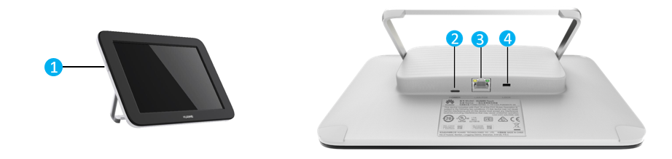


While there are different Touch models, their software functionalities are identical. The only distinctions are the screen size and the power button's location. The power button might be on the left, right, or top bezel of the screen, so please refer to the actual device for its precise position.
                - Component description
No. | Component | Function
1 | Power button | Press to put the Touch in sleep mode or wake it up. Press and hold to turn the Touch on or off.
2 | Type-C port | Connects to the power adapter using a Type-C cable to supply power to the Touch. You need to buy your own Type-C cable and a 5 V power adapter. The power adapter must have the China Compulsory Certification (CCC) and an output current of at least 2 A.
3 | PoE port | - Connects to the PoE port on the PoE adapter using the Touch network cable. The Touch is powered through the PoE adapter and connects to the IdeaHub through Wi-Fi.  - Connects to the PoE port on the PoE adapter using the Touch network cable. The Touch is powered through the PoE adapter. The DATA port on the PoE adapter connects to the network where the IdeaHub is located.
4 | Kensington security slot | Connects to a Kensington lock to secure the Touch. The Kensington lock should be prepared separately.

To learn more, see the Touch Quick Start Guide delivered with the Touch.

Controller
You can configure the Controller and Controller receiver for the endpoint. The Controller can be used to perform routine operations on multiple types of endpoints and provide convenient control functions.
              - Controller and receiver
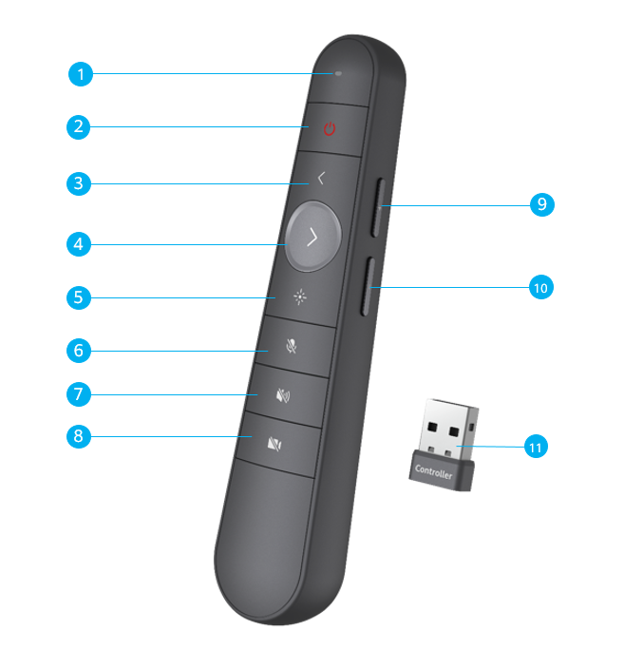

                - Functions of the Controller and receiver
No. | Function and Name | Description
1 | Indicator | Displays the working status of the Controller.
2 | Sleep/Wake up | After you press this button, the endpoint enters or wakes up from the sleep mode.
3 | Turn to the previous page | Go back to the previous page on the whiteboard and in presentations and documents.
4 | Turn to the next page | Turn to the next page on the whiteboard and in presentations and documents.
5 | Laser pointer | Press and hold the button to move the laser pointer icon, and press the button to perform the tap operation.
6 | Mute/Unmute the microphone | Press the button to mute or unmute the microphone.
7 | Mute/Unmute the speaker | Press the button to mute or unmute the speaker.
8 | Enable/Disable the camera | Press the button to turn on or off the camera.
9 | Increase the volume | Press or hold the button to increase the volume.
10 | Decrease the volume | Press or hold the button to decrease the volume.
11 | Controller receiver | Insert the Controller receiver into the USB Type-A port at the lower right corner of the front screen to receive signals from the Controller.

Smart Control 2.0
You can configure Smart Control 2.0 for the endpoint. Smart Control 2.0 features a minimalist design and comfortable grip. You can use its keys to perform routine operations on the endpoint. In addition, Smart Control 2.0 supports the pointing interaction function, which allows you to perform operations such as pressing, sliding, marking, and dragging, providing efficient and convenient control functions.
              - Appearance of Smart Control 2.0
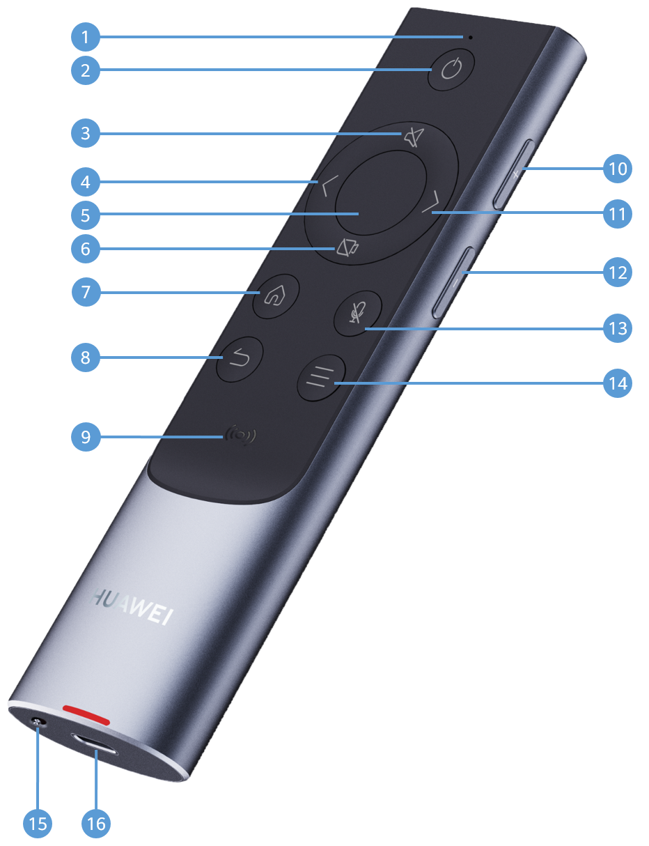

                - Smart Control 2.0 functions
No. | Function and Name | Description
1 | Indicator | Displays the working status of Smart Control 2.0.
2 | Sleep/Wake up | Press the key to put the endpoint into sleep mode or wake up the endpoint.
3 | Mute/Unmute the speaker | Press the key to mute or unmute the speaker.
4 | Previous | Go back to the previous page on the whiteboard and in presentations and documents.
5 | Confirm | - Press to confirm the current operation.  - After the pointing function is enabled, you can press and hold the confirm key on the whiteboard screen to crop or write on the annotation background.  - After the pointing function is enabled, you can press and hold the confirm key to drag the floating window.  - After the pointing function is enabled, you can press the confirm key to slide up, down, left, or right.
6 | Enable/Disable the camera | Press the key to turn on or off the camera.
7 | Display the home screen | Press the key to return to the home screen of the endpoint.
8 | Back | Press the key to return to the previous screen.
9 | NFC sensor area | Place your Huawei phone close to the NFC sensor area of the Smart Control 2.0 to trigger pairing. Then you can project your phone screen to the endpoint.
10 | Increase the volume | Press or hold the key to increase the volume.
11 | Next | Turn to the next page on the whiteboard and in presentations and documents.
12 | Decrease the volume | Press or hold the key to decrease the volume.
13 | Mute/Unmute the microphone | Press the key to mute or unmute the microphone.
14 | Open/Close the sidebar | Press the key to open or close the sidebar.
15 | Pointing switch | Enable or disable the pointing function of the Smart Control 2.0.
16 | Type-C charging port | Use this port to charge the Smart Control 2.0.

OPS
The Open Pluggable Specification (OPS) is optional for endpoints. After an OPS is configured, endpoints can run the Windows OS in the OPS to install and run third-party software.
When third-party meeting software is used to hold a meeting in the OPS scenario, the microphone, speaker, and camera of the IdeaHub can be used. In addition, AI functions such as intelligent tracking and voice tracking are supported.
- The OPS must match the product.
- Functions of different third-party meeting apps may vary in the OPS scenario.
Appearance
                - Main appearance differences of OPSs
OPS Name & Code | Main Modules on the Front Panel | Appearance
- ICD OPS i5 D (06190009)  - ICD OPS i7 D (06190010)  - ICD OPS i7 Z (06190011)  - OPS W021 Z (06190037)  - OPS W022 Z (06190034)  - OPS W021 D (06190041)  - OPS W022 D (06190040)  - OPS W021 Z (06190054)  - OPS W022 Z (06190053) | Ports:  - 1 x RJ45 network port  - 1 x DP display port  NOTE  Only the ICD OPS i5 D, ICD OPS i7 D, ICD OPS i7 Z, OPS W021 Z, and OPS W022 Z are involved.  - 1 x HDMI display port  - 1 x LINE IN microphone jack  - 1 x LINE OUT audio output port  - 2 x Wi-Fi antenna port  - Type-A port  NOTE  - The ICD OPS i5 D, ICD OPS i7 D, ICD OPS i7 Z, OPS W021 Z (06190037), and OPS W022 Z (06190034) include three USB 2.0 Type-A ports and three USB 3.0 Type-A ports.  - The OPS W021 D and OPS W022 D include three USB 2.0 Type-A ports and three USB 3.2 Type-A ports.  - The OPS W021 Z (06190054) and OPS W022 Z (06190053) include two USB 2.0 Type-A ports and four USB 3.0 Type-A ports.  - 1 x USB 3.0 Type-C port  NOTE  Only the OPS W021 Z (06190054) and OPS W022 Z (06190053) are involved.  Buttons:  - 1 x Power button  - 1 x One-click restoration button  - 1 x Restart button  NOTE  Only the OPS W021 Z (06190037) and OPS W022 Z (06190034) are involved.  Indicators:  - 1 x Power-on indicator (green)  - 1 x Power indicator (red)  - 1 x Disk indicator (yellow)  Others:  1 x Security lock hole | Figure 3-10  Figure 3-11  Figure 3-12  Figure 3-13  Figure 3-14

              - Appearance of the ICD OPS i5 D or ICD OPS i7 D
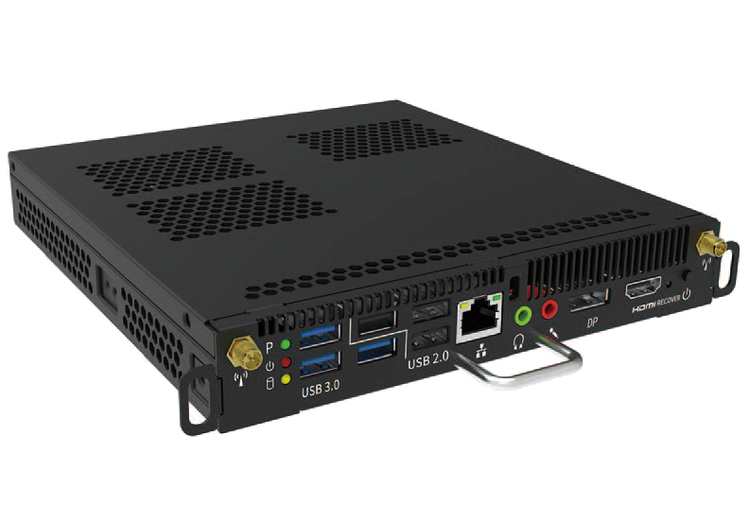

              - Appearance of the ICD OPS i7 Z
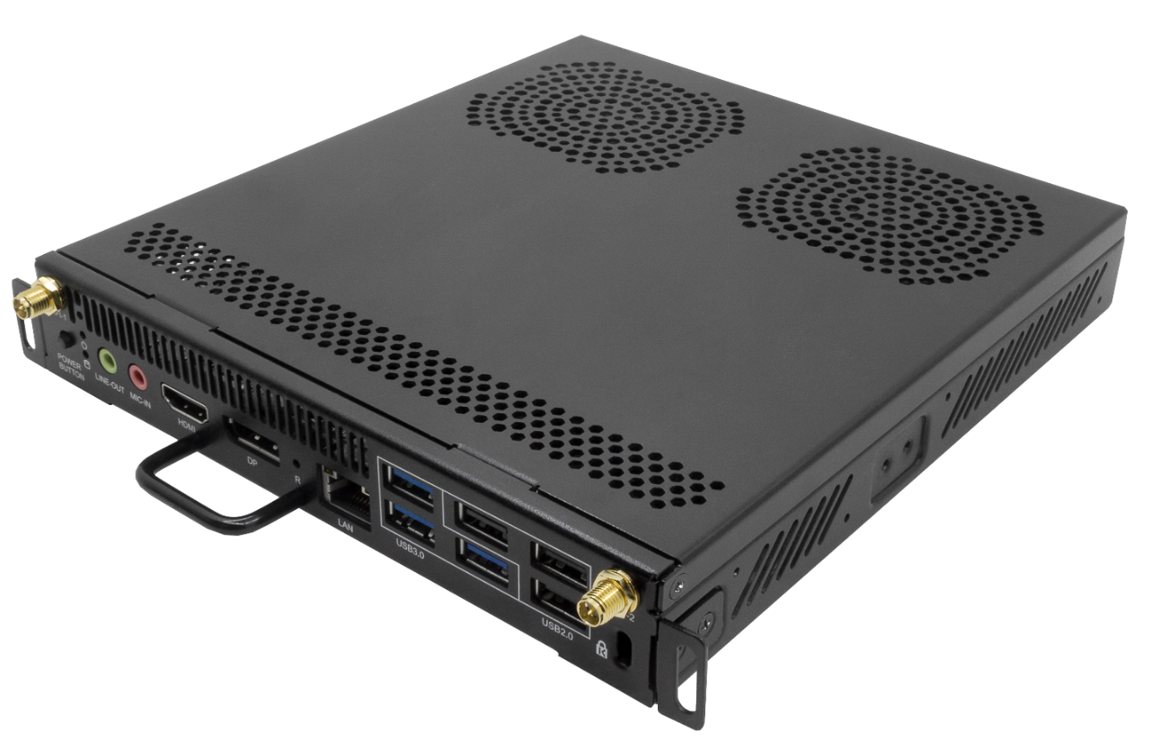

              - Appearance of the OPS W021 Z (06190037) or OPS W022 Z (06190034)
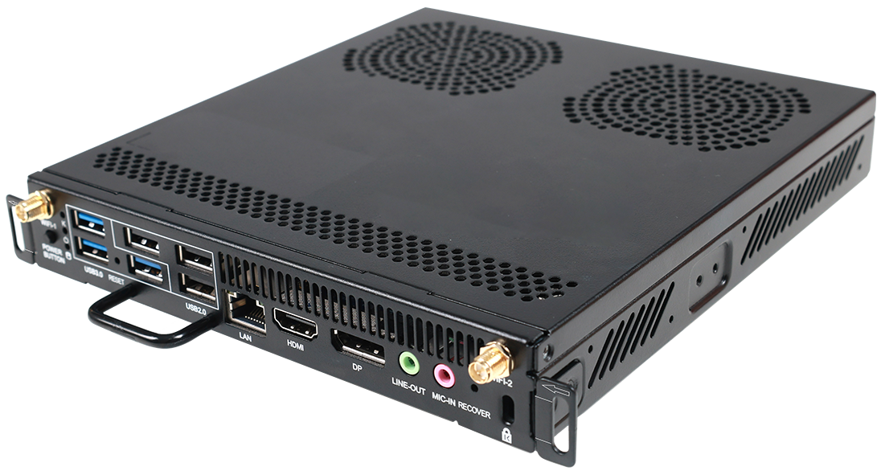

              - Appearance of the OPS W021 D or OPS W022 D
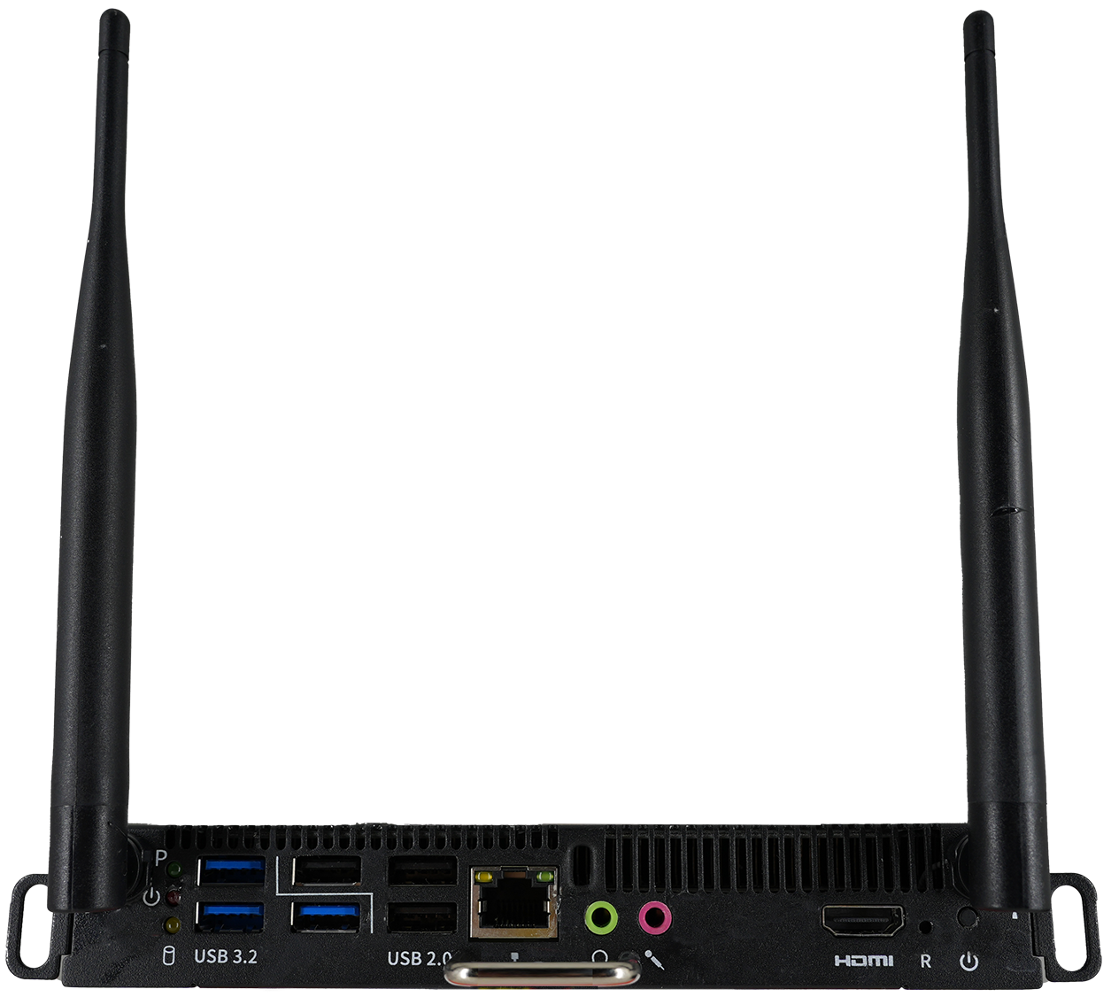

              - Appearance of the OPS W021 Z (06190054) or OPS W022 Z (06190053)
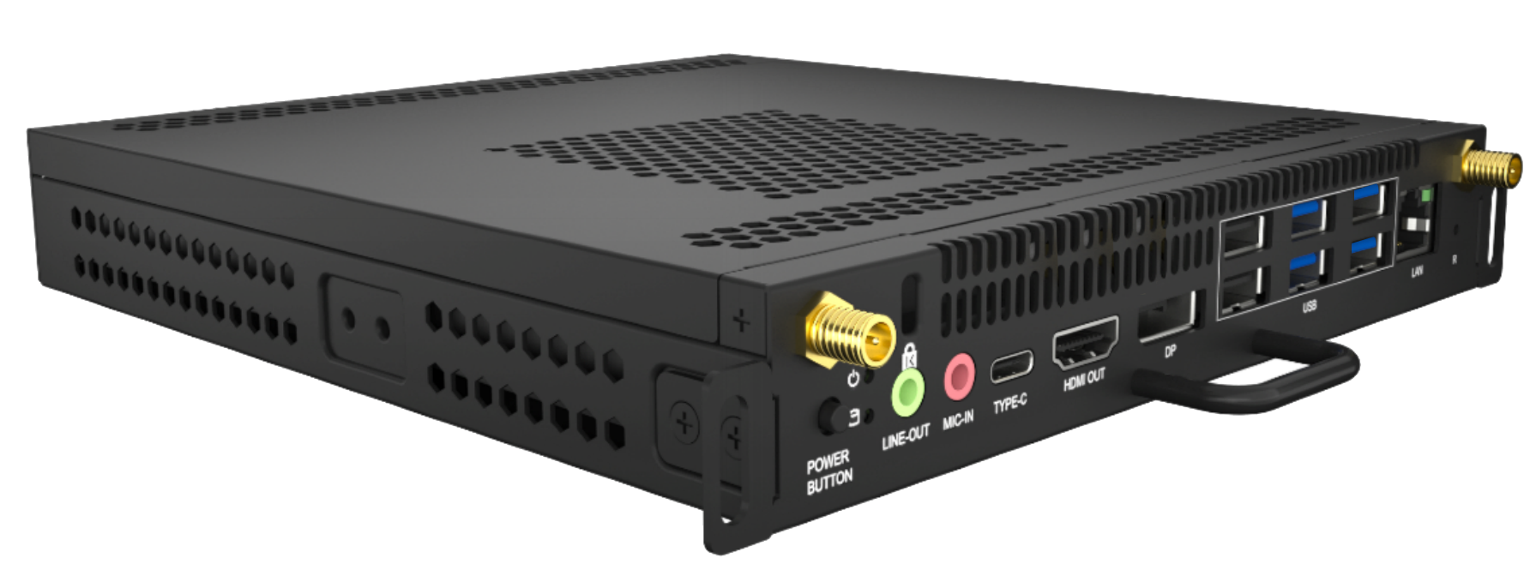

Installation Position
As an embedded computer module, the OPS can be easily installed or removed simply using a screwdriver.
- Endpoints of different sizes differ slightly in appearance, but their installation methods are similar. The following uses one endpoint as an example.
- When installing or removing an OPS, ensure that the endpoint is powered off. Otherwise, the OPS may be abnormal.
              - OPS installation position
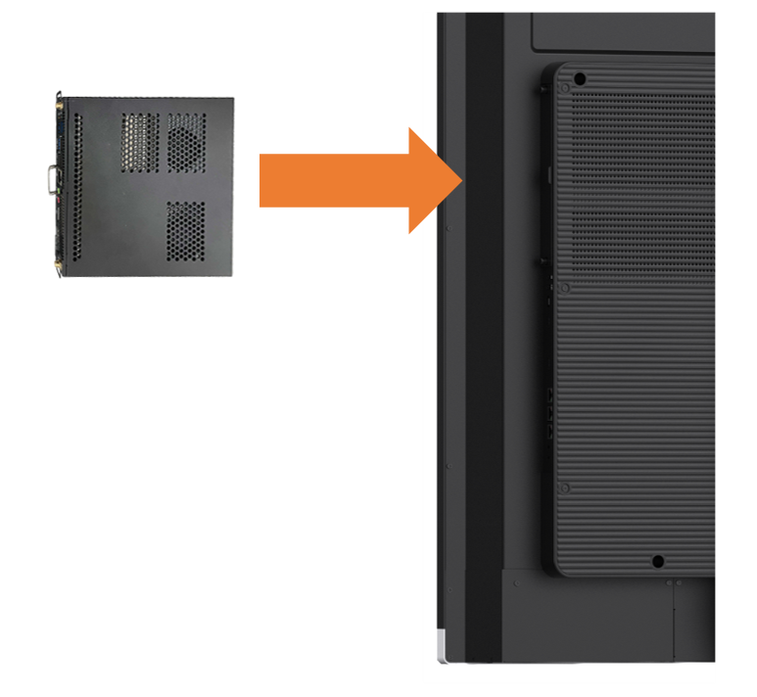

Functions and Features

Ultra-HD Display Resolution
The IdeaHub supports a resolution of 4K 60 fps. 4K delivers four times the resolution of 1080p screens, giving incredible clarity and lifelike detail to images on a larger screen.
              - 4K ultra-HD video
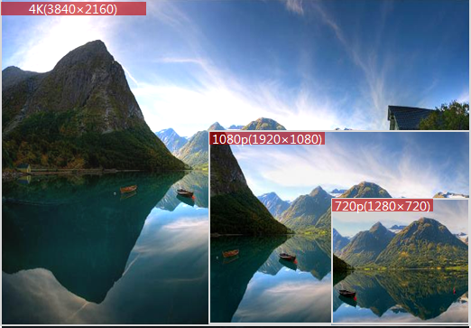

Hi-Fi Audio
- Supports Acoustic Echo Cancellation (AEC), Automatic Noise Suppression (ANS), and Automatic Gain Control (AGC), as well as VoiceClear, AudioEnhancer, reverberation suppression, and lip synchronization.
- Supports Opus, Forward Error Correction (FEC), Backward Error Correction (BEC), Packet Loss Concealment (PLC), Net Automatic Transfer-Enhancement (netATE), and Audio Jitter Buffer (AJB).
- Leverages the built-in microphone for the clear, crisp audio, and supports an external microphone for extending pickup distance.
- Based on the installation mode of the large screen, you can select the corresponding configuration item on the touchscreen or web interface. For example, you can select Standard (floor stand-mounted), Wall-mounted, or Wall-recessed to achieve better audio and video effects.

Intelligent Meeting
Adapting to Cloud Meetings
The IdeaHub adapts to the Huawei Cloud Meeting SmartRooms, Tencent Meeting Rooms, and Lark Meetings. Cloud meetings support HD video meetings with a resolution of up to 1080p.
BYOM
The IdeaHub can be connected to mobile devices, computers, or OPS modules. After the connection, the camera, microphone, speaker, and screen of the IdeaHub can be used by the mobile devices, computers, or OPS modules. When you use a computer to project content or use an OPS module and invoke the BYOM capability of the large screen, you can use the image enhancement function to improve the video definition on the large screen.
Participants can enjoy a wide field of view and long-distance sound pickup in professional meeting rooms. More participants at the local site can participate in efficient discussions; the video and audio played at the remote site is clear.

Smart Projection
The IdeaHub supports wired and wireless projection modes. Both modes provide basically the same functions. You can use either of the two modes based on your needs to easily share audio files, videos, images, and other files on your mobile device or PC. In addition, the IdeaHub supports reverse control and annotation, making projection and information interaction simple and efficient.
Wired Projection
The IdeaHub can be connected to a computer using an HDMI cable or USB Type-C cable to share the computer desktop. The IdeaHub supports plug-and-share. After performing wired projection using a Type-C cable, the computer can directly use the camera, microphone, and speaker of the IdeaHub. In addition, the IdeaHub allows mobile devices to perform projection using a USB Type-C cable.
Wireless Projection
Wireless projection frees you from complex cable connections and allows you to easily share your computer and mobile device screens.
- With Huawei Cloud Meeting and IdeaShare mobile clients, you can share your mobile device screen.
- With Huawei Cloud Meeting and IdeaShare Windows/macOS PC clients, you can share your PC desktop.
- With the IdeaShare Android/HarmonyOS/Windows client, the Wi-Fi P2P connection mode is supported. Projection can be started even if the mobile device and IdeaHub are not on the same network.
- The IdeaShare client supports ultrasonic projection. That is, when the client and endpoint are on the same network, the client can discover nearby endpoints through ultrasonic waves, implementing projection without the need to enter the projection code.
- Simply insert the IdeaShare Key into the IdeaHub for pairing and then into your computer to easily share your desktop with the IdeaHub.
- When using the IdeaShare client or the IdeaShare Key (Type-C) on a Windows or macOS computer, the screen extension feature is supported, allowing the extended screen to be shared to the endpoint.
- A maximum of nine clients or IdeaShare Keys (Type-C) can be used to share content of up to nine devices to one endpoint at the same time. A maximum of six IdeaShare Keys (Type-C) can be connected at the same time.
- With the IdeaShare Windows client or IdeaShare Key (Type-C), which supports BYOM, the camera, microphone, and speaker of the IdeaHub can be used as virtual peripherals for third-party meeting software installed on computers.
- On the large screen and devices with host rights, you can manage screen sharing permissions for the client and IdeaShare Key.
              - IdeaShare Key (Type-A)
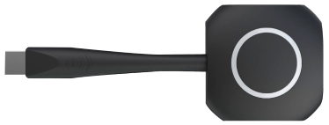

              - IdeaShare Key (Type-C)
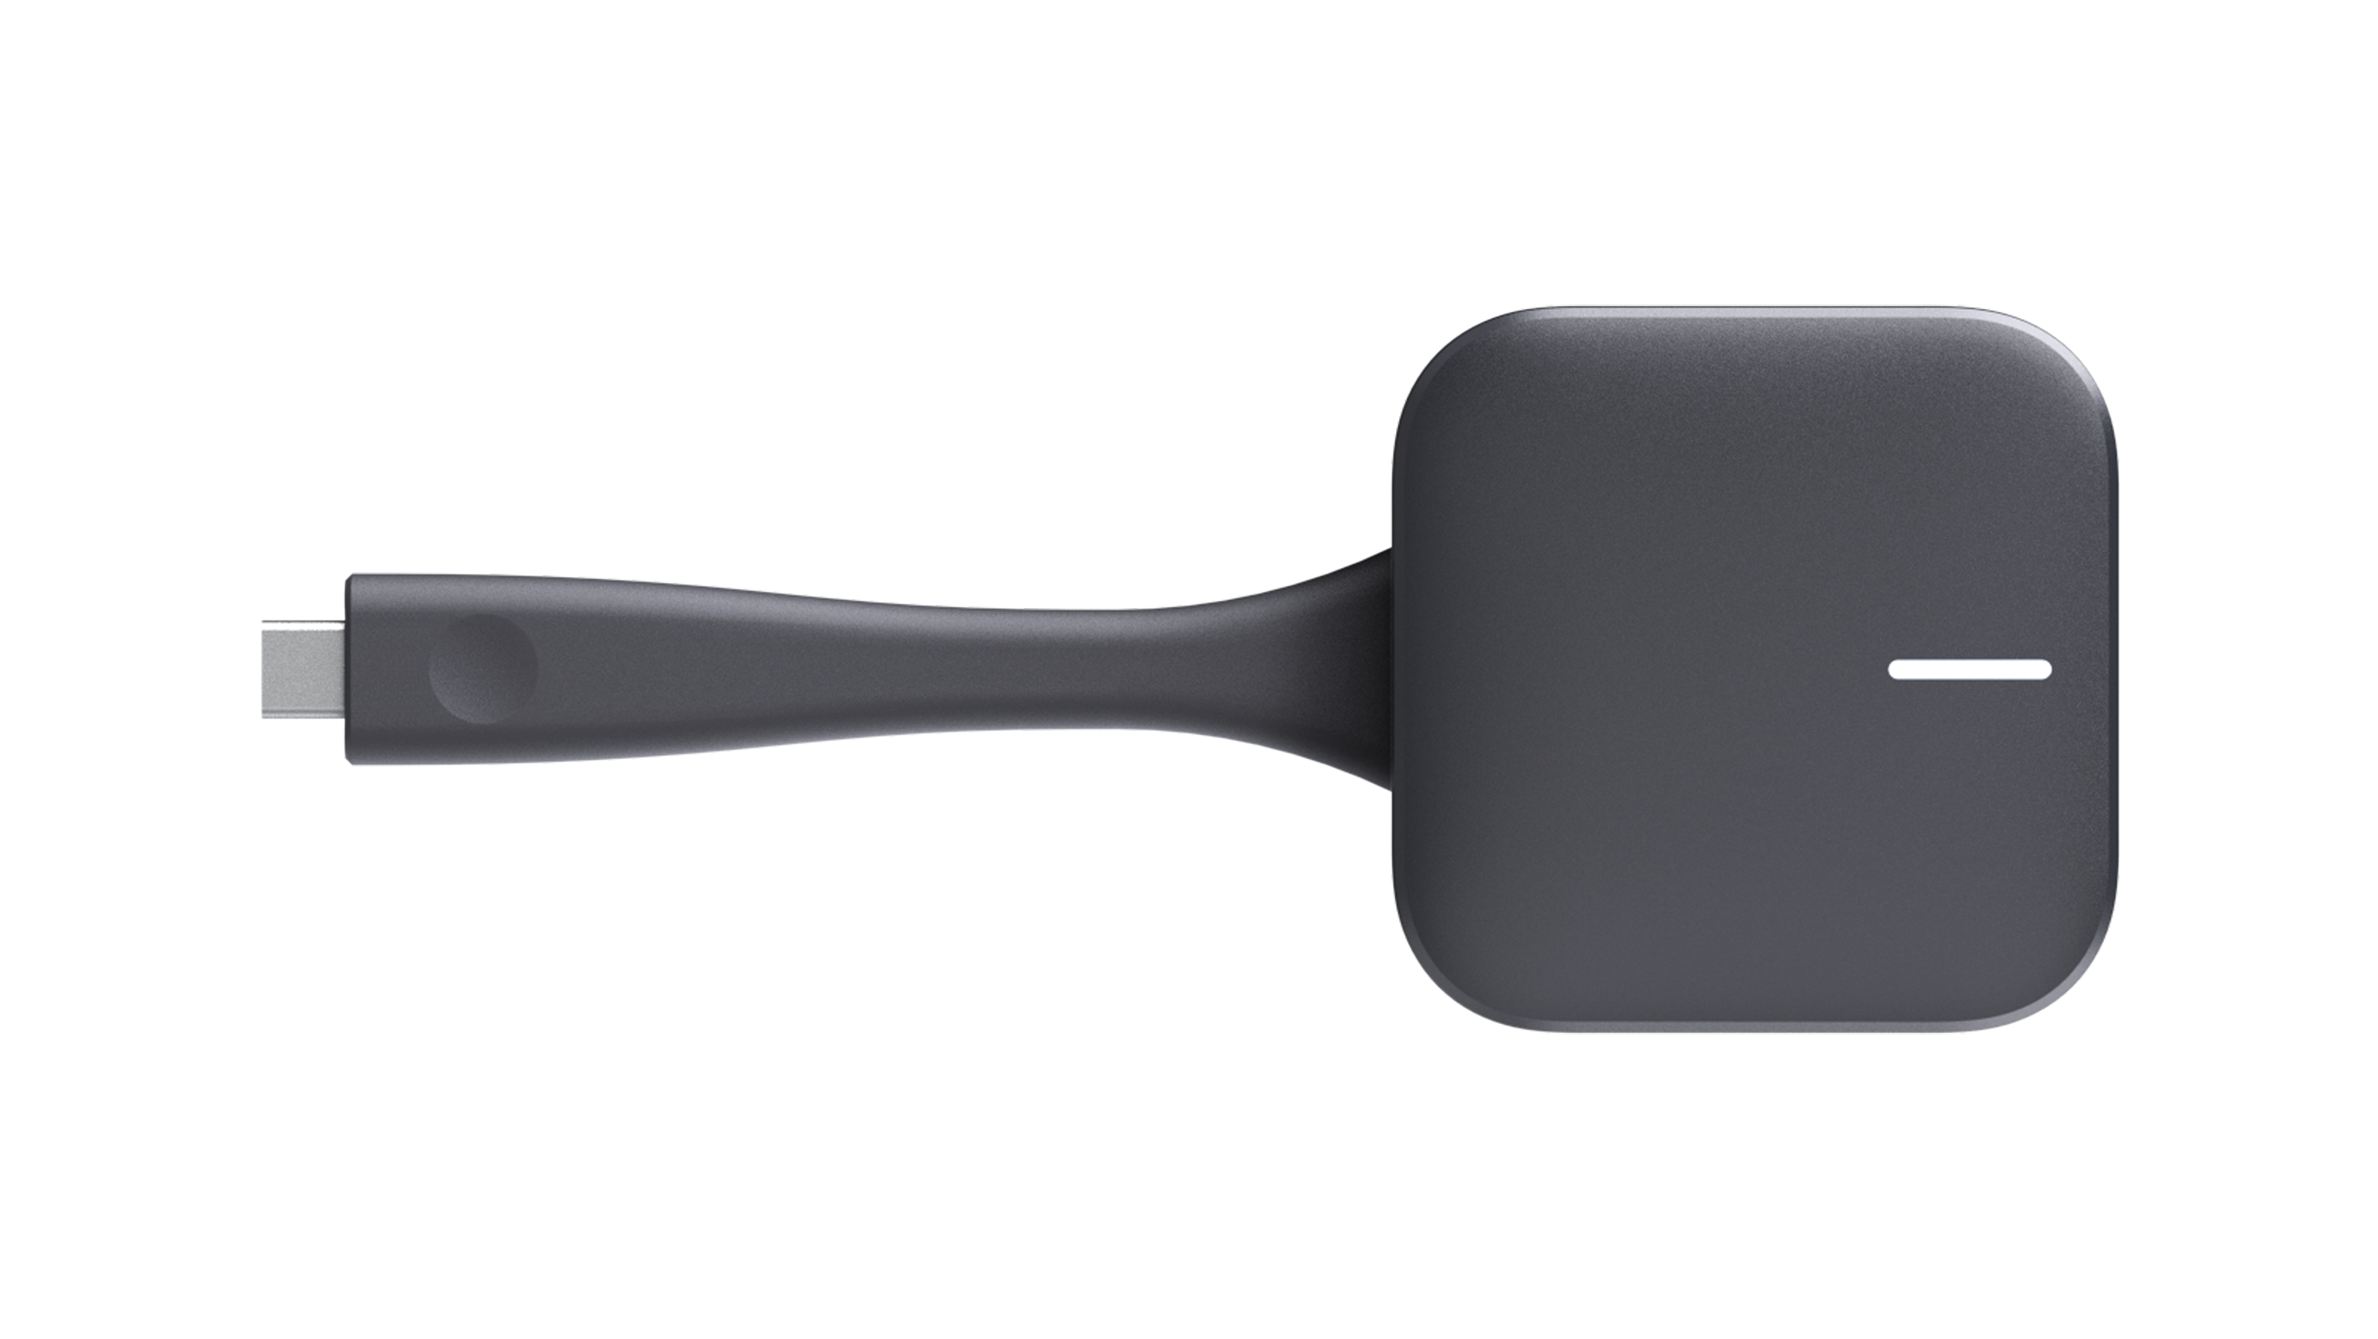

DLNA Projection
If a third-party audio or video app supports DLNA-based projection, you can project images, music, or videos to the IdeaHub via this app.
Cast+ Wireless Projection
You can use the wireless projection function on the control center of your Huawei phone to quickly project your phone screen to the IdeaHub, without the need to connect cables.
Projection with Miracast
Android phones or Windows computers that support Miracast projection can use the wireless projection function to quickly project content from your phone or computer to the IdeaHub. Your device does not need to be on the same LAN as the endpoint.
NFC OneHop Projection
Enable NFC on your Huawei phone, and place your phone close to the NFC sensor area of the IdeaHub to trigger pairing. Then you can project your phone screen to the IdeaHub.
Reverse Control
The IdeaHub allows you to reversely control the computer desktop from the touchscreen by performing tap, drag, and double-tap operations on the touchscreen. When a PowerPoint presentation is in slide show mode on the computer, you can change slides or end the show using the touchscreen.

Whiteboard Collaboration
The IdeaHub's built-in whiteboard features ultra-low writing latency and smooth writing. The whiteboard provides multiple writing modes and mistouch prevention to meet the requirements of daily office and education writing scenarios. Whiteboard content can be easily saved and transferred through multiple methods. Users can choose a method as they like.
                - Whiteboard collaboration functions
Function | Description
Creating a whiteboard | Create a maximum of 100 whiteboard pages and set their background color to white, gray, or dark green.
Writing on a whiteboard | - Write with your finger or a stylus pen.  - Support a handwriting effect for a fountain pen.  - Support writing with up to ten fingers at the same time.  - Support intelligent writing recognition of shapes and texts.  - Select, move, zoom in, zoom out, delete, and edit shapes and texts, or cancel the preceding operations.  - Support writing in the highlighter effect.  - Support adjustment of line thickness for handwriting (in fountain pen, pencil, and highlighter effects).  - Insert shapes such as triangles, quadrilaterals, and circles.  - Insert images.  - Insert content from the favorites.  - Use the intelligent search function in the whiteboard app and insert the search results into the whiteboard. These functions are available only after an endpoint is connected to the IdeaManager (cloud service) and a large model is configured on the IdeaManager (cloud service).
Operating a whiteboard | - Perform operations such as zooming in, zooming out, erasing, and dragging the canvas by using your finger.  - Circle an area. You can move, zoom in/out on, copy, paste, or delete the selected content, add it to favorites, or change the color in the circled area.  - Support precise erasing and full screen clearing.  - Erase only highlighter strokes.  - Crop a single image.
Saving a whiteboard | - Save the whiteboard to a local directory.  - Save the whiteboard to a USB flash drive.  - Transfer the whiteboard content via emails on condition that email accounts have been configured.  - Scan the QR code with the Huawei Cloud Meeting client to save the whiteboard content.  - Save whiteboard content to a configured third-party server by scanning the QR code.  - Save content by scanning the QR code through the browser.  - Share whiteboard files to third-party apps.
Closing a whiteboard | Before closing a whiteboard, you can choose whether to save the whiteboard content.
Deleting a whiteboard | Delete whiteboard pages or files.
Opening a whiteboard | - Open a whiteboard from a local directory.  - Open a whiteboard in a USB flash drive.  - Scan the QR code with the Huawei Cloud Meeting client to open the whiteboard.
Sharing a whiteboard | - Support whiteboard sharing during meetings.  - Support collaboration on the whiteboard shared between local and remote sites in a data meeting.
Annotation | - Annotate on local apps.  - Allow annotations to be projected.  - Support cross-screen annotation when a PPT file is played in full screen on the IdeaShare Windows client.  - Support global annotation.  - Save annotations to a local directory of the endpoint.  - Open annotation files from a local directory of the endpoint.  - Send annotated content via email.  - Share annotations in a meeting.  - Support collaboration on annotations shared between local and remote sites in a data meeting.  - Add content on one split screen to the other, which is the whiteboard, as an image using the annotation function.  - Touch and hold the annotation background to enter the editing state and crop the annotation background.

Instant Writing with Stylus
With Instant Writing with Stylus enabled on the IdeaHub, you can use a new-gen stylus to write on the screen for annotation. When dynamic annotation is enabled, the dynamic display of the screen content is not affected during annotation.
After the writing is complete, the content can be imported to the whiteboard, saved, transferred by QR code scanning, sent by email, or shared to a third-party app.

Intelligent Tracking
Auto-Framing
A dual-lens camera consisting of a wide-angle lens and a telephoto lens is used to perform panoramic photography, and the endpoint automatically adjusts its camera based on the number and position of participants, in order to ensure the optimal panoramic view.
              - Auto-Framing
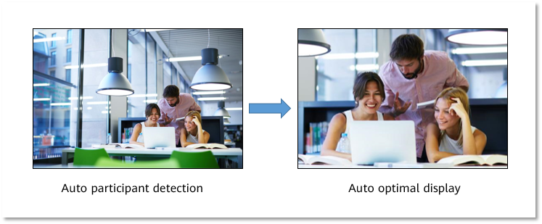

Only the inner camera supports Auto-Framing.
Voice Tracking
The IdeaHub uses voice tracking and face detection algorithms to detect and locate the sound source. Using this information, it automatically displays a close-up image of the speaker.
Voice tracking is applicable to two-person conversations. When two persons speak in turn (such as A-B-A mode), the large screen will trigger a conversation mode and display the speakers in one or two panes based on their distance.
Only the inner camera and microphone support voice tracking.
Auto-Crop View
The IdeaHub supports the auto-crop view function, in which the video layout is adjusted based on the number and position of participants to ensure that each participant is displayed in the optimal view.
              - Auto-crop view
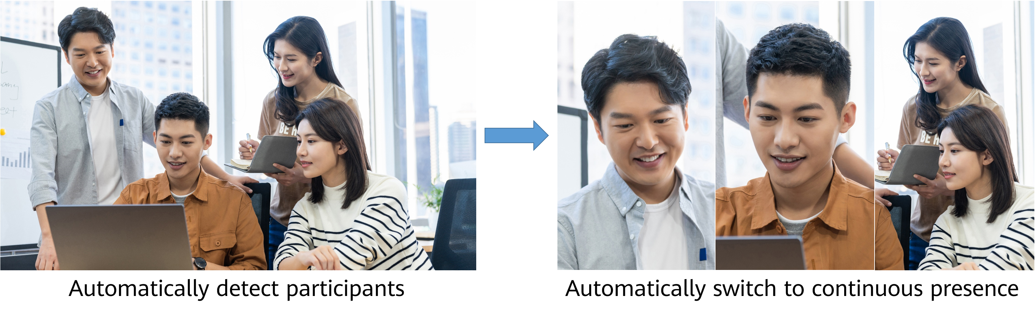

- Only the inner camera supports auto-crop view.
- A maximum of six panes are supported.

Acoustic Baffle
When the acoustic baffle function is enabled on the IdeaHub during a meeting, noise outside the invisible sound wall at the local site can be effectively reduced to prevent impact on remote sites.
The acoustic baffle function supports the following types:
- Sector acoustic baffle
The sound pickup range covers a 60° or 80° sector area directly in front of the large screen, centered on the camera.
              - Sector acoustic baffle
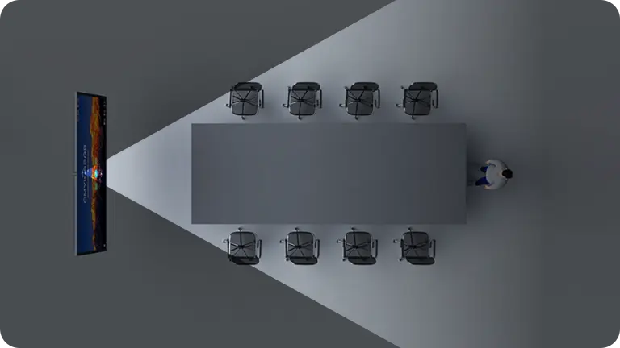

- Round acoustic baffle
The sound pickup range covers a circular area with a 2 m or 3 m radius centered on the large screen camera.
              - Round acoustic baffle
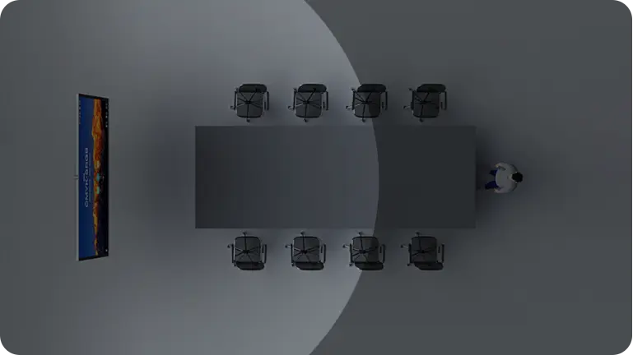

- T-shaped acoustic baffle
The sound pickup range includes a rectangular area measuring 2.6 m × 3 m in front of the large screen, as well as a 60° sector area directly ahead.
              - T-shaped acoustic baffle
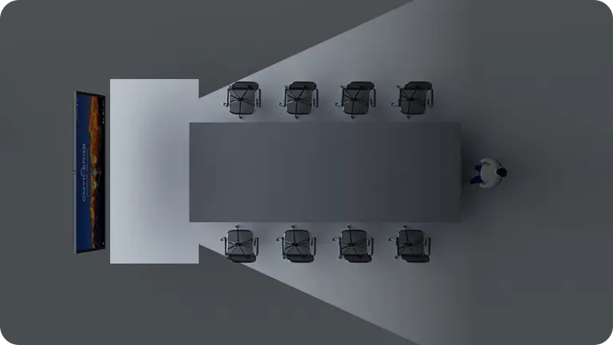

Mirror & Control
After the IdeaShare client, IdeaShare Key (Type-C), or Touch is connected to the IdeaHub, the IdeaHub is mirrored to devices for remote viewing and portable control.
On the large screen and devices with host rights, you can manage mirror & control permissions for the client and IdeaShare Key.

Dual-Screen Display
The IdeaHub supports dual-screen extension or clone. You can connect an IdeaHub to an external screen using an HDMI cable to display content such as the video and presentation separately on two screens or clone the content on the IdeaHub to another display. Dual-screen extension supports content exchange between the primary and secondary screens.

App Multiplier
App Multiplier lets you have the same app open in two different windows on one large screen, improving visual perception and user experience. The system automatically selects an appropriate display mode based on the application type. The modes are as follows:
- Navigation mode: You can open the app in two windows, with the left one displaying the app homepage and the right one displaying the newly opened page.
- Shopping mode: You can open the app in two windows, with both displaying the latest two pages, which is perfect for a multi-hierarchy app.
- Single window mode: You can open the app in one window which will be displayed in the center of the screen when you are using the app. This is a minimum guarantee for apps that do not support landscape display.
- EasyGo mode: Third-party app developers can customize the window display mode based on service scenarios.

Multi-Window
The IdeaHub allows you to open two apps at the same time in split-screen mode, reducing complex operations caused by app switching and improving usage efficiency. You can also adjust the split-screen ratio and switch the left and right split screens of app windows for proper display areas.
              - Multi-Window example
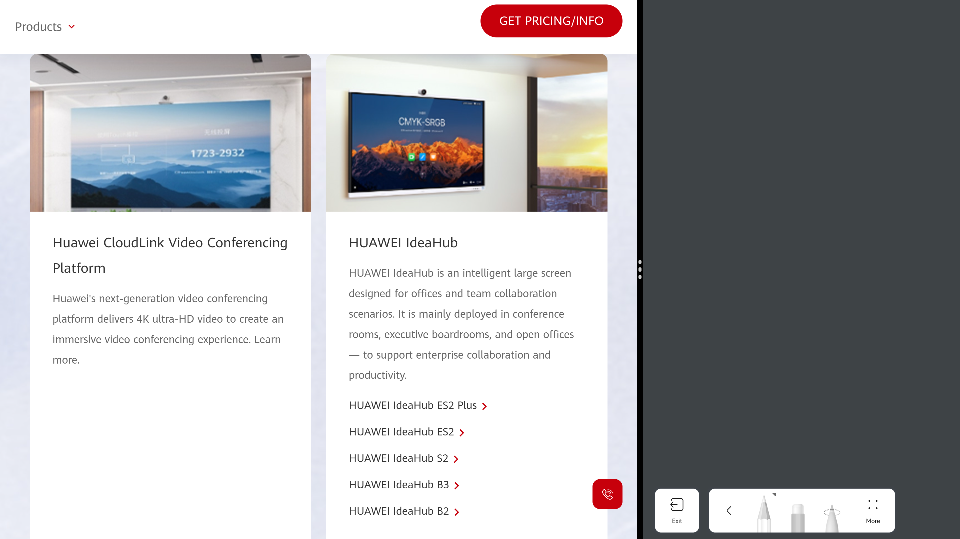

Wireless Connections
The endpoint supports 2 x 2 Wi-Fi technology (that is, 2-channel input and 2-channel output of Wi-Fi data), dual antennas, and dual bands (2.4 GHz and 5 GHz). Both Wi-Fi and hotspot can be enabled at the same time.
If Wi-Fi is enabled, the endpoint automatically detects and connects to Wi-Fi networks. You can set the IP address in DHCP or static mode. This function applies to scenarios in which no wired network is available and you need to connect the endpoint to the network via Wi-Fi.
When the IdeaHub has its hotspot enabled, it can serve as a hotspot for connecting other devices (such as a PC) to Wi-Fi.
This device contains the radio transmission module with the type approval code CMIIT ID:2022AP2900.

Bulletin Board
The IdeaHub supports releasing various types of information on the home screen, including corporate culture, team objectives, administrative services, and guest greetings. Content can be flexibly defined to fit different uses.
              - Bulletin Board
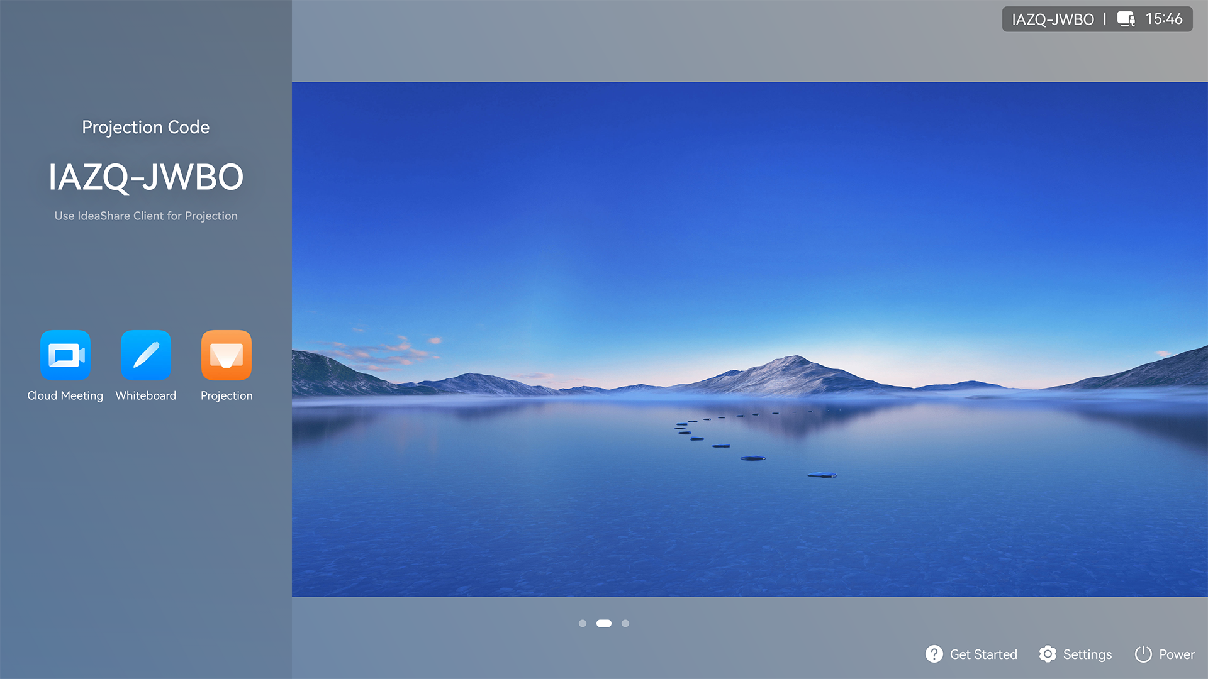

HiBoard Welcome Page
The IdeaHub supports the HiBoard welcome page. Three welcome page background images are available by default and users can customize the content and font of the welcome page. You can also upload customized welcome page background images.
              - HiBoard
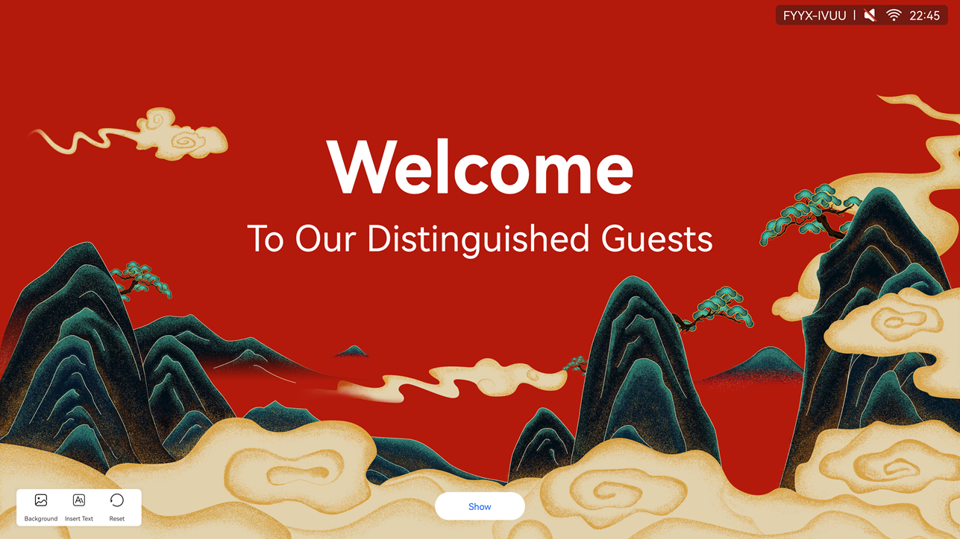

Apps
The IdeaHub has common enterprise apps pre-installed, covering various office scenarios such as meeting, whiteboard, and projection, satisfying users' requirements for digital office. You can customize the apps on the home screen based on use frequency, in a simple and efficient manner.
You can also download third-party apps in the IdeaHub section from the pre-installed HUAWEI AppGallery on an IdeaHub.
              - Apps
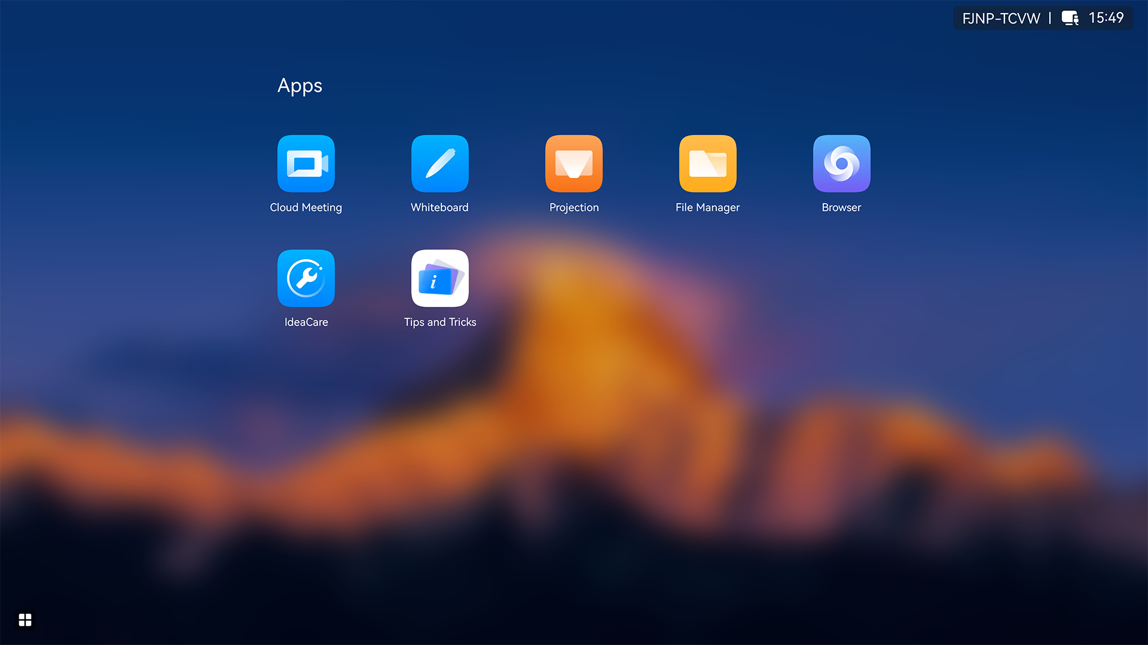

The content displayed on the endpoint may vary depending on large screen configurations and models.

Globalization
The IdeaHub supports multiple languages and time zone settings. If some countries and regions in the selected time zone use daylight saving time (DST), the IdeaHub automatically enables DST and changes its clock to comply with DST, meeting needs of different users.
The IdeaHub supports the following languages: Simplified Chinese, traditional Chinese, English, Spanish, French, Japanese, Arabic, Italian, Portuguese (Brazil), German, Thai, Türkiye, Korean, Kazakh, Romanian, Bulgarian, Sinhala, Serbian, Hungarian, Greek, and Polish.
- Only the touchscreen UI and web interface of the endpoint support Serbian.
- Portuguese (Brazil) is supported only after the Portuguese license is imported.

Operations, Administration, and Maintenance

Batch Configuration
The IdeaHub can be connected to enterprise services, and deliver configurations through the management platform (IdeaManager or SMC) to complete key configurations in batches, improving O&M efficiency.

Customizing a Startup Animation and Changing a Wallpaper
- The startup animation can be replaced with a customized animation to meet personalized requirements.
- You can change the wallpaper on the web interface, touchscreen, or Touch.

Resetting the Web Password
If no administrator information is configured for the IdeaHub or you forget the administrator password, you can reset the password in the following ways:
- If the IdeaHub is connected to the IdeaManager (cloud service), click Forgot Password? on the web login interface, use your mobile device to scan the QR code, log in to the IdeaManager (cloud service) as prompted, and reset the password.
- If the IdeaHub is connected to the Huawei Cloud Meeting (with the IdeaManager activated), SMC, or IdeaManager, contact the network management platform administrator to log in to the platform and deliver the password again.
- In other scenarios, you are advised to restore factory settings and reset the password.
The IdeaManager (cloud service) requires a compatible version of the IdeaManager to use the Forgot Password function.

APIs for Third-Party Integration
The IdeaHub provides APIs for third-party integration and development based on HTTP (Hypertext Transfer Protocol). Users can choose necessary APIs based on their actual needs to develop required functions and integrate functions of the IdeaHub into other products or apps.

Serial Port Control
The IdeaHub's open RS232 protocol control API enables efficient remote endpoint management.
The API provides the following functions:
- Remote shutdown/startup
- Remote sleep
- Remote wakeup
- Volume adjustment
- Screen brightness adjustment
- Third-party app opening/closing
- Signal source switching
- Operating system switching (HarmonyOS/Windows) after OPS installation
- Key endpoint status query

Keeping Applications Alive in the Background
The IdeaHub allows users to select applications that need to be kept alive in the background to prevent them from being automatically closed by the system.

Developer Options
Developer options provide users with in-depth optimization functions. It is recommended that users disable developer options immediately after using them. Developer options of the IdeaHub include:
- USB Debugging: When enabled, you can debug the IdeaHub, copy data, and install apps on it using the computer connected to the IdeaHub through a USB port.
- Revoking USB Debugging Permission: Revoke the previously granted USB debugging permissions from all the computers. After the permissions are revoked, the current USB debugging stops.
- Auto System Update: When enabled, auto update of forcible update packages in System & Update is allowed.

Security and Reliability

Operating System Security
Security maintenance for the system layer ensures that the operating system runs smoothly and also supports stable services at the application layer. The IdeaHub uses HarmonyOS and provides powerful anti-attack capabilities.

Email Security
To ensure the security of email accounts and sent emails, the STARTTLS protocol is used by default to authenticate the email server and send encrypted emails.

Web Login Security Protection
Users can log in to the IdeaHub web interface to remotely manage the IdeaHub. The following protection measures are taken to ensure web login security:
- When a user requests access to a specified web page which requires access authorization or submits an HTTPS request, the endpoint checks whether the user's session identifier is valid and whether the user is authorized to perform the operation.
- The server implements the final authentication on the user.
- Before transmitting user-generated data to clients, the server verifies the data and encodes it using HyperText Markup Language (HTML) to prevent malicious code injection and cross-site scripting attacks.
- Web security scan software is used to scan the web server and web apps to prevent security vulnerabilities.

Protocol Anti-Attack Measures
- The communication matrix is provided in the product documentation. Do not enable the services and ports that are not described in the communication matrix.
The communication matrix contains the following information:
- Open ports
- Transport layer protocols used by the ports
- NEs that use the ports to communicate with peer NEs
- Application layer protocols used by the ports and description of the services at the application layer
- Whether services at the application layer can be disabled
- Authentication modes adopted by the ports
- Port functions (such as data traffic control)
- Multiple security encryption measures, such as Transport Layer Security (TLS) and HTTPS, are used to ensure user security.
- Robustness testing tools are used to avoid security vulnerabilities.
- The endpoint supports anti-brute-force-cracking. When the number of authentication failures reaches the preset value, the IP address or account is locked. You can access the endpoint again only when this duration ends.

Protection of Sensitive Data
- The log, diagnostics, debug, and alarm information do not contain sensitive data such as passwords and ciphering contexts. If sensitive data is included, it is displayed as "***".
- Sensitive data can be transmitted through secure channels or after being encrypted.
- The endpoint checks the complexity of passwords. When a password is being entered, each stroke is displayed as "." or "*", and the entered password cannot be copied.
- Sensitive data such as passwords and encrypted contexts must not be recorded in logs. If sensitive data really needs to be recorded, it should be displayed as "***".
- Only standard encryption algorithms and key negotiation mechanisms are used. Proprietary algorithms are not allowed.

System Management and Maintenance Security
- Software packages (including patches) are released only after they are scanned by at least three types of mainstream antivirus software and no issues are detected. In special cases, an explanation is provided for alarms.
- All user operations and system exceptions are logged.
- A two-level certificate chain is supported to ensure the transmission security of confidential data.

Security Design
- Safety labels and tags are attached to the exterior of the product to remind users to avoid high-risk operations.
- The component security design meets the admission requirements of the EU and China.

Secure Startup
The IdeaHub supports secure startup. During the startup process, the integrity of the U-Boot, kernel, and application software is verified level by level to ensure that all software running on the IdeaHub is valid, thereby ensuring reliable and secure running of the IdeaHub.

Operations and Maintenance

GUIs

Touchscreen UI
The IdeaHub uses a brand-new touchable collaboration system. You can simply tap icons to perform basic operations, such as to open an app, turn on/off a camera, or adjust the volume.
              - Home screen of the touchscreen
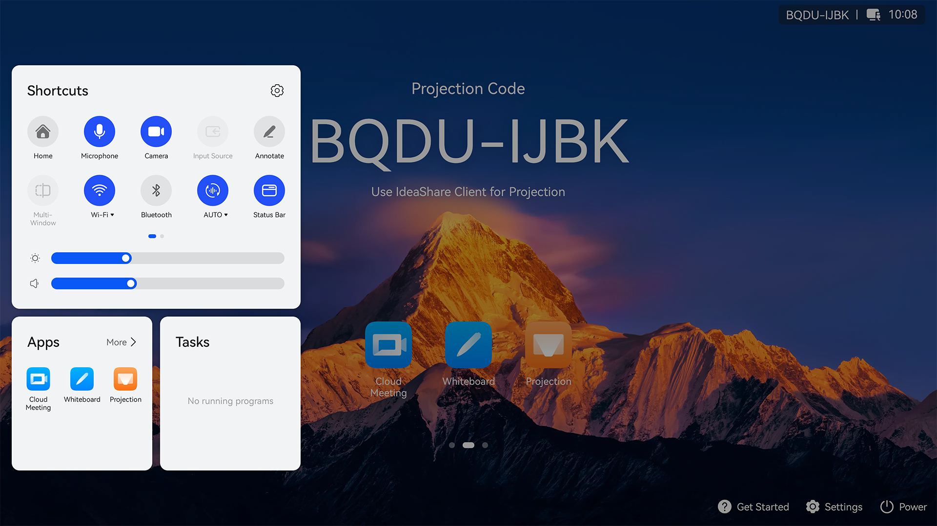

The content displayed on the endpoint may vary depending on large screen configurations and models.

Touch UI
The Touch is an optional component of the IdeaHub. It provides a graphical touchscreen. You can easily share content, control the camera, microphone, and speaker, perform mirror & control, and modify other endpoint settings by simply tapping icons.
              - Home screen of the Touch UI
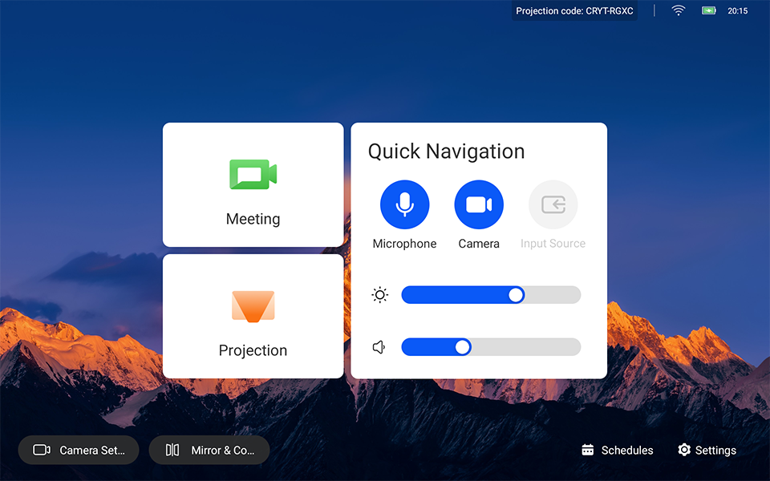

Web Interface
The IdeaHub can be remotely managed by the administrator from the endpoint web interface. The web interface allows simultaneous operations from up to 10 users using the same account. When multiple users log in to the system at the same time, the latest operation of a user takes effect. In addition, the operations of different users can be recorded in logs.
The figure below shows the basic layout of the web interface, which varies depending on the model or license import.
              - Web interface example
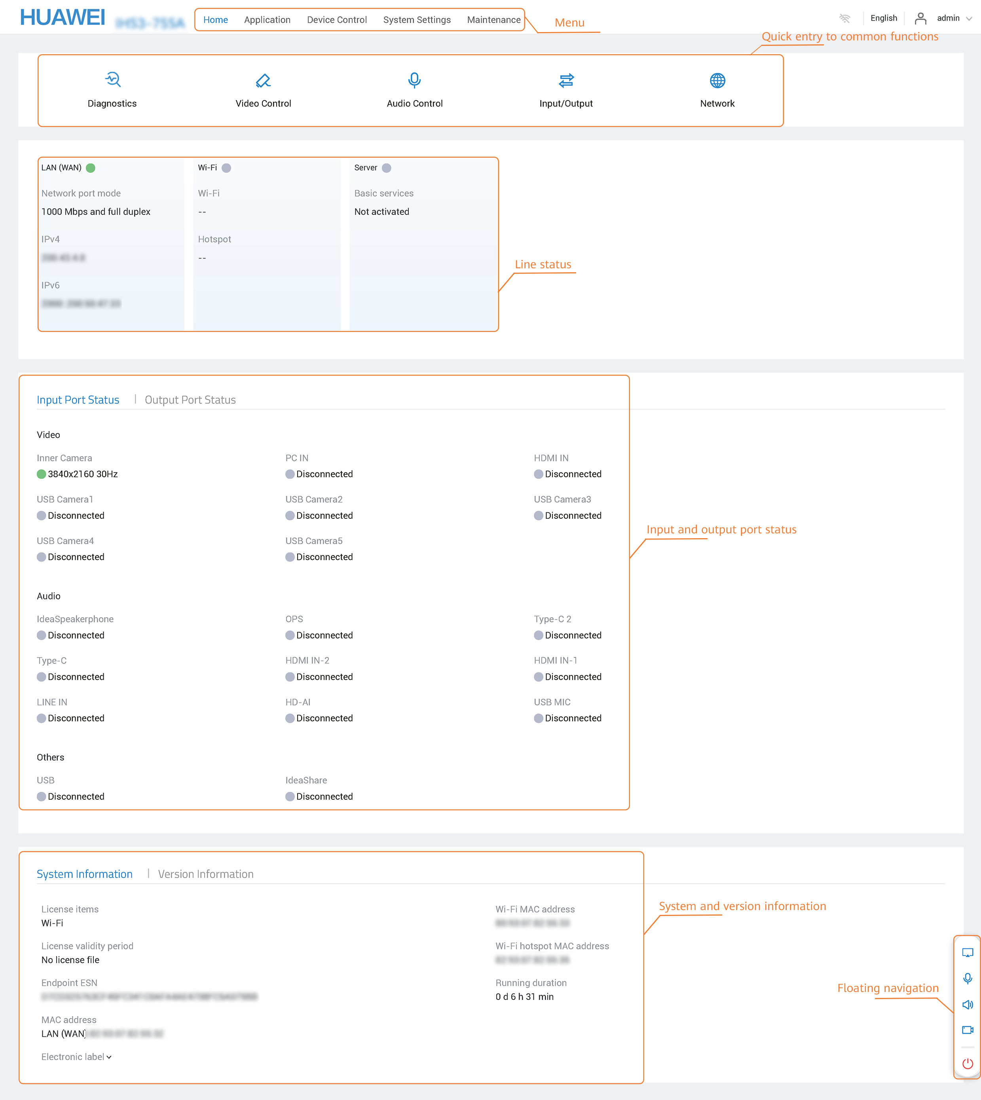

IdeaShare UI
The IdeaShare is a wireless projection client designed for the IdeaHub. It can be installed on an Android/iOS/HarmonyOS mobile device or Windows/macOS computer. A maximum of 50 users can be connected at the same time. When one site is sharing content, other sites can preempt the presentation sharing right.
The IdeaShare wireless projection clients for Android/iOS/HarmonyOS/macOS and Windows integrate the remote control function, allowing users to mute or unmute the microphone, turn on or off the camera, adjust the volume, and leave or end a meeting. In addition, the Android, HarmonyOS, macOS, Windows, and iOS versions of the IdeaShare wireless projection client is integrated with the mirror & control function, allowing users to remotely view and control the large screen.
              - IdeaShare UI
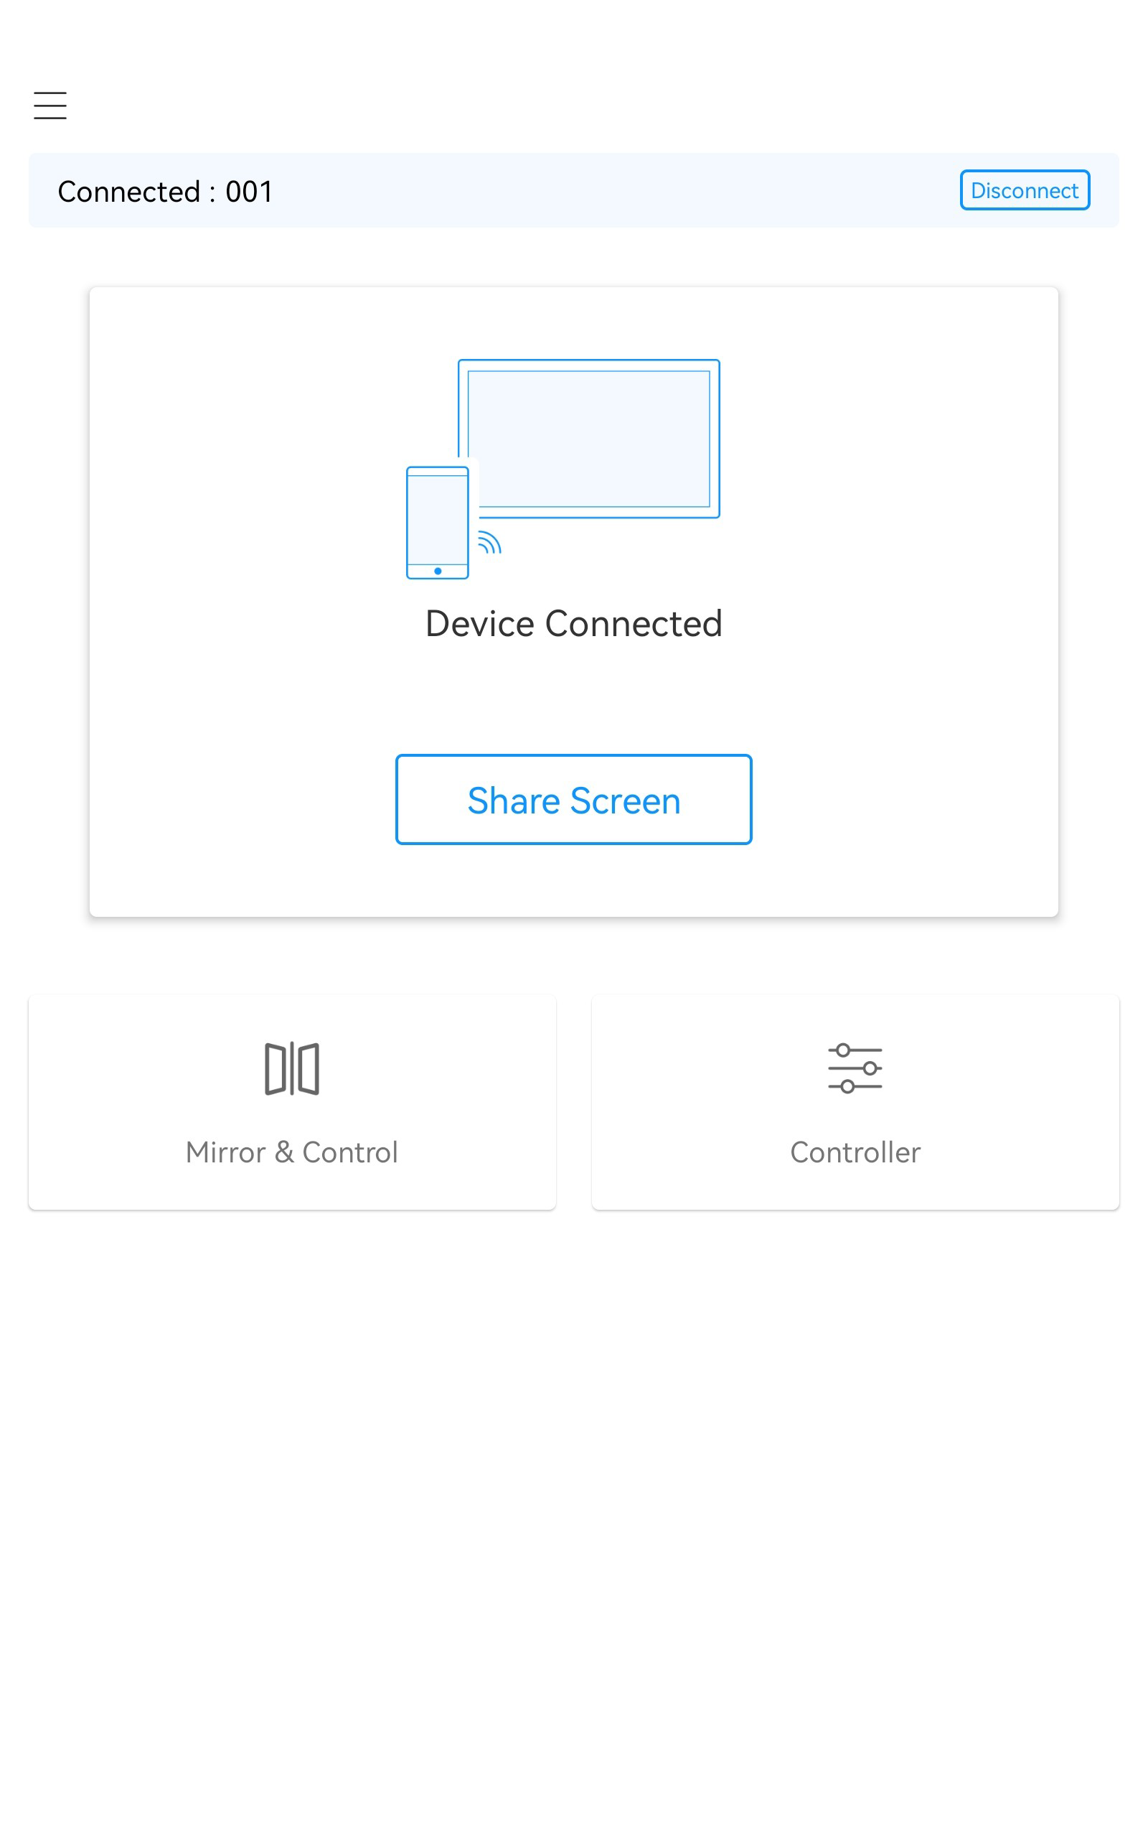

Maintenance and Upgrade

Log Management
The IdeaHub records logs about user operations and system exceptions, helping the administrator maintain the system and locate faults.
Logs are saved as files. You can view or export logs on the web interface.

Device Diagnostics
The IdeaHub has a built-in IdeaCare app. You can use this app on the touchscreen to perform full diagnostics, quick diagnostics, diagnostics by category, and one-click diagnostics, and export diagnostics reports.

Inspection
The following inspection tasks can be executed on the SMC2.0, SMC, and IdeaManager for the IdeaHub:
- Check the status of IP lines.
- Check the system software version.
- Check the system performance, including the temperature status.
- Check the content source connection status and input port settings.
- Check the video input cable connection status and video input port settings.
- Collect certificate information. (Only the SMC and IdeaManager support this task.)
- Check whether the HTTP switch configuration is secure. (Only the SMC and IdeaManager support this task.)
- Report the inspection result and status to the SMC2.0, SMC, or IdeaManager.

Upgrade
You can upgrade the endpoint to fix vulnerabilities and use new functions. The following upgrade methods are supported:
- Manually upgrade the endpoint on the web interface.
- Upgrade the endpoint by importing the upgrade file from a USB flash drive.
- Upgrade the endpoint in eRecovery mode.
- After the endpoint is connected to the public network, the software version of the endpoint can be automatically updated. You can also manually check for the latest version on the touchscreen and update the software.
- Manually upgrade the endpoint on the SMC web interface.
- Manually upgrade the endpoint on the SMC2.0 web interface.
The endpoint supports independent version upgrade of the IdeaShare Key software without being released with the endpoint version.
- The IdeaShare Key software version can be manually upgraded on the web interface.
- The IdeaShare Key software version can be upgraded by importing an upgrade file from a USB flash drive.
- The IdeaShare Key software version can be manually upgraded on the SMC web interface.

User Experience Improvement Program
The program helps improve products and services to provide better user experience. With your consent, the device collects personal data, including location, network, device, and application information. Before joining this program, you are advised to read its related statement and Personal Data Description carefully. After joining this program, you can opt out of the program at any time.

Technical Specifications

Physical Specifications
                - Physical specifications
Parameter Name | Content
System
CPU | 8 cores
Memory | 8 GB
Storage space | 128 GB
AI computing power | 4T+4T
Operating system | Built-in HarmonyOS, with OPS (optional) support for Windows 10 or Windows 11 Enterprise.
Screen display
Backlight type | D-LED
Aspect ratio | 16:9
Resolution | 3840 x 2160
Display area | - 65-inch model: 1428.48 mm x 803.52 mm  - 75-inch model: 1649.66 mm x 927.94 mm  - 86-inch model: 1895.04 mm x 1065.96 mm
Pixel distance | - 65-inch model: 372.0 μm x 372.0 μm  - 75-inch model: 429.6 μm x 429.6 μm  - 86-inch model: 493.5 μm x 493.5 μm
Pixel defect | The defect standard complies with ISO 9241 Class I.
Refresh rate | 60 Hz
Response time | 8 ms
Brightness (typical value) | 350 nits
Screen brightness uniformity | ≥ 70%
Contrast | 1200:1
Viewing angle | ≥ 178°
Color depth | 10 bits (8 bits + FRC)
Hardware-based anti-blue light | Supported
Glass surface treatment | Anti-glare
Screen lamination | Zero-gap bonding
Glass surface hardness | ≥ 7H
Screen touch control
Touch control precision | ±0.5 mm
Maximum number of touch points | Windows: 50  HarmonyOS: 32
Touch control type | Infrared touch control
Touch response time | ≤ 5 ms
Automatic screen brightness adjustment | Supported
Inner camera
Lens type | Fixed focus (1W + 1T)
Sensor size | 1/2.8''
Horizontal field of view | Wide: 80°  Tele: 65°
Aperture | Wide: F1.8  Tele: F1.85
Video resolution | Wide: 4K 30 fps (3840 x 2160)  Tele: 4K 30 fps (3840 x 2160)
Zoom | 5x zoom (including 1.38x optical zoom)
Vertical angle of view | Wide: 50°  Tele: 39°
Lens cap for privacy protection | Supported (electric privacy cover)
TV distortion | Wide: < 2%  Tele: < 2%
Shooting distance | Wide: 0.5 m to infinity  Tele: 0.5 m to infinity
PTZ adjustment | e-PTZ
Automatic exposure (AE) | Supported
Automatic white balance (AWB) | Supported
Camera presets | Local camera: 32 at most; remote camera: 6 at most
Built-in microphone
Quantity | 24
Sampling frequency | 48 kHz
Sampling bits | 24 bits
Sound pickup distance | 15 m
Sound pickup angle | 180°
Built-in speaker
Quantity | 2 x (tweeter + full-frequency unit) + 1 x bass unit + 2 x passive radiator
Total speaker power | 2 x 20 W + 1 x 30 W
Sound output mode | Front tweeters and full-frequency speakers and rear woofers
Frequency response range | 60 Hz to 20 kHz
Stereo | Supported
Maximum sound level | 98 dB SPL@1 m
Electricity supply requirements
Rated operating voltage | 100–240 V AC
Operating frequency | 50 Hz/60 Hz
Maximum power consumption | - 65-inch model: < 450 W  - 75-inch model: < 500 W  - 86-inch model: < 550 W
Typical power (without OPS; brightness of 300 nits) | - 65-inch model: 318 W  - 75-inch model: 377 W  - 86-inch model: 428 W
Standby power | < 0.5 W
Environmental requirements (in use)
Ambient temperature | IdeaHub: 0°C to 40°C  Touch: 0°C to 35°C
Relative humidity | 10% to 95%
Operating altitude | ≤ 5000 m
Operating duration (hour/day) | ≤ 16 hours/day
MTBF | > 100,000 hours
Device operating lifespan | 5 years
Environmental requirements (idle)
Ambient temperature | –20°C to +60°C
Relative humidity (non-condensing) | 5% to 95%
Physical parameters of the entire system
Product dimensions ^{[1]} | - 65-inch model: 935.5 mm x 1484.5 mm x 91.6 mm  - 75-inch model: 1059.9 mm x 1705.7 mm x 91.8 mm  - 86-inch model: 1200 mm x 1953.0 mm x 91.8 mm
Package dimensions | - 65-inch model: 1050 mm x 1650 mm x 220 mm  - 75-inch model: 1170 mm x 1900 mm x 220 mm  - 86-inch model: 1300 mm x 2090 mm x 250 mm
Net weight | - 65-inch model: 37.0 kg  - 75-inch model: 49.5 kg  - 86-inch model: 64.4 kg
Gross weight (including the package) | - 65-inch model: 47.3 kg  - 75-inch model: 61.0 kg  - 86-inch model: 78.4 kg
(Optional) Floor stand
Product dimensions | 1525.0 mm x 1302.0 mm x 764.0 mm
Package dimensions | 180 mm x 1390 mm x 845 mm
Net weight | 19.5 kg
Gross weight (including the package) | 24.8 kg
(Optional) Wall-mounted bracket
Product dimensions | 34 mm x 1100 mm x 200 mm
Package dimensions | 55 mm x 1260 mm x 345 mm
Net weight | 4.3 kg
Gross weight (including the package) | 5.3 kg
(Mandatory) Stylus pen
Quantity | 2
Wi-Fi
Wi-Fi protocol | 802.11 a/b/g/n/ac/ax
Supported frequency band | - 2.4 GHz to 2.4835 GHz  - 5 GHz to 5.85 GHz
Maximum transmit power | - 2.4 GHz to 2.4835 GHz: < 20 dBm  - 5 GHz to 5.85 GHz: < 23 dBm
Bluetooth
Bluetooth version | Bluetooth 5.2
Voice tracking
Distance | 6 m
Installation
Installation mode^{[2]} | Floor stand-mounted, wall-mounted, or wall-recessed
Peripherals
Microphone | Up to two VPM220s or Mic 500s can be connected.

- Dimensions: H x W x D
- [1]: The height of the product includes the height of the camera.
- [2]: Vertical hanging is required for product usage. Horizontal transport is prohibited.

Performance Specifications
                - Performance specifications
Item | Specifications
Content sharing capabilities | - IdeaShare app  Sharing in a meeting:  - IdeaShare mobile client (Android): up to 1080p 30 fps  - IdeaShare mobile client (HarmonyOS): up to 1080p 30 fps  - IdeaShare mobile client (iOS): up to 1080p 30 fps  - IdeaShare PC client (Windows): up to 4K 30 fps^{[1]}/1080p 60 fps  - IdeaShare PC client (macOS): up to 1080p 30 fps  Local projection:  - IdeaShare mobile client (Android): up to 1080p 30 fps  - IdeaShare mobile client (HarmonyOS): up to 1080p 30 fps  - IdeaShare mobile client (iOS): up to 1080p 30 fps  - IdeaShare PC client (Windows): up to 4K 30 fps^{[2]}/1080p 60 fps  - IdeaShare PC client (macOS): up to 2K 30 fps  - IdeaShare Key:  Sharing in a meeting:  - IdeaShare Key (Windows): up to 4K 30 fps^{[3]}/1080p 60 fps^{[4]}  - IdeaShare Key (macOS): up to 1080p 30 fps  Local projection:  - IdeaShare Key (Windows): up to 4K 30 fps^{[5]}/1080p 60 fps^{[6]}  - IdeaShare Key (macOS): up to 2K 30 fps  - HDMI/Type-C projection:  Input resolution: 640 x 480 60/72/75/85 fps, 800 x 600 56/60/72/75/85 fps, 1024 x 768 60/70/75/85 fps, 1152 x 864 60/75/85 fps, 1280 x 600 60 fps, 1280 x 720 60/75/85 fps, 1280 x 768 60/75/85 fps, 1280 x 800 60/75/85 fps, 1280 x 960 60/75/85 fps, 1280 x 1024 60/75/85 fps, 1360 x 768 60 fps, 1366 x 768 60 fps, 1440 x 900 60 fps, 1400 x 1050 60 fps, 1600 x 900 60 fps, 1600 x 1200 60 fps, 1680 x 1050 60 fps, 1920 x 1080 24/25/30/50/60 fps, 1920 x 1200 60 fps, 3840 x 2160 25/30/50/60 fps  Output resolution: 1920 x 1080, 3840 x 2160
Operating system and hardware requirements for IdeaShare mobile client installation | - Android 8.0 or later  - iOS 13 or later  - HarmonyOS 2.0 to 5.0 (excluding 5.0)
Operating system and hardware requirements for IdeaShare PC client installation | - Windows 7, 8, 8.1, 10, and 11 (32- and 64-bit, x86 architecture)  - macOS 10.13.6 or later
Operating system requirements for the IdeaShare client to support Wi-Fi Direct | - Android 8.0 or later  - Windows 10.0.10240.0 or later  - HarmonyOS 2.0 to 5.0 (excluding 5.0)
Operating system requirements for DLNA projection devices | - Android 7.0 or later  - iOS 9.0 or later  - HarmonyOS 2.0 or later
Operating system requirements for Cast+ manual projection devices | - EMUI 10.1.0 or later  - HarmonyOS 2.0 or later
Operating system requirements for Miracast projection devices | - Windows 10 or later  - Android 8.0 or later
Operating system requirements for NFC OneHop projection devices | - EMUI 11.0.0.150 or later  - HarmonyOS 2.0 or later
Operating system requirements for the IdeaShare client to support mirror & control | - Android 8.0 or later  - iOS 13 or later  - HarmonyOS 2.0 to 5.0 (excluding 5.0)  - Windows 10 or 11 (32-bit and 64-bit)  - macOS 10.15 or later
Operating system requirements that support mirror & control using an IdeaShare Key (Type-C) | - Windows 10 or 11 (32-bit and 64-bit)  - macOS 10.15 or later
Operating system requirements for the IdeaShare client to support cross-screen annotation | Windows 10 or 11 (32-bit and 64-bit)
Operating system requirements for the IdeaShare client to support ultrasonic projection | - Android 8.0 or later  - iOS 13 or later  - HarmonyOS 2.0 to 5.0 (excluding 5.0)  - Laptop running Windows 7, 8, 8.1, 10, and 11 (32- and 64-bit)  - Laptop running macOS 10.13.6 or later
Operating system requirements for the IdeaShare Key (Type-C) in app mode and IdeaShare client to support screen extension | - Windows 10 1607 or later  - macOS 10.14 or later
Recommended client and IdeaShare Key versions for device control permissions (screen sharing and mirror & control) | - IdeaShare client:  - Android/HarmonyOS/Windows: V7.06.1.50 or later  - macOS: V7.06.1.70 or later  - iOS: V2.3.1 or later  - IdeaShare Key (Type-C):  - Windows: V7.06.1.50 or later  - macOS: V7.06.1.70 or later

- The specifications are obtained from lab tests. The actual specifications may vary depending on the environment and devices.
- [1], [2], [3], and [5]: Hardware requirements: Intel Core i7-6600 or later (the first two digits of the version number are greater than 6) and driver version 26.20.100.6861 (April 2019) or later
- [4] and [6]: The IdeaShare Key (Type-C) supports up to 1080p 60 fps in DP mode.

Protocol and Standards Compliance
                - Protocol and standards compliance
Item | Protocol/Standard
Network transmission protocols | TCP/IP, RTP, DHCP, DNS, SNTP, SSH, HTTP, HTTPS, TR069, 802.1X, and 802.1P/Q
Other communications protocols | UVC and UAC
IP protocols | IPv4 and IPv6
Wi-Fi standards | - 802.11 a/b/g/n/ac/ax are supported.  - The AP, STA, and P2P modes can coexist.  - Wi-Fi supports the following authentication modes: OPEN, SHARE, WPA-PSK, WPA2-PSK, WPA3-Personal, and 802.1x EAP.  - Wi-Fi supports the following encryption modes: NONE, WEP, TKIP, and AES.  - The Wi-Fi server supports the following authentication mode: WPA2-PSK.  - The Wi-Fi server supports the following encryption mode: AES.

HEVC Authorization
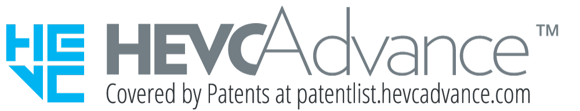

Glossary
                - Glossary
Numerics
802.11 | Wireless local area network (WLAN) standard defined by the Institute of Electrical and Electronics Engineers (IEEE) for wireless network communication.
802.1P/Q | A VLAN tag contains a 12-bit VLAN ID and a 3-bit priority code point (PCP). The 802.1Q standard defines the tag added to the Ethernet MAC data frame, but the 802.1Q VLAN standard does not define or use the PCP. The 802.1P standard defines the PCP. 802.1P is an extended protocol of 802.1Q. 802.1P and 802.1Q work together to enable Layer 2 network switches to provide traffic priority and dynamic multicast filtering services.
802.1X | Client/Server-based access control and authentication protocol. It prevents unauthorized users or devices from accessing the LAN/WLAN through an access port. After a client associates with an AP, the 802.1X authentication result determines whether the client can use the wireless services provided by the AP. The client can access WLAN resources only after being authenticated.
A
AEC | Acoustic Echo Cancellation
AES | Advanced Encryption Standard
AGC | Automatic Gain Control
AJB | Audio Jitter Buffer
ANS | Automatic Noise Suppression
AP | Access Point
API | Application Programming Interface  A particular set of rules and specifications that are used for communication between software programs.
Auto-Framing | Based on the number, location, and motion of participants, this function automatically adjusts the camera to provide a dynamic overview of the full room.
B
BEC | Backward Error Correction
D
DHCP | Dynamic Host Configuration Protocol  A LAN network protocol that uses UDP to automatically assign IP addresses to internal networks or network service providers and centrally manage all computers for users or internal network administrators. For details, see "RFC 2131".
DLNA | Abbreviation of the Digital Living Network Alliance, which is an organization of consumer electronics, mobile phones, and computer manufacturers. The organization aims at defining a set of interoperability guidelines for sharing digital data between multimedia devices from different manufacturers.
DNS | Domain Name System  A mechanism that maps easy-to-remember domain names to IP addresses recognizable to network devices.
E
EAP | Extensible Authentication Protocol
F
FEC | Forward Error Correction
H
HD | High Definition
HDMI | High Definition Multimedia Interface
HTML | Hypertext Markup Language
HTTP | Hypertext Transfer Protocol
HTTPS | Hypertext Transfer Protocol over Secure Sockets Layer  An HTTP protocol that runs over transport layer security (TLS) and Secure Sockets Layer (SSL) for secured transactions. It is used to establish a reliable channel for encrypted communication and secure identification of a network web server.
M
Miracast | A wireless display standard based on Wi-Fi Direct and formulated by the Wi-Fi Alliance in 2012. 3C devices that support this standard can share video images in wireless mode without any cable or wireless hotspot.
MTBF | Mean Time Between Failures  A key metric for device operational reliability and stability.
N
NetATE | Net Automatic Transfer-Enhancement
NFC | Near Field Communication
O
OPS | Open Pluggable Specification
Opus | A digital audio coding format for lossy audio compression, developed by the Xiph.Org Foundation and then standardized by the Internet Engineering Task Force (IETF), with the goal of efficiently encoding speech and general audio in a single format. It ensures sound quality while maintaining a low enough delay to implement instant interactive communication, has a low enough complexity for a low-end embedded processor, and is applicable to instant sound transmission with a low delay on a network.
P
P2P | Peer-to-Peer
PD 3.0 fast charging protocol | USB Power Delivery 3.0 is a charging standard widely used in electronic devices such as mobile phones, tablets, and laptops. It aims to provide efficient and flexible charging and data transmission capabilities through the USB Type-C port.
PLC | Packet Loss Concealment
R
RS232 | A commonly used serial communication interface standard between data terminal equipment (DTE) and data communications equipment (DCE) for serial binary data exchange. It was jointly formulated by the Electronic Industry Association (EIA), Bell System, modem manufacturers, and computer manufacturers in 1970.
RTP | Real-time Transport Protocol  A protocol for transmitting audio and video streams. RTP is based on UDP. In the RTP header, a timestamp is defined to ensure that audio and video data can be transmitted and synchronized in real time.
S
SMC | Service Management Center  A video conferencing service management system that manages video conferencing devices (including GKs, MCUs, and site endpoints) and allocates video conferencing resources.
SNTP | Simple Network Time Protocol  This protocol is adapted from Network Time Protocol (NTP) for clock synchronization between computers on the Internet.
sound pickup distance | The maximum distance within which sounds can be picked up by a microphone.
SSH | Secure Shell  A network security protocol formulated by the IETF's Network Working Group on the basis of the application layer to implement secure remote login and other secure network services. The use of SSH can effectively prevent information leakage during remote management. It was initially a program in the Unix operating system and then adopted by other operating platforms. SSH can fix vulnerabilities on the network when it is used correctly. The SSH client is applicable to multiple platforms. SSH can run on almost all Unix platforms, including HP-UX, Linux, AIX, Solaris, Digital UNIX, IRIX, and other platforms.
STA | Station
T
TCP/IP | Transmission Control Protocol/Internet Protocol
TKIP | Temporal Key Integrity Protocol  An alternative security protocol used in the IEEE 802.11 wireless network standard.
TLS | Transport Layer Security
TR069 | A communication protocol between the customer premises equipment (CPE) and the auto configuration server (ACS). The CPE can use this protocol to complete necessary actions of initialization and operations management, such as service provisioning, function setting, file upload and download, and system detection.
U
UAC | USB Audio Class  A basic standard for audio communication between USB devices. It defines the communication mode between USB audio devices and the host computer.
U-Boot | A boot loader for embedded systems.
USB | Universal Serial Bus  A public interface that implements communication between the equipment and the host controller.
UVC | USB Video Class  A protocol standard defined for USB video capture devices.
W
WEP | Wired Equivalent Privacy  A method of encrypting data transmitted between two devices to prevent unauthorized users from eavesdropping on or intruding into a wireless network.
Wi-Fi | Wireless Fidelity  A short-distant wireless transmission technology. It enables wireless access to the Internet within a range of hundreds of feet wide.
Wi-Fi P2P | Wi-Fi Peer-to-Peer, also called Wi-Fi Direct, is a technology developed by the Wi-Fi Alliance to directly connect devices. It enables users to perform one-to-one or one-to-many communication without using a LAN or AP.
WPA | Wi-Fi Protected Access  A wireless security protocol replacing WEP and aiming to provide stronger security for the IEEE 802.11 WLAN. WPA is a subset of IEEE 802.11i, whose core is IEEE 802.1X and TKIP.
WPA2-PSK | An enhanced version of WPA-PSK. It applies to individual or common home networks. It uses a pre-shared key and supports TKIP and AES encryption modes.
WPA3-Personal | WPA3-Personal uses the 192-bit security protocol and provides higher encryption strength than WPA2. It introduces the Simultaneous Authentication of Equals (SAE) algorithm to prevent brute force cracking attacks on Wi-Fi passwords and uses the forward secrecy mechanism, providing better data protection.
WPA-PSK | WPA-Preshared Key  A WEP pre-shared key authentication mode. Compared with the encryption mode and key authentication mode, the mode is more secure.

