Immersive Telepresence
Conference Room Decoration Guide
25.1
Issue:01
Date:2026-06-30
Copyright © Copyright Holder. All rights reserved.

Notice
The information in this document is subject to change without notice. Every effort has been made in the preparation of this document to ensure accuracy of the contents, but all statements, information, and recommendations in this document do not constitute the warranty of any kind, express or implied.

Contents
1 Purpose 1-1
2 Construction Standards 2-1
2.1 Basic Device Information 2-1
2.1.1 Single-Row Telepresence Device 2-1
2.1.2 Dual-Row Telepresence Device 2-2
2.2 Space Standards 2-2
2.2.1 Standard Room Dimensions 2-2
2.2.1.1 Single-Row Telepresence Room 2-2
2.2.1.2 Dual-Row Telepresence Room 2-3
2.3 Illumination Design 2-4
2.3.1 Color Temperature and CRI 2-5
2.3.2 Illuminance Distribution 2-5
2.3.3 Glare Control 2-6
2.4 Acoustics Design 2-7
2.4.1 Sound Absorption 2-7
2.4.2 Noise Control 2-10
2.5 Ceiling Transformation 2-11
2.6 Wall Reconstruction 2-12
2.6.1 Wall Color 2-12
2.6.2 Fabric Wall Panels 2-12
2.6.3 Baseboards 2-14
2.7 Floor Reconstruction 2-14
2.8 Air Conditioning and Fresh Air Systems 2-14
2.8.1 Central Air Conditioning System 2-14
2.8.2 Local Air Conditioning System 2-15
2.8.3 Fresh Air System 2-16
2.9 Power Supply 2-17
2.9.1 Power Supply 2-17
2.9.2 Power Grounding 2-18
2.10 Network 2-19
2.11 Indoor Air Quality 2-19
2.12 Fire Protection Requirements 2-21
2.13 Environmental Protection Requirements 2-21
3 Recommended Conference Room Environment 3-1
3.1 Acoustics 3-1
3.1.1 Sound Absorption Plan I 3-1
3.1.2 Sound Absorption Plan II 3-3
3.2 Illumination 3-5
3.2.1 Light Fitting Layout 3-5
3.2.1.1 Single-Row Telepresence Rooms 3-5
3.2.1.2 Telepresence Room with Double-Row Tables 3-6
3.2.2 Lamp Selection 3-7
3.3 Wall Reconstruction 3-9
3.3.1 Background Wall 3-9
3.3.2 Foreground Wall 3-9
3.3.3 Right Side Wall 3-9
3.3.4 Left Side Wall 3-10
3.3.5 Floor 3-10
3.4 Effect Pictures 3-11
3.4.1 Single-Row Telepresence Room Effect Drawing 3-11
3.4.2 Dual-Row Telepresence Room Effect Drawing 3-12
4 Appendix 4-1
4.1 Appendix 1 4-1

Purpose
Huawei immersive telepresence conference rooms must be uniformly decorated to ensure consistent site environments, as well as high-definition (HD) video and high-fidelity (Hi-Fi) audio experience. This document provides design requirements for the telepresence rooms, including acoustics, illumination, and heating, ventilation, and air conditioning (HVAC) requirements.

Construction Standards

The unit of all dimensions in this document is millimeter.

Basic Device Information
Immersive telepresence devices are classified into single-row and dual-row telepresence devices.

Single-Row Telepresence Device
Dimensions (H x W x D): 5576 mm x 3185 mm x 1776 mm.
              - Equipment dimensions
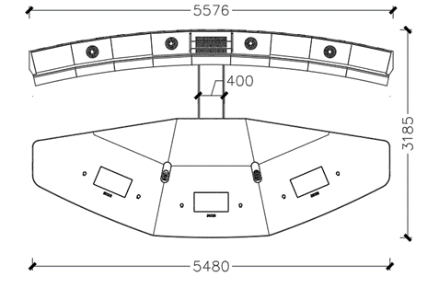

Dual-Row Telepresence Device
Dimensions (H x W x D): 8500 mm x 5185 mm x 1776 mm.
              - Equipment dimensions
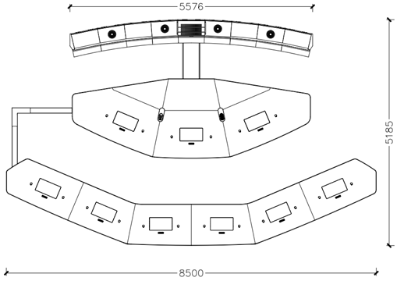

Space Standards

Standard Room Dimensions
To deliver a comfortable conferencing experience, you need to take the calculation and test data of ergonomics into consideration, such as the average human body size, operation space, and psychological space, when designing the telepresence room dimensions.

Single-Row Telepresence Room
After the room is decorated, the standard dimensions (H x W x D) of the telepresence room must be at least 7480 mm x 5085 mm x 2700 mm. No irremovable objects, such as columns, are allowed to occupy the equipment area or the circulation zone around attendees' chairs. The dimensions of the chosen telepresence room must be greater than or equal to the standard dimensions.
              - Standard-sized telepresence room floor plan
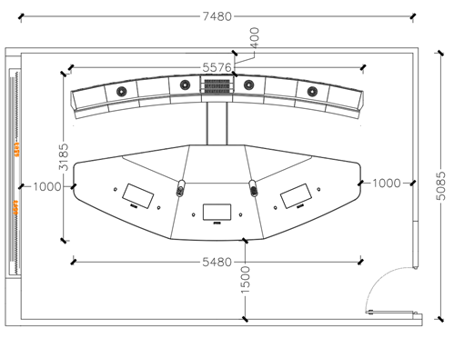

              - Standard-sized telepresence room elevation plan
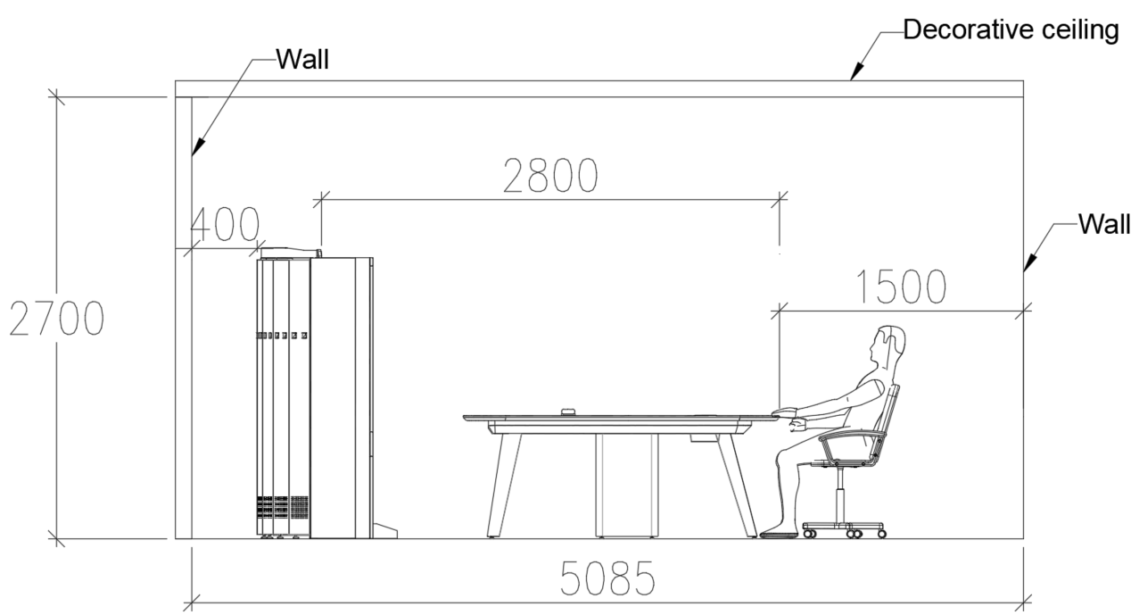

Dual-Row Telepresence Room
After the room is decorated, the standard dimensions (H x W x D) of the telepresence room must be at least 10500 mm x 7085 mm x 2700 mm. No irremovable objects, such as columns, are allowed to occupy the equipment area or the circulation zone around attendees' chairs. The dimensions of the chosen telepresence room must be greater than or equal to the standard dimensions.
              - Standard-sized telepresence room floor plan
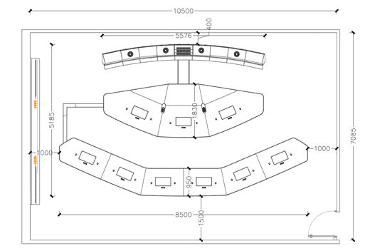

              - Standard-sized telepresence room elevation plan
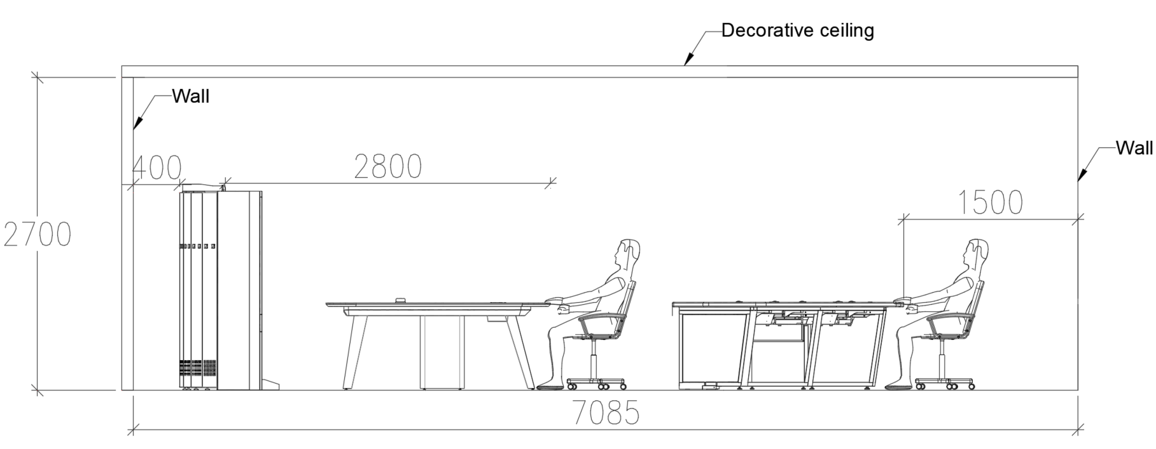

Illumination Design
A good illumination design provides appropriate:
- Color temperature and color rendering index (CRI)
- Illuminance distribution
- Glare control

Color Temperature and CRI
Color temperature and CRI are the two important measurements of light source quality.
Warm color light approximates to afterglow and creates an amiable and relaxed mood; it is suitable for resting and nesting places. It is recommended that video conferencing sites use a light source with a relatively high color temperature. After getting into the conference room, the natural light will shine on human faces. The color temperature and illuminance of the natural light keep changing, which will affect the image effect.
Light sources with high color rendering can better reproduce image color, so the color displayed is much closer to the natural color. On the contrary, light sources with low color rendering are poor in reproducing image color, which results in big color deviation.
              - Contrast between higher and lower CRIs
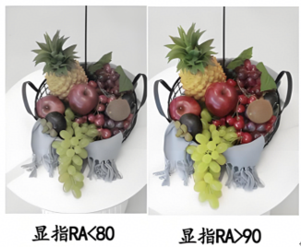

In a telepresence room, artificial light sources with color temperature of 4000 K and CRI (Ra) higher than 90 are used.

Illuminance Distribution
The telepresence system supports 720p, 1080p, and 4K HD video experience. Telepresence conference rooms have high requirements on illuminance. If the illuminance in the room is low, the image noise is obvious, which severely affects the HD video experience. In addition, proper illuminance distribution can also create a good three-dimensional sense of people.
In a telepresence room, the vertical illuminance is about 850±100 lux, the horizontal illuminance is about 950±100 lux, and the uniformity ratio of illuminance is greater than 0.7. Generally, when the illuminance ratio between the vertical illuminance and horizontal illuminance is smaller than 2, the three-dimensional quality of people is high. Contour illumination makes the face and shoulder contour clearer and more vivid.
              - Illuminance distribution measurement
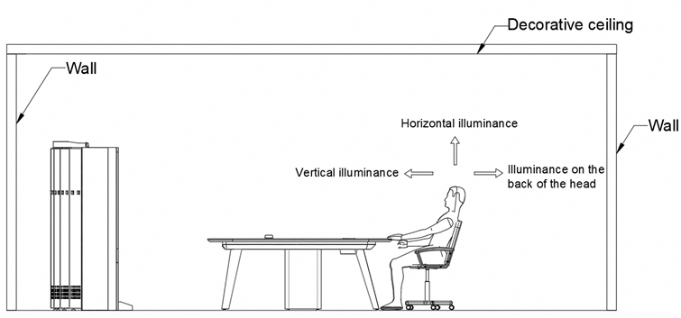

Usually, the illuminance measurement point is 1.2 meters away from the light. The vertical illuminance specifies the illuminance generated when the photoreceptor of the illuminometer faces the camera and screen. The horizontal illuminance specifies the illuminance generated when the photoreceptor of the illuminometer faces the ceiling.

Glare Control
When you sit in a telepresence room and look squarely at the display, you may perceive uncomfortable glare if the display area within the field of view is much brighter or darker than the surrounding wall or ceiling. Attendees' vision will be impaired if they are in such an environment for a long period of time. The glare degree is determined by a variety of elements, such as the light source location, size, and brightness, observation direction, brightness distribution, and distribution curve flux of lamps.
              - Glare control
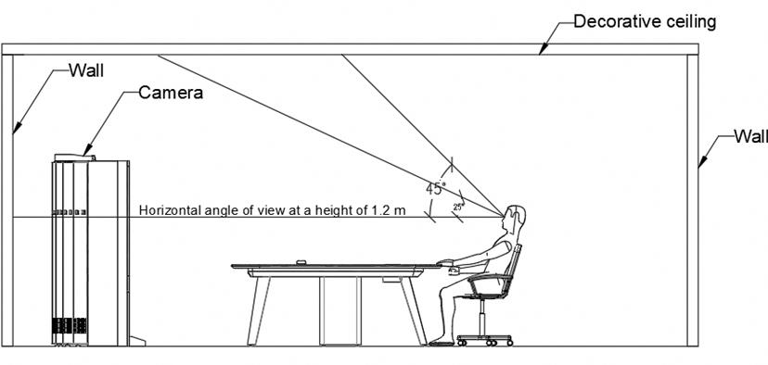

To avoid uncomfortable glare, note the following when arranging light fixtures:
- Within 25° higher than the eye level, do not place light sources or objects that have brightness contrast compared with the screen.
- Use indirect lighting in the range of 25° to 50° higher than the eye level.
- Arrange light fixtures properly based on the light distribution curve.

Acoustics Design
Acoustics design in a telepresence room mainly involves voice amplification. To deliver supreme voice quality, the following must be ensured:
- Controlled reverberation time by using appropriate sound absorbing materials.
- Effective sound insulation and low background noise.
- Adequate loudness and Speech Transmission Index (STI).
- Uniform sound field without quality defects that affect listening.
The loudness and sound field issues are addressed by the telepresence sound amplification system. This section describes the acoustics design in two aspects: sound absorption and noise control.

Sound Absorption
Principles for applying sound absorbing materials: The ceiling, background wall, and floor are mainly applied with porous sound absorbing materials that absorb mid-range and high frequencies of sound. The sound absorbing materials used in telepresence conference rooms mainly include:
For ceilings: Paper surfaced gypsum boards, perforated gypsum boards, perforated aluminum panels, fiberglass wool boards, acoustic mineral wool panels, and soft-film ceiling absorbers are used. These materials must meet the following requirements: noise reduction coefficient (NRC) greater than or equal to 0.5, fire protection level A, and environmental protection level E1.
Figure 2-10 shows the common sound absorbing materials for the ceiling.
              - Main sound absorbing materials on ceilings
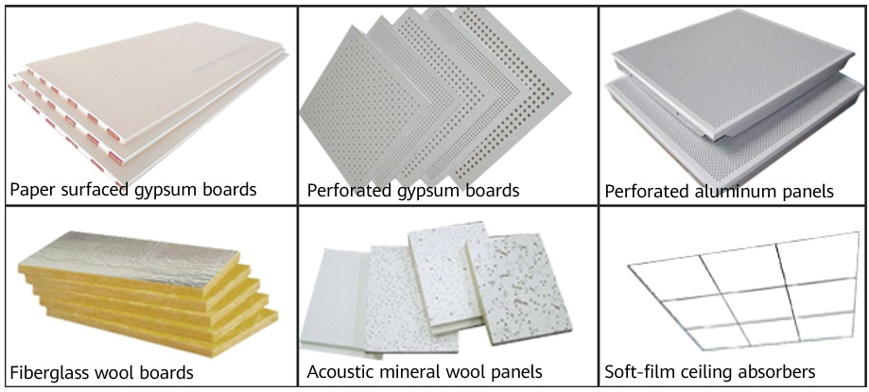

For walls: Fabric wall panels, sound absorbing wall fabric, acoustic curtains, wooden grooved acoustic panels, polyester fiber acoustic panels, perforated wooden acoustic panels that meet fire protection level A and environmental protection level E1 requirements are used for absorbing full-band frequencies of sound. Figure 2-11 shows some sound absorbing materials on walls.
- Main sound absorbing walls: Main walls must be applied with fabric wall panels. For example, the background wall and side walls must be applied with sponges with a thickness of 30 mm (1.18 in.) and density of 45 kg/M3 or more. The sponge must meet environmental protection level E1, NRC of 0.9 or higher, and fire protection level A requirements. In addition, the surface fabric must meet requirements of fire protection level A, environmental protection level E1, and gram weight 250g/m².
- Other walls: If windows are located on the side or foreground wall, common curtains that can shade light are sufficient and acoustic curtains are not mandatory. If windows are located on the background wall, shade curtains with a curtain folding rate of 200% must be used for absorbing low and mig-range frequencies of sound. For example, the foreground wall can be applied with thin lacquered boards or wooden veneer structure.
              - Sound absorbing materials on walls
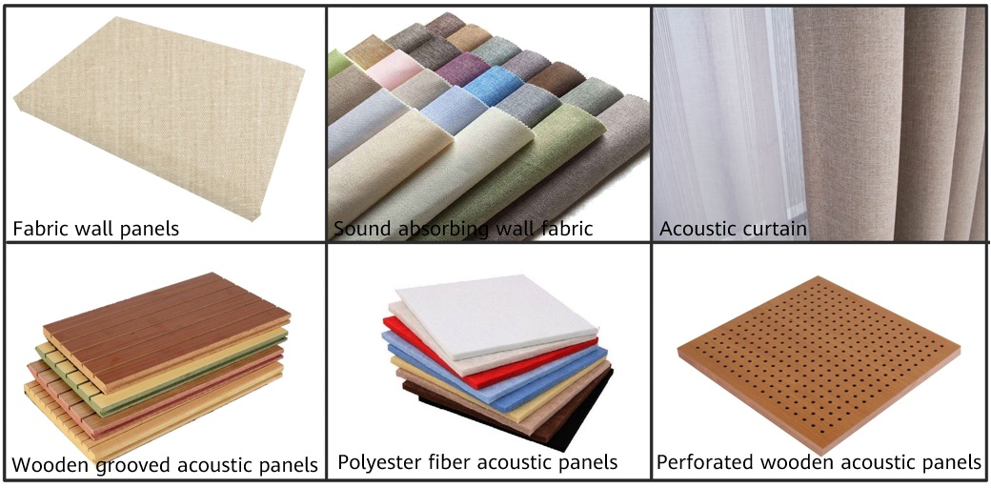

For the floor: Lay high-density chemical fiber carpets on the entire floor. The carpet must have a thickness of 6 mm and a density of 700–1000 g/m², and it shall meet the following requirements: fire protection level B1 or B2 specified in the GB 50222—2001 Code for Fire Prevention in Design of Interior Decoration of Buildings, and environmental protection level A in the GB 18587—2001 Indoor Decorating and Refurbishing Materials–Limitations of Harmful Substances Emitted from Carpets, Carpet Cushions and Adhesives.
              - Carpet style reference
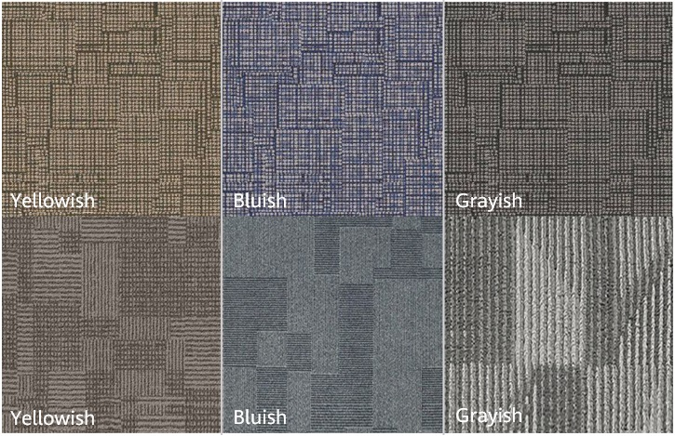

Noise Control
Noise reduces communication efficiency. Extremely loud noise may cause irreversible hearing damage. Studies show that:
- When the noise is at 30 dB(A) or lower, the environment is quiet. Examples are recording studios and hospitals.
- When the noise is at the 30–40 dB(A) level, the environment is neither quiet nor noisy. A typical office environment should be at this level.
- When the noise level is at the 50–60 dB(A) level, the environment is noisy. Mental work and communication in such an environment will be disturbed. When the background noise reaches 65 dB during calls, it is difficult for the two persons to hear each other.
- When the noise reaches 80 dB, hearing is extremely difficult.
If the outside environment of a telepresence room is noisy, increase the sound insulation of the enclosure (doors, windows, and partitions) of the telepresence room to keep out external noise. Table 2-1 lists the SRI of common walls for reference.
                - SRI of common walls
Structural Drawing | Description | SRI (dB) | Wall Thickness (mm)
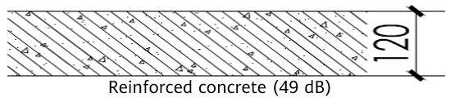 | Reinforced concrete | 48 | 120
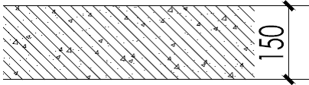 | Reinforced concrete | 52 | 150
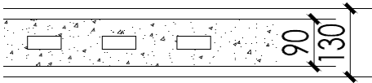 | Hollow brick with double-sided plaster | 45 | 130
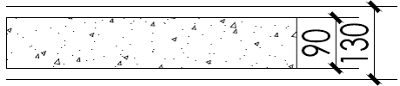 | Autoclaved aerated concrete (AAC) with double-sided plaster | 43 | 130
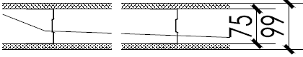 | Double-sided, single-layered 12 mm gypsum board | 42 | 99
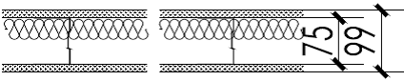 | Double-sided, single-layered 12 mm gypsum board with 50 mm fiberglass wool | 45 | 99
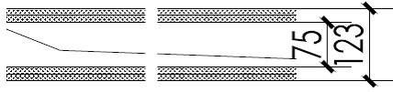 | Double-sided, double-layered 12 mm gypsum board | 48 | 123
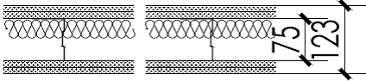 | Double-sided, double-layered 12 mm gypsum board with 50 mm fiberglass wool | 51 | 123

In a telepresence conference room, the noise must be less than or equal to 40 dB when all air conditioners and devices are turned off, and must be less than or equal to 43 dB when the fresh air and air conditioning systems are turned on but the doors and windows are closed. Acoustic attenuation measures must be taken on the air conditioner ventilation duct in the ceiling.
When designing SRI, consider the impact of sound amplification in the telepresence room on neighboring rooms and confidentiality of conferences.
Because the average sound pressure level in a telepresence room is 90 dB and the minimum background noise for typical offices is 45 dB, the SRI of telepresence room walls must be 45 dB (90 dB – 45 dB = 45 dB) or higher. If the noise source around the telepresence room is 92 dB, the SRI of room walls must be 49 dB (92 dB – 43 dB = 49 dB) or higher. Sound reduction for doors, windows, and holes in walls is crucial to the wall SRI.

Ceiling Transformation
Ceiling reconstruction involves style, illumination, sound absorption, fire control, and air conditioning.
- Style: The ceiling can be in layered cascading or flat style. By adopting sound absorbing materials, the ceiling must maintain a balance between being decorative and sound absorptive.
- Illumination: For details, see 2.3 Illumination Design.
- Sound absorption: The sound absorption coefficient of ceiling materials must be 0.5 or higher. Therefore, the materials mentioned in 2.4.1 Sound Absorption are recommended.
- Fire control: The suspended ceiling in a telepresence room must be installed with fire control facilities, such as smoke sensors and fire sprinklers. Do not seal fire control facilities to ensure the safe use of the telepresence room. If the ceiling of the room is already equipped with fire control facilities, ensure that any modifications to the ceiling do not damage them. If possible, do not change their installation locations; adjust the layout of the light fixtures and vents of air conditioners, if required. If location change is involved, ensure that the new location meets construction standards for indoor fire control.
- Air conditioning: For details, see 2.8 Air Conditioning and Fresh Air Systems.

Wall Reconstruction

Wall Color
The color of walls in a telepresence room can be wheat or light blue. The background walls of all telepresence rooms under the same contract must use the same color. Table 2-2 lists the colors and their Pantone values.
                - Colors and Pantone values
Model | Color
Pantone 726C  (Wheat color) | 
Pantone 7542C  (Light blue) | 

Fabric Wall Panels
The wall reconstruction includes soundproofing and sound absorption. If soundproofing over the original room meets requirements, acoustic structure can be constructed on existing walls. If soundproofing over the original room does not meet requirements, customers can first construct soundproofing walls by referring to 2.4.2 Noise Control and then construct sound absorbing walls. Table 2-3 describes several ways to construct a sound absorbing wall.
                - Ways to construct a sound absorbing wall
Wall with a Fabric Wall Panel | Description | Application Scenario
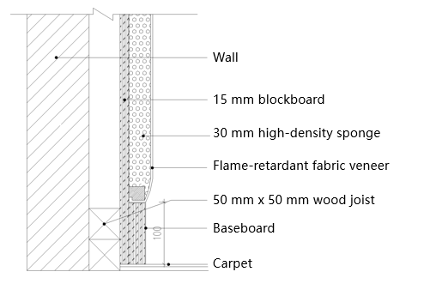 | - Composition: wall, wood or light steel joist, and fabric wall panel  - The fabric wall panel uses sponge with a thickness of 30 mm (1.18 in.) and a density of 45 kg/M3. The sponge must meet environmental protection level E1, NRC of 0.9 or higher, and fire protection level A requirements. The fabric veneer must meet requirements of fire protection level A, environmental protection level E1, and gram weight of 250 g/m². | The SRI of the existing walls is greater than 48 dB, which meets soundproofing requirements.
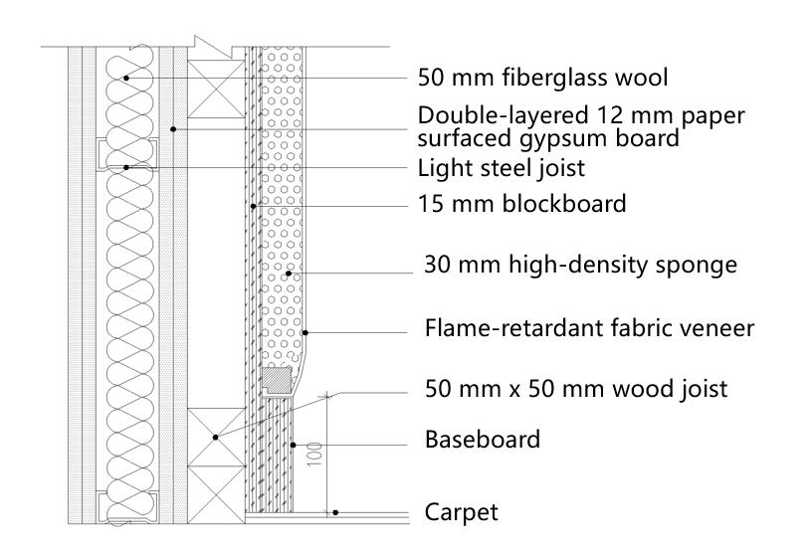 | - Composition: specialized soundproofing wall, wood or light steel joist, and fabric wall panel  - The fabric wall panel uses sponge with a thickness of 30 mm (1.18 in.) and a density of 45 kg/M3. The sponge must meet environmental protection level E1, NRC of 0.9 or higher, and fire protection level A requirements. The fabric veneer must meet requirements of fire protection level A, environmental protection level E1, and gram weight of 250 g/m². | Walls are newly constructed and required to provide SRI of higher than 50 dB.
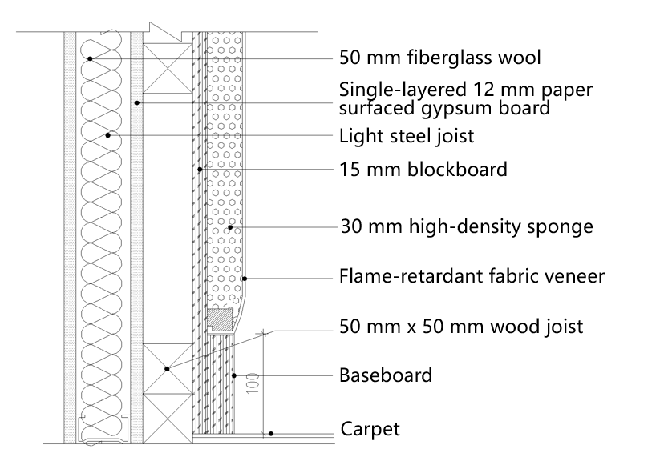 | - Composition: common soundproofing wall, wool or light steel joist, and fabric wall panel  - The fabric wall panel uses sponge with a thickness of 30 mm (1.18 in.) and a density of 45 kg/M3. The sponge must meet environmental protection level E1, NRC of 0.9 or higher, and fire protection level A requirements. The fabric veneer must meet requirements of fire protection level A, environmental protection level E1, and gram weight of 250 g/m². | Walls are newly constructed and required to provide SRI of higher than 45 dB.

Baseboards
Baseboards must be installed in the telepresence conference room. Install baseboards after carpeting, and ensure that the baseboards cover the carpet edges. The seams of the baseboards must be smooth, and the height and thickness of the baseboards must be consistent. The recommended height of the baseboards is 100 mm.

Floor Reconstruction
A flame-retardant carpet must be laid in a telepresence room. Flatten the floor before carpeting, and ensure that baseboards cover carpet edges without tilts. To protect the carpet at the entrance, secure the carpet edge using aluminum alloy or antimony edge strips.

Air Conditioning and Fresh Air Systems

Central Air Conditioning System
A telepresence room must be equipped with a centralized or decentralized air conditioning system. The central air conditioning system that contains fan coil units (FCUs) and fresh air system (FAS) is recommended.
Layout 1: Install the air conditioning system vents in the five square white aluminum alloy grilles on the suspended ceiling. The dimensions of the air vents are 600 mm x 600 mm (23.62 in. x 23.62 in.). Deploy an air return vent and an exhaust vent for the FCU in the grilles near the foreground wall. This ensures that hot air generated within the room is recycled through the air return vent and some stale hot air is dissipated through the exhaust vent of the FAS. Deploy a fresh air intake vent and an air supply vent for the FCU in the grilles near the background wall. In this way, the conditioned and fresh air can be brought into the telepresence room to blow air against the background wall.
Layout 2: Place the air vents, including the air supply/return vents of the air conditioning system and the fresh air intake vent and exhaust vent within the suspended ceiling and away from the direct blowing position above the seats. These vents appear in rectangular format for aesthetics purpose. Customize the dimensions of the air vents based on the onsite ceiling and keep a certain distance between the air conditioning vents and the fresh air vents.

Local Air Conditioning System
It is recommended that an independent air conditioning system be deployed for a telepresence room that has no central air conditioning system. The air conditioner within the independent air conditioning system must have a cooling capacity of at least 3.0 P and noise less than 45 dB. A ceiling-mounted, wall-mounted, or floor-stand air conditioner can be used. Table 2-4 and Table 2-5 list the cooling requirements for the local air conditioning system.
                - Cooling requirements for a conference room housing a single-row table with six seats
Heat Source | Required Cooling Capacity (W) | Remarks
Human body | 130 x 10 = 1300 | -
Illumination | About 850 | -
Devices of the single-row table with six seats | 1500 | -
Reduction by 5°C in 10 minutes | 1200 | For a telepresence room, the room temperature must decrease by 5°C every 10 minutes.

The preset fresh air system requires 2000 W for operation and a cooling capacity of 7000 W or higher is needed. Therefore, install a 3P air conditioner.
                - Cooling requirements of a conference room housing dual-row tables with 18 seats
Heat Source | Required Cooling Capacity (W) | Remarks
Human body | 130 x 18 = 2340 | -
Illumination | About 1400 | -
Devices of the dual-row tables with 18 seats | 2500 | -
Reduction by 5°C in 10 minutes | 2100 | For a telepresence room, the room temperature must reduce by 5°C every 10 minutes.

The preserved fresh air system requires 2000 W for operation and a cooling capacity of 10000 W or higher is needed. Therefore, install a 4P air conditioner.

Fresh Air System
A telepresence room must be equipped with a fresh air system. The amount of fresh air circulated in the room must meet country-specific indoor standards (China's indoor standard: ≥ 30 m³/h per person). The fresh air system must be independently controlled to provide fresh air and cooling all day.
If the telepresence room does not have a fresh air system, adopt the solutions described in Table 2-6 to supply fresh air while maintaining the quietness in the room.
                - Solutions when no fresh air system is provided
Environment | Solution | Remarks
Ventilated conference rooms with windows but without the fresh air system | - Deploy an independent ventilation system that consists of a silent blower.  - Specifications of the blower:  High: ≥ 500 m³/h; noise: ≤ 35 dB(A)  Low: ≥ 400 m³/h; noise: ≤ 30 dB(A)  Install the blower on the ceiling of the corridor and extend its exhaust duct to the telepresence room. The duct outlet is located on the suspended ceiling next to the equipment cabinet in the conference room. | Select the specific model based on the site situation and recommendations from the ventilation system suppliers.
Stuffy conference room without windows or the fresh air system | - Deploy an independent ventilation and fresh air system that consists of a total heat exchanger.  - Specifications of the total heat exchanger:  High: 500 m³/h; noise: ≤ 37 dB(A)  Low: 300 m³/h; noise: ≤ 34 dB(A)  - Install the total heat exchanger above corridor. Extend the exhaust and fresh air ducts into the telepresence room, and the air exhaust and supply vents to the outdoors.  - Add an air purifier if required.

Power Supply

Power Supply
A telepresence conference room requires four independent power supply systems. The first one is used to supply power to the lighting system. The second one is used to supply power to the telepresence system. The third one is used for the telepresence system to control devices that require long-term power supply. The fourth one is used to power devices such as air conditioners.
The telepresence system requires one 16 A socket (for devices inside the media wall) and one 10 A socket (for devices inside the media wall that require long-term power supply). A 16 A socket can also be reserved as backup.
              - Power supply
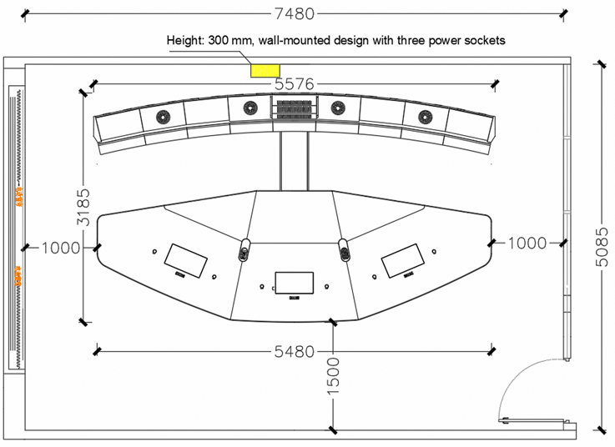

In a conference room with six seats in a single row, the power consumption of the telepresence equipment does not exceed 3072.5 W, and the power supply for the illumination system is at least 720 W.
In a conference room with 18 seats in two rows, the power consumption of the telepresence equipment does not exceed 3492.5 W, and the power supply for the illumination system is at least 1080 W.
At least three wall outlets shall be installed behind the media wall, centered and positioned 300 mm above the floor. The power socket specifications shall comply with local standards.
The telepresence system must be powered by two independent sockets. The other end of the plug is controlled by a circuit breaker, which can be turned off during holidays to completely power off the system.

Power Grounding
The media wall uses dedicated protective grounding. The standard yellow-green PE ground cable is used to connect the device enclosure. During construction, the dedicated ground bolt on the device enclosure must be connected. Paint and rust on the contact surface must be polished in advance to ensure good conductivity. Flat washers and spring washers must be used to prevent loosening. Metal electrical devices must be connected to a three-hole socket that meets the requirements and grounded through the dedicated ground cable of the building. It is prohibited to use the neutral wire or water pipe as the ground cable.
In addition, switches or fuses must not be installed on the ground cable. The cabinet door and cabinet body must be connected using short jumper wires. The copper-core yellow-green ground cable must be used in compliance with the specifications to prevent loose or incorrect connections and ensure electrical safety.

Network
At least one RJ45 network port must be reserved in the telepresence room. It is recommended that two RJ45 network ports be reserved. At least one RJ45 network port must be reserved on the front wall to meet the network access requirements of the telepresence system, and one RJ45 network port must be reserved on the wall on the right side of the device to meet other network access requirements. The network bandwidth must meet the access requirement of 6 Mbit/s per screen.
              - Network
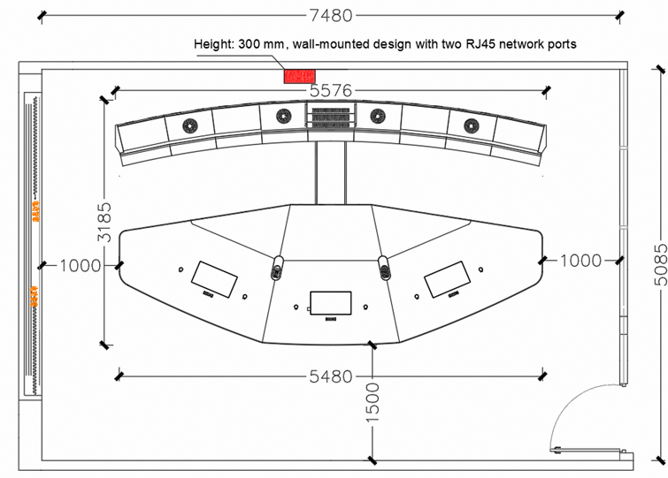

Indoor Air Quality
A telepresence room is enclosed video conferencing space. To provide a comfortable environment for efficient communication, the indoor air must be clean, which imposes high requirements on decoration materials.
The following are requirements for decoration materials used in Huawei telepresence rooms:
- According to the 10 standards for decoration and refurbishment materials on hazardous substance emission in China, materials that emit hazardous substances beyond the specified limits cannot be used in telepresence rooms. If the materials do not meet the requirements, they must be treated before being used in telepresence rooms.
- According to the GB50325-2020 Code for Indoor Environmental Pollution Control of Civil Construction Projects and the Environmental Air Quality Standards developed by China's National Health Commission, the limits of harmful substances such as radon (Rn-222), formaldehyde, ammonia, benzene, and total volatile organic compounds (TVOCs) in telepresence rooms after decoration must be accepted according to Class I standards. A total of seven items are tested (toluene and xylene are added in the 2020 version). The acceptance limits are as follows (mg/m³; radon is measured in Bq/m³):
                - Sources and control standards for main indoor air pollutants
Contaminants | Class I Building | Class II Building | Main Source
Formaldehyde | ≤0.07 | ≤0.08 | Man-made boards, adhesives, coatings, and furniture.
Benzene | ≤0.06 | ≤0.09 | Solvent-based paints, adhesives, and thinners.
Toluene | ≤0.15 | ≤0.20 | Solvents, paints, and composite materials.
Xylene | ≤0.20 | ≤0.20 | Solvents, paints, and composite materials.
Ammonia | ≤0.15 | ≤0.20 | Concrete antifreeze, urea-formaldehyde resin, and bathrooms.
Total Volatile Organic Compound (TVOC) | ≤0.45 | ≤0.50 | Building materials, furniture, cleaning agents, and paints.
Radon (Rn-222) | ≤150 | ≤150 | Soil, stone, and underground fissures.

Class I buildings include houses, dormitories, hospitals, buildings for the aged, kindergartens, schools, and so on.
Class II buildings include hotels, office buildings, cultural and entertainment venues, bookstores, libraries, exhibition halls, stadiums, shopping malls (stores), waiting rooms for public transportation, hospital waiting rooms, restaurants, barbershops, and so on.

Fire Protection Requirements
According to the flammability of the materials, decoration materials are classified into four levels listed in Table 2-8.
                - Flammability
Level | Flammability
A | 100% noncombustible
B1 | Difficult to ignite
B2 | Normal combustibility
B3 | Easily ignited

Table 2-9 provides the flammability requirements on different components of a telepresence room.
                - Telepresence room flammability requirements
Location | Flammability
Location | Ceiling | Wall | Floor | Separator | Furniture | Curtain | Other Decoration Materials
Telepresence room | A | B1 | B1 | B1 | B2 | B2 | B2

Environmental Protection Requirements
The emission limits of hazardous substances in the main decoration and refurbishment materials of telepresence conference rooms must comply with the 10 national standards, such as the Limits of Hazardous Substances in Indoor Decoration and Refurbishment Materials of China. For details, see Table 2-10.
                - Standards for decoration and refurbishment materials on hazardous substance emission
Standard No. | Standard Name
GB 18580-2017 | Limits of formaldehyde emission from wood-based panels and their products
GB 18581-2020 | Limits of harmful substances in solvent-based wood coatings
GB 18582-2020 | Limit of harmful substances of architectural wall coatings
GB 18583-2008 | Limits of harmful substances in adhesives
GB 18584-2001 | Limits of harmful substances in wooden furniture
GB 18585-2023 | Limits of harmful substances in wallpapers
GB 18586-2001 | Limits of harmful substances in PVC roll flooring
GB 18587-2001 | Limits of harmful substance emissions from carpets, carpet underlays, and carpet adhesives
GB 18588-2001 | Limits of ammonia emissions from concrete admixtures
GB 6566-2010 | Limit of radionuclides in building materials

These national standards outline the limits of harmful elements in indoor decoration materials, including formaldehyde, total volatile organic compounds (TOVC), benzene, toluene, xylene, ammonia, free toluene diisocyanate (TDI), vinyl chloride monomer, styrene monomer, soluble lead, chromium, cadmium, mercury, and arsenic. The limits of radionuclides in building materials are also clearly specified.

Recommended Conference Room Environment

Acoustics
This chapter takes the single-row telepresence room as an example to analyze the requirement on the acoustic aspect.

Sound Absorption Plan I
All walls, including the foreground, background, and side walls, are solid walls. The door is on the right side wall, and a French window is on the left side wall.
              - Sound absorption plan I
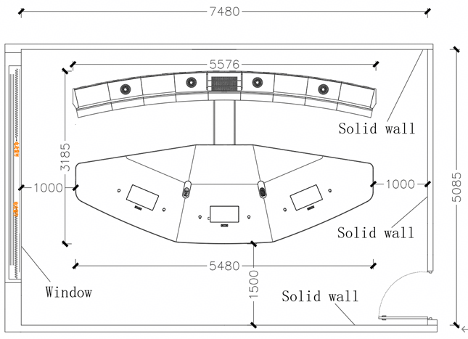

Based on the design principles described in 2.4 Acoustics Design, the sound absorption plan is as follows:
Ceiling: perforated materials, such as perforated aluminum panels and perforated gypsum boards.
Foreground wall: existing wall and white lacquered boards/ fabric wall panels.
Side wall 1: French window and sound absorbing, flame-retardant fabric curtain.
Side wall 2: entrance door, solid wall, and fabric wall panels.
Background wall: fabric wall panels.
Floor: carpet.
Assume that the overall structure of a single-row telepresence system (including the devices, sheet metal, and conference table) does not have sound absorption properties. In a fully occupied telepresence room, six participants are seated on soft chairs. According to the simulation analysis using acoustic design software, the reverberation time (RT) curve of the conference room is relatively flat. The average RT across all frequency bands is 0.38 seconds. For a telepresence room primarily focused on voice communication, this RT value can deliver a good speech transmission index (STI). The Figure 3-2 shows the RT curve.
              - Reverberation time (RT) curve
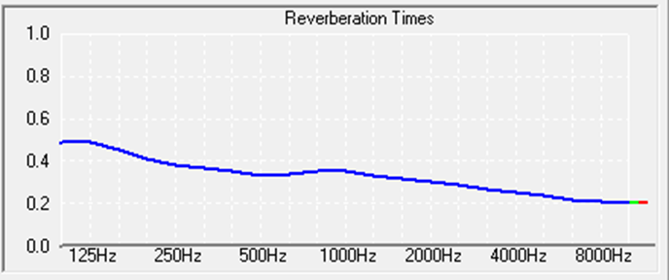

In this sound absorption plan, the STI is greater than 0.838, and the corresponding level is excellent. As shown in Figure 3-3.
              - Speech transmission index (STI)
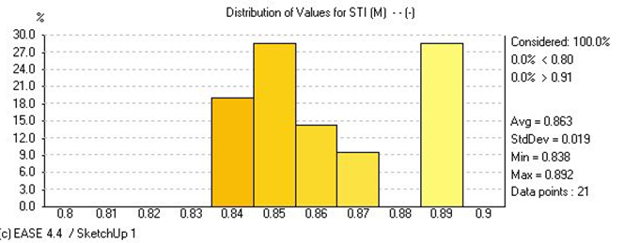

Sound Absorption Plan II
The foreground and background walls of the conference room are solid walls. The door is on the right side wall, and a glass window is on the left side wall. The right side wall has a French window and an entrance.
              - Sound absorption plan II
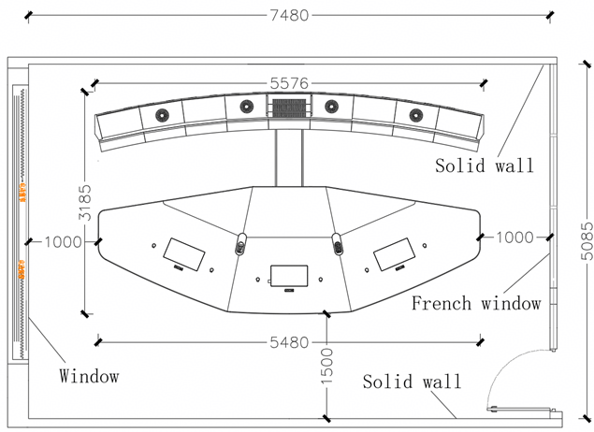

Based on the design principles described in 2.4 Acoustics Design, the sound absorption plan is as follows:
Ceiling: perforated materials, such as perforated aluminum panels and perforated gypsum boards.
Foreground wall: existing wall and white lacquered boards/wood veneer/fabric wall panels.
Side wall 1: French window and sound absorbing, flame-retardant fabric curtain.
Side wall 2: French window and sound absorbing, flame-retardant fabric curtain.
Background wall: fabric wall panels.
Floor: carpet.
Assume that the overall structure of a single-row telepresence system (including the devices, sheet metal, and conference table) does not have sound absorption properties. In a fully occupied telepresence room, six participants are seated on soft chairs. According to the simulation analysis using acoustic design software, the RT curve shows that the low-frequency part is relatively active and the high-frequency part is well absorbed. The average RT is 0.42 seconds. For a telepresence room primarily focused on voice amplification, this RT value can deliver a good speech transmission index (STI). The Figure 3-5 shows the RT curve.
              - Reverberation time (RT) curve
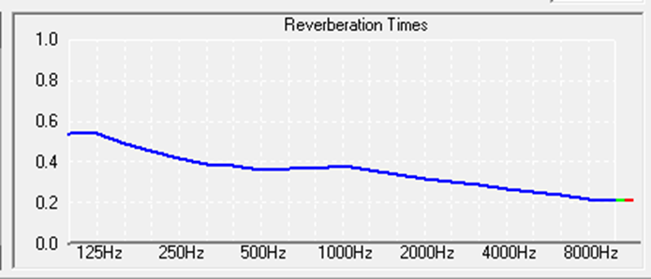

In this sound absorption plan, the speech transmission index is greater than 0.826, and the corresponding level is excellent. As shown in Figure 3-6.
              - Speech transmission index (STI)
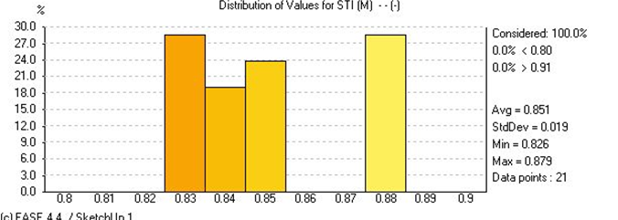

Illumination

Light Fitting Layout

Single-Row Telepresence Rooms
The following uses a single-row telepresence room with six seats as an example. Twelve flat panel spotlights are evenly distributed in three rows on the ceiling. According to the lighting software analysis, when the lights are turned on, the illumination in the entire conference area and around the conference table is even. The maximum illumination is about 1400 lux, the average illumination is 1281 lux, and the illumination on the wall is 850 lux. The illumination parameters are within the required range of the telepresence room, and the unified glare rating (UGR) ranges from 13 to 15. The glare evaluation level is slight glare, which can be ignored. This plan provides a good lighting environment.
              - Light fitting layout
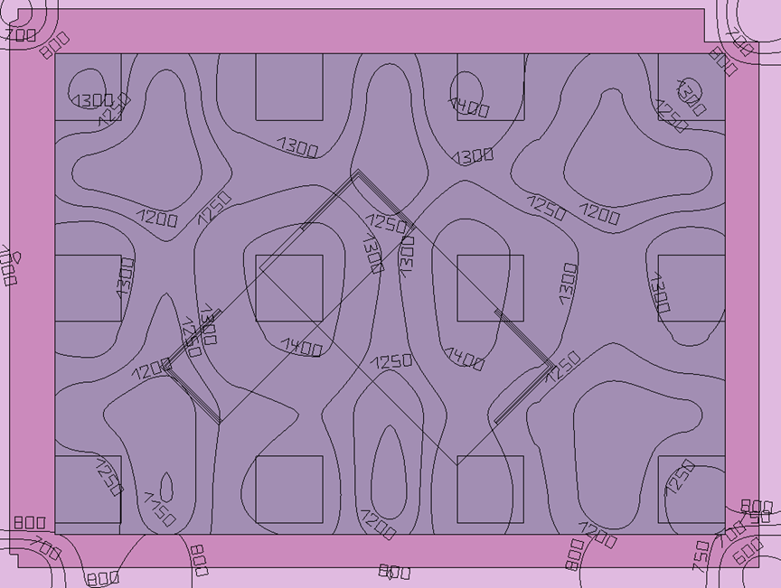

Telepresence Room with Double-Row Tables
The following uses a dual-row telepresence room with 18 seats as an example. Eighteen flat panel spotlights are evenly distributed in three rows on the ceiling. According to the lighting software analysis, when the lights are turned on, the illumination in the entire conference area and around the conference table is even. The maximum illumination is about 2788 lux, and the average illumination is 1463 lux. The illumination parameters are within the required range of the telepresence room, and the unified glare rating (UGR) ranges from 13 to 15. The glare evaluation level is slight glare, which can be ignored. This plan provides a good lighting environment.
              - Light fitting layout
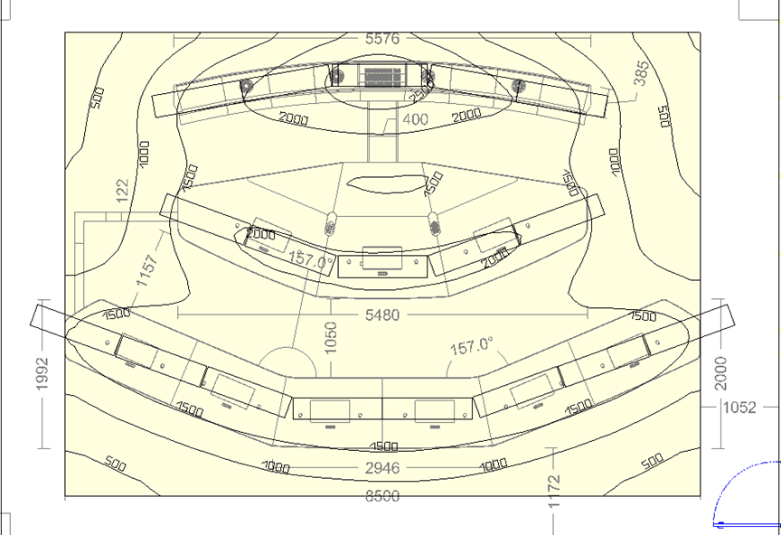

Lamp Selection
Recommended Light Sources for Single-Row Telepresence Room Lighting
Light source parameters: high CRI LED light source, 4000K color temperature, color rendering index (Ra) ≥ 90, and service life of more than 20,000 hours.
                - Lamp parameters
Brand | Model | Power | CRI | Size
Ewinlight | SP-1 | 60W | Ra≥90 | 595 mm x 595 mm x 73 mm

              - Flat spotlight (SP-1)
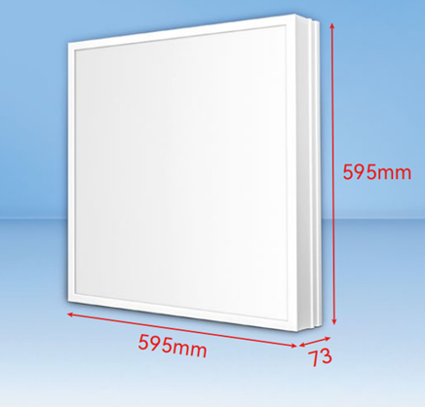

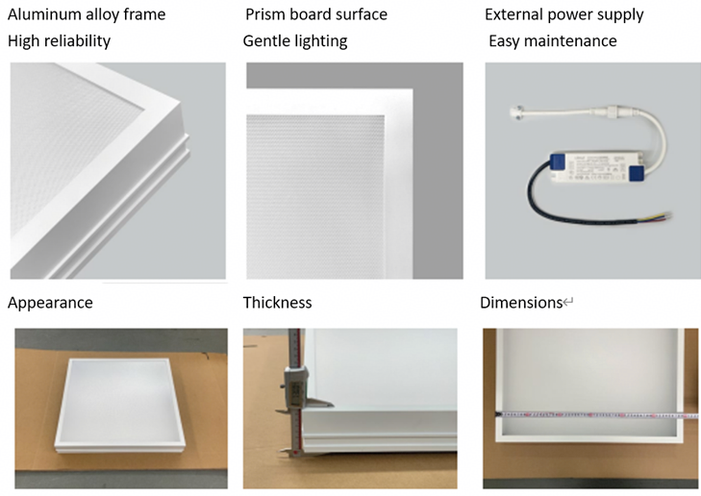
Recommended Light Sources for Dual-Row Telepresence Room Lighting
Light source parameters: high CRI LED light source, 4000K color temperature, color rendering index (Ra) ≥ 90, and service life of more than 20,000 hours.
                - Lamp parameters
Brand | Model | Power | CRI | Size
Ewinlight | SP-3 | 60W | Ra≥90 | 1195 mm x 295 mm x 73 mm

              - Flat spotlight (SP-3)
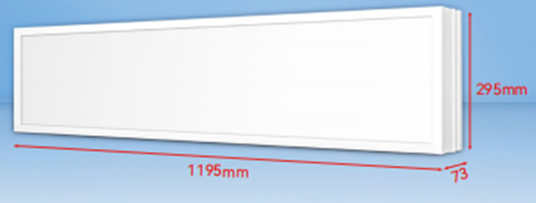

Wall Reconstruction

Background Wall
Principally, the entrance door is not allowed in the background wall. If the door is in the background wall, apply fabric wall panels to the door inside using the flame-retardant fabric.
The background wall must be soundproof and be able to absorb high-frequencies of sound. It is comprised of an existing wall, wood joist, 15 mm (0.59 in.) blockboard, 30 mm (1.18 in.) sound absorbing sponge and flame-retardant fabric wall panels. All materials must be of the fire protection level B1 and environmental protection level E1.

Foreground Wall
The foreground wall of a telepresence room must be soundproof and be able to absorb low-frequency sound.
Foreground wall structure: original wall + 9 mm thick white lacquered board/wood veneer (all the materials must meet the fireproof B1 and environmental protection E1 standards).

Right Side Wall
Principally, the right side wall in a telepresence conference room must be soundproof and be able to absorb high-frequencies of sound. If there is a window in the right side wall, it is comprised of an existing wall, wood joist, 15 mm (0.59 in.) blockboard, 30 mm (1.18 in.) sound absorbing sponge, flame-retardant fabric, and acoustic curtain with high shading rate. All materials must be of the fire protection level B1 and environmental protection level E1.

Left Side Wall
The entrance door must be installed in a side wall, near the devices. Principally, the door cannot be installed in the background wall or captured by the camera.
You do not need to change the door if it is a solid wood door and meets the sound insulation requirement for doors specified in Evaluation Standard for Green Building, that is, not less than 45 dB.
Use 1000 mm (39.37 in.) single-swing wooden door or 1400 mm (55.11 in.) double-swing wooden door as the entrance door. Glass doors are prohibited. Door frames must be sealed for sound insulation, and the sound insulation capability must conform to the requirement specified in Evaluation Standard for Green Building, that is, not less than 45 dB.
The side walls provides sound absorption and insulation functions. The left side wall is comprised of an existing wall, wood joist, 15 mm (0.59 in.) blockboard, 30 mm (1.18 in.) sound absorbing sponge and flame-retardant fabric. All materials must be of the fire protection level B1 and environmental protection level E1. Install double light switches on the right side wall of the entrance.

Floor
The color of the carpet must be the same as that of the wall. The carpet must meet the following requirements: environmentally friendly, electrostatic discharge preventive, pile height (thickness) of 6 mm (0.24 in.), and density of 700–1000 g/m². All materials must be of the fire protection level B1 and environmental protection level E1.

Effect Pictures

Single-Row Telepresence Room Effect Drawing
              - Reference effect drawing 1
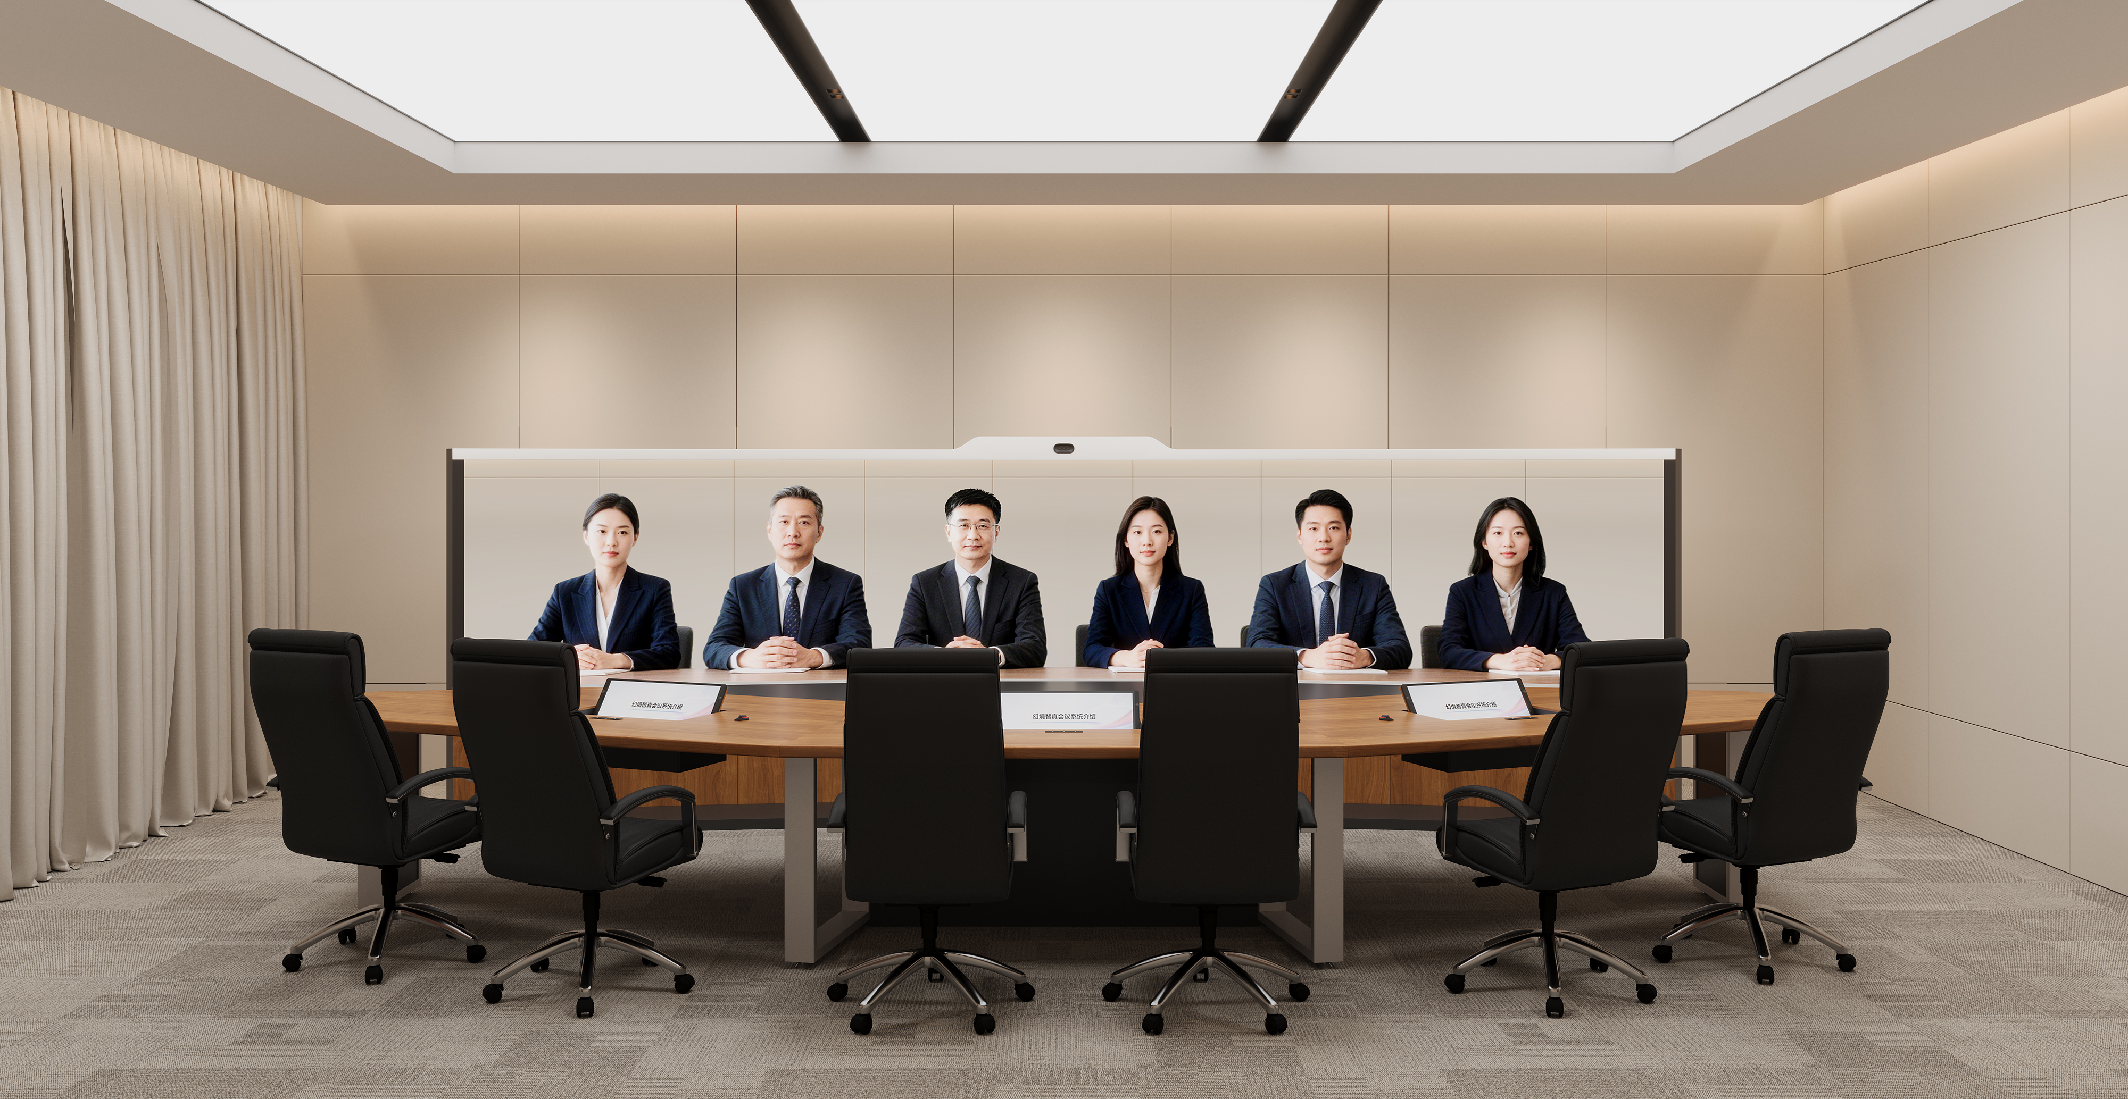

              - Reference effect drawing 2
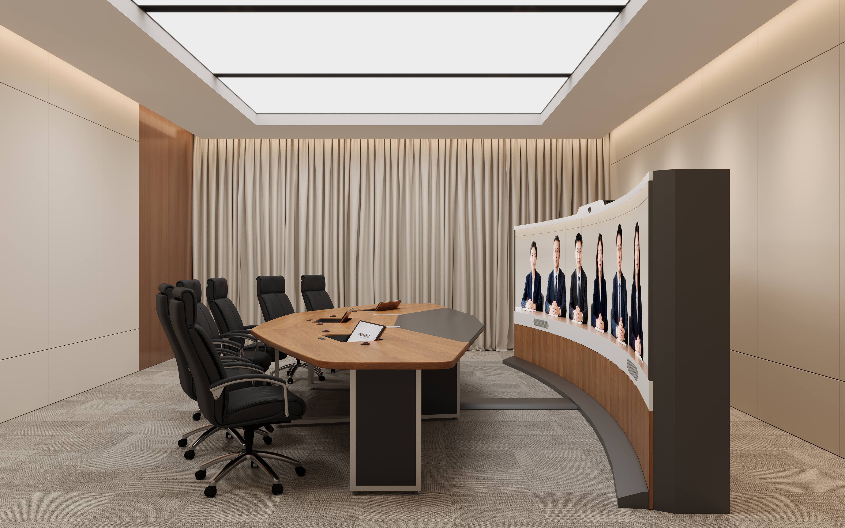

              - Reference effect drawing 3
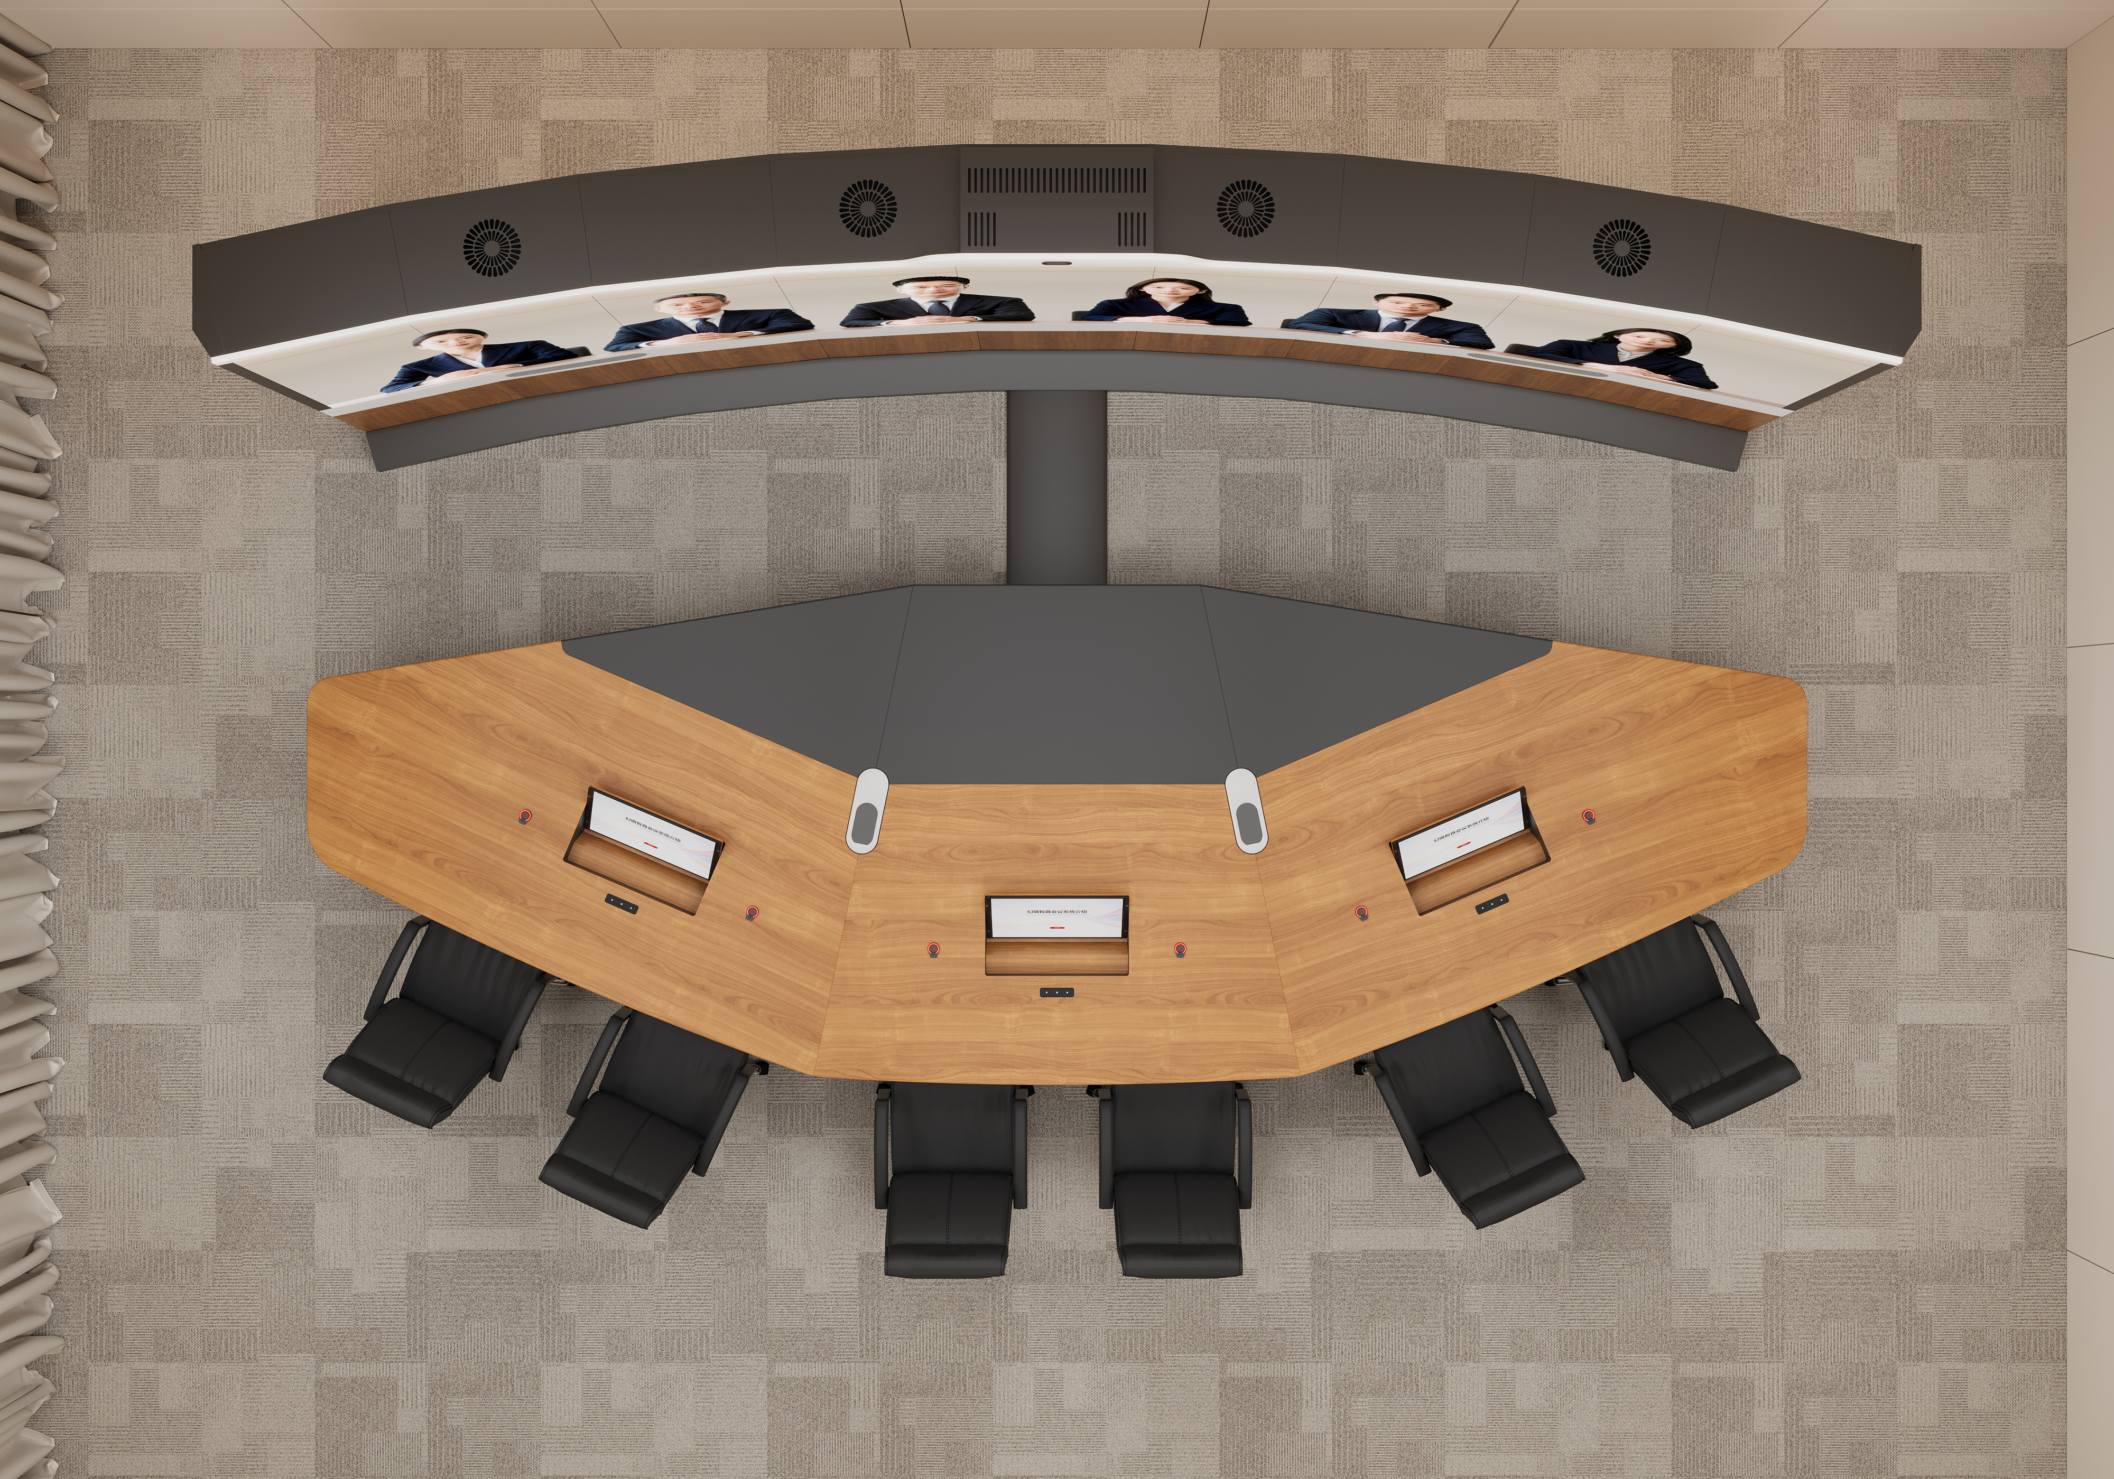

Dual-Row Telepresence Room Effect Drawing
              - Reference effect drawing 1
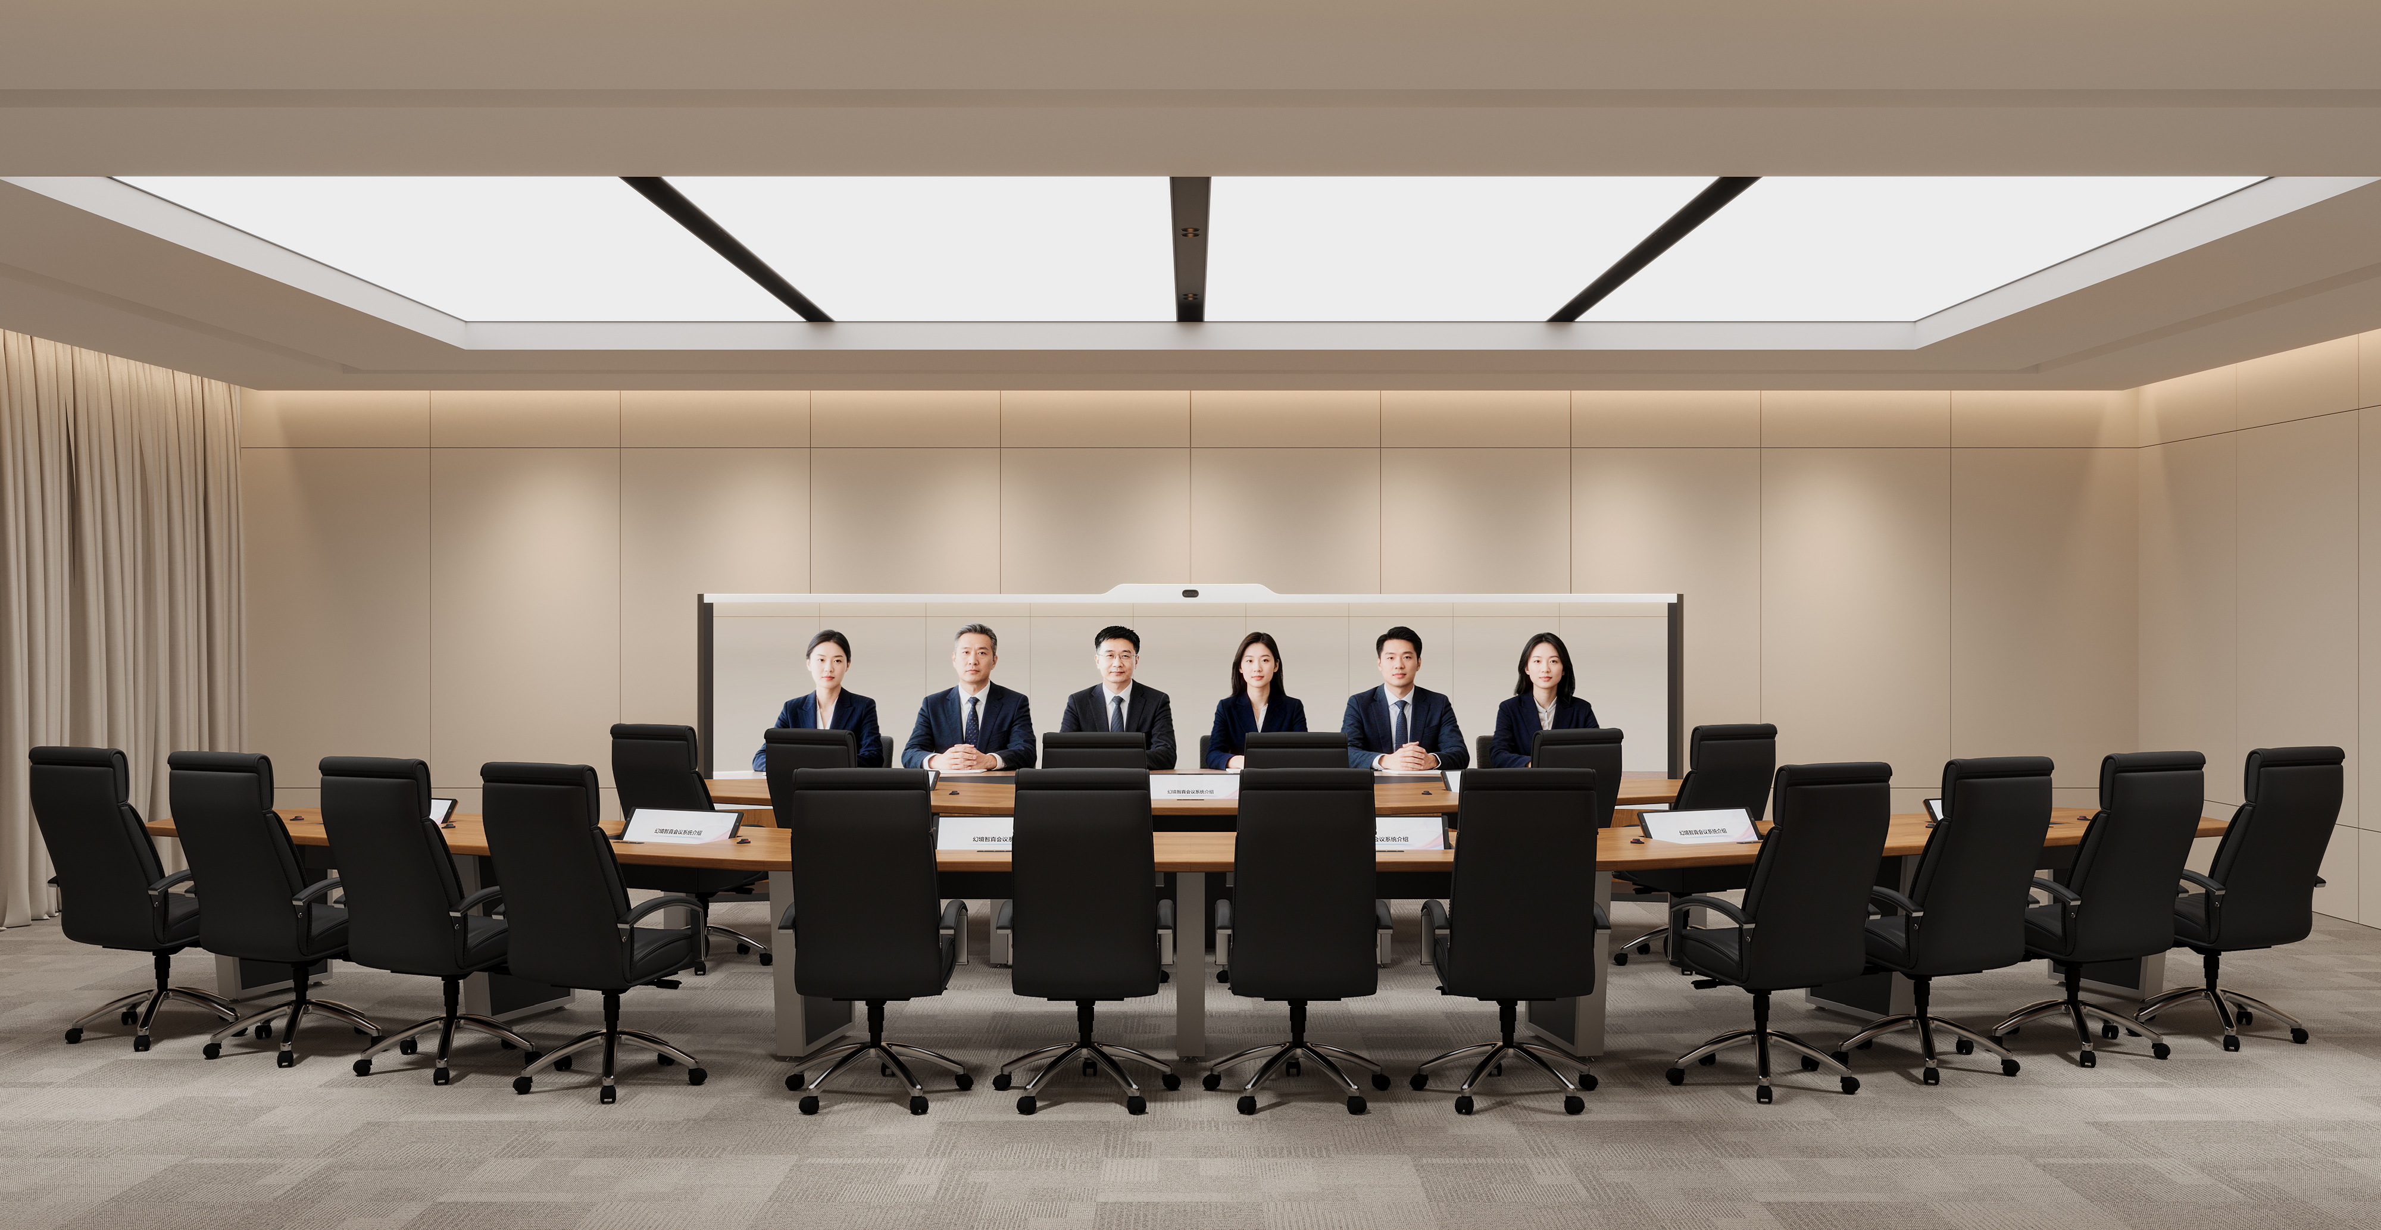

              - Reference effect drawing 2
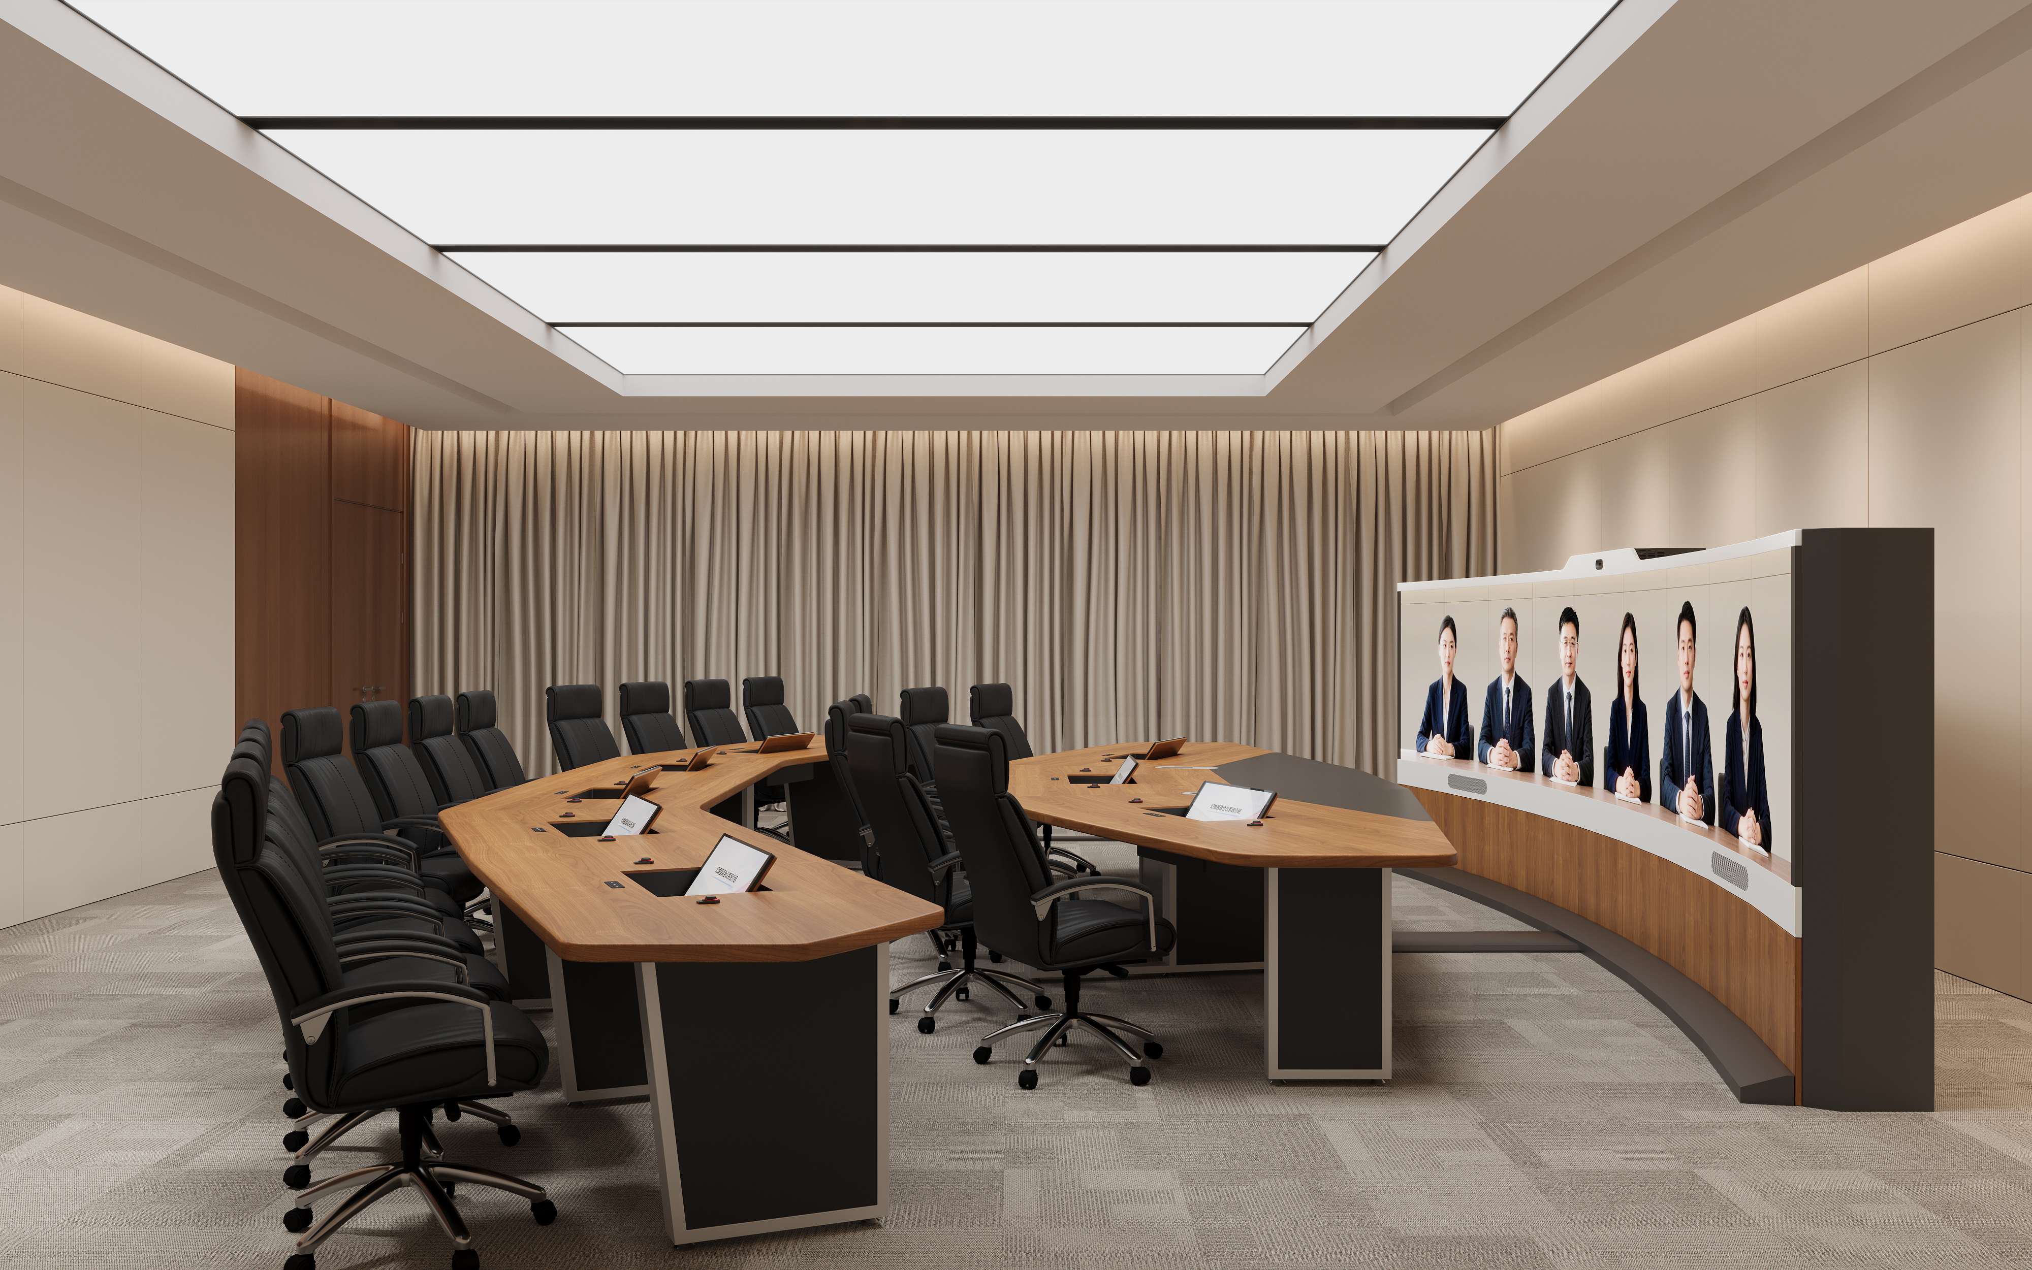

              - Reference effect drawing 3
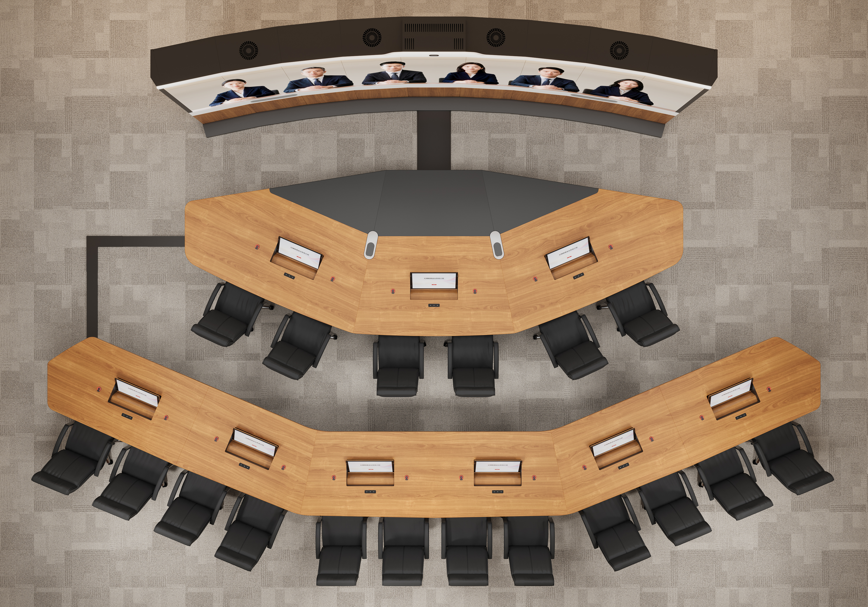

Appendix

Appendix 1
                - Decoration design standards
No. | Name | Standard No.
1 | Code for Construction Project Management | GB/T50326-2017
2 | Code for Management of Engineering Contracting Projects | GB/T50358-2005
3 | Unified Standard for Constructional Quality Acceptance of Building Engineering | GB 50300-2013
4 | Code for Construction Quality Acceptance of Building Decoration | GB 50210-2018
5 | Code for Construction Quality Acceptance of Building Decoration | GB 50210-2018
6 | Code for Construction and Acceptance of Building Ground Engineering | GB 50209-2008
7 | Code for Indoor Environmental Pollution Control of Civil Building Engineering | GB 50325-2010
8 | Code for Indoor Environmental Pollution Control of Civil Building Engineering | GB 50325-2010
9 | Indoor Decorating and Refurbishing Materials–Limit of Formaldehyde Emission of Wood-Based Panels and Finishing Products | GB 18580-2017
10 | Indoor Decorating and Refurbishing Materials–Limit of Harmful Substances of Solvent-Based Coatings for Woodenware | GB 18581-2009
11 | Indoor Decorating and Refurbishing Materials–Limit of Harmful Substances of Adhesives | GB 18583-2001
12 | Indoor Decorating and Refurbishing of Materials–Limit of Harmful Substances of Wood-Based Furniture | GB 18584-2001
13 | Indoor Decorating and Refurbishing Materials–Limitations of Harmful Substances Emitted from Carpets, Carpet Cushions and Adhesives | GB 18587-2001
14 | Limit of Radionuclides in Building Materials | GB 6566-2010
15 | Standard of Construction Safety Inspection | JGJ 59-2011
16 | Standard of the Work Safety Assessment for Construction Company | JGJ/T77-2010, J278-2010
17 | Code for Fire Prevention Installation and Acceptance in Construction of Interior Decoration Engineering of Buildings | GB50354-2005
18 | Technical Code for Safety of Temporary Electrification on Construction Site | JGJ 46-2005
19 | Technical Specification for Safety Operation of Construction Machinery | JGJ 33-2009
20 | Standard of Environment and Sanitation of Construction Site | JGJ146-2014
21 | Standard for Architectural Drawings | GB/T50104-2010
22 | Inspection and Testing Specification of Construction Engineering Quality | DGJ32/J21-2009
23 | Code for Construction Project Document Filling and Arrangement | GB/T50328-2014
24 | Standard for Lighting Design of Buildings | GB50034-2013
25 | Test Methods for Noise of Household Utensil and That of Similar Usage | GB/T 4214.1—2017
26 | Design Guide for Acoustic Workplace of Low Noise and Noise Control Plan | GB/T17429.1-1999
27 | Fireproof Specification for Interior Decoration Design | GB 50222-2017

The specifications for the indoor decoration design used outside Chinese mainland must be changed based on the laws and regulations of the local country or region.

